<https://www.examtopics.com/discussions/servicenow/view/72024-exam-cad-topic-1-question-5-discussion/>

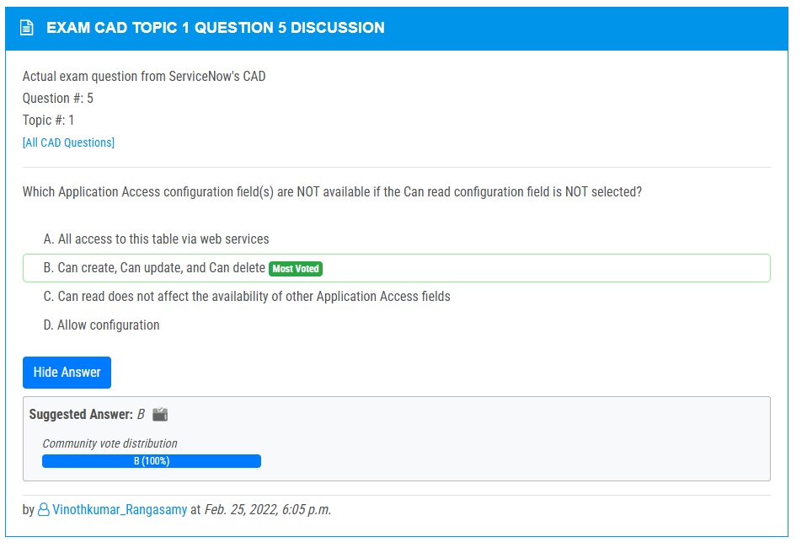

<https://www.examtopics.com/discussions/servicenow/view/82740-exam-cad-topic-1-question-7-discussion/>

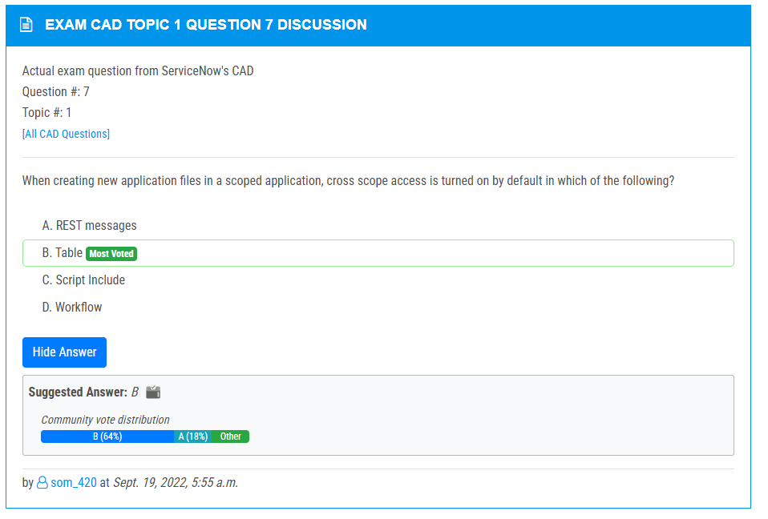

<https://www.examtopics.com/discussions/servicenow/view/73400-exam-cad-topic-1-question-86-discussion/>

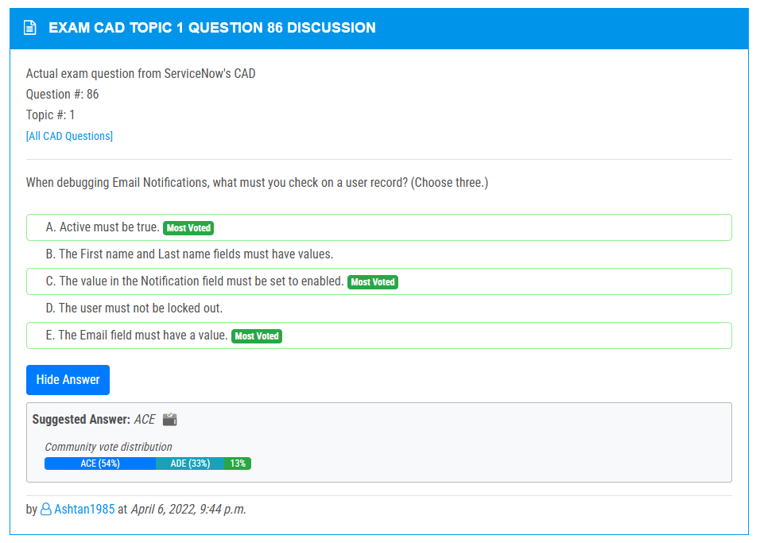

<https://www.examtopics.com/discussions/servicenow/view/70403-exam-cad-topic-1-question-76-discussion/>

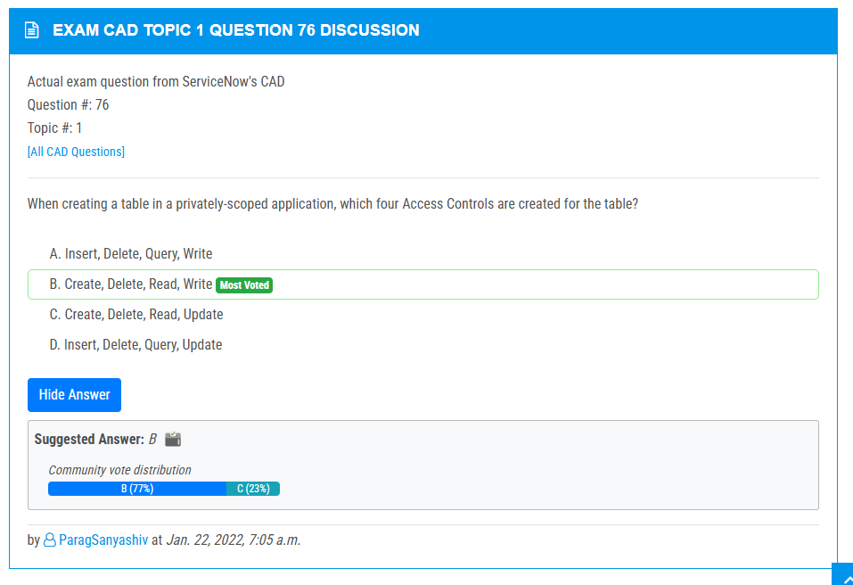

<https://www.examtopics.com/discussions/servicenow/view/64121-exam-cad-topic-1-question-34-discussion/>

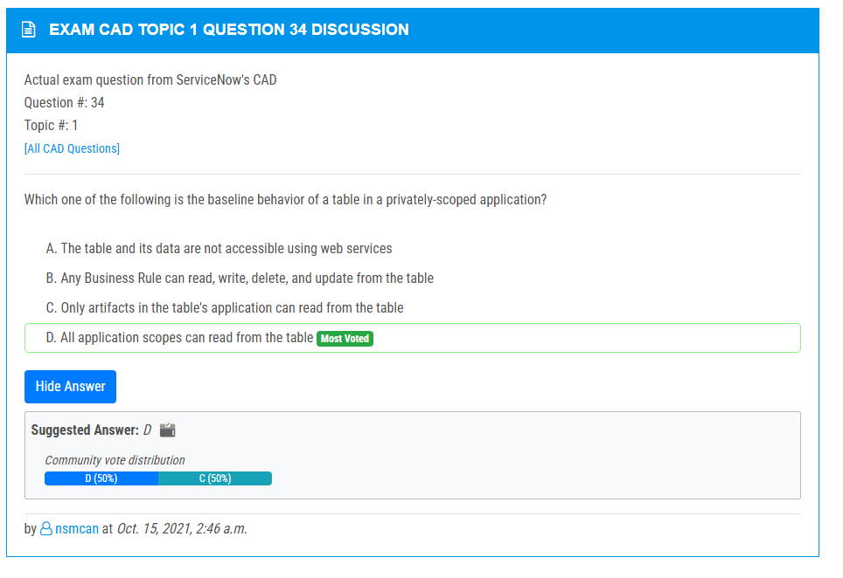

<https://www.examtopics.com/discussions/servicenow/view/78197-exam-cad-topic-1-question-14-discussion/>

<https://www.examtopics.com/discussions/servicenow/view/64113-exam-cad-topic-1-question-17-discussion/>

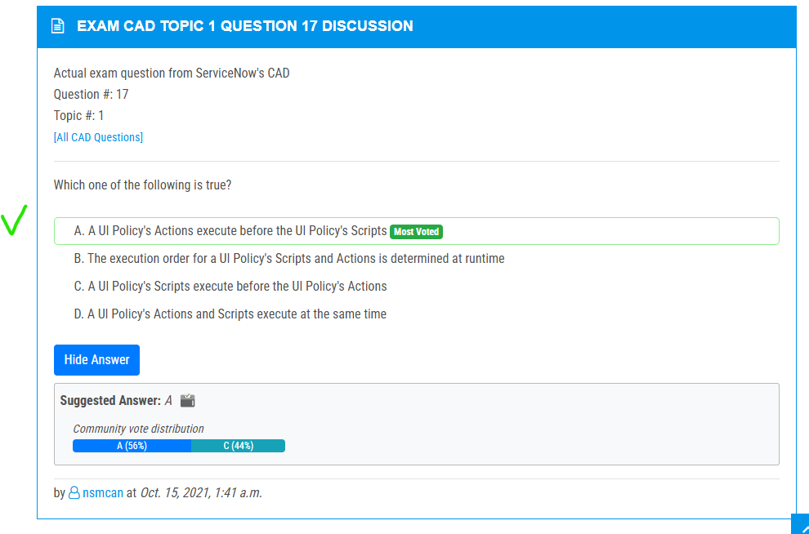

<https://www.examtopics.com/discussions/servicenow/view/154409-exam-cad-topic-1-question-148-discussion/>

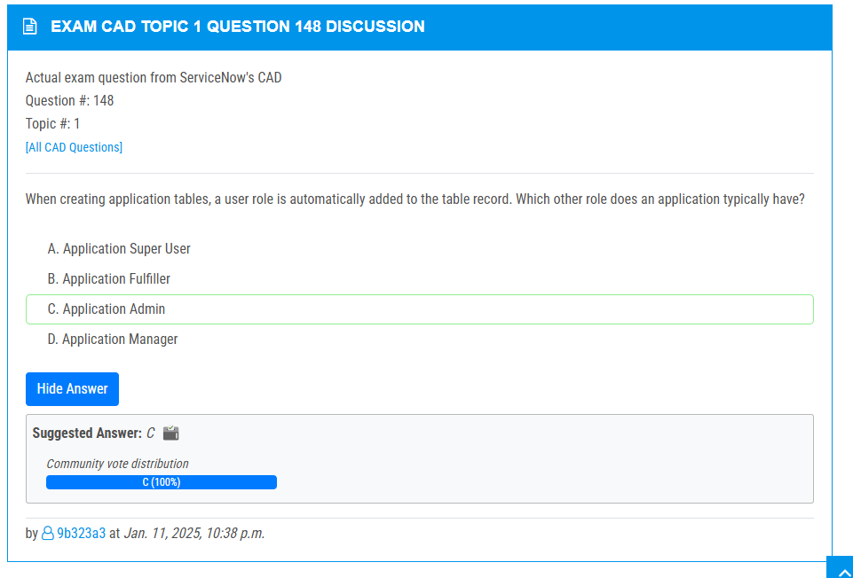

<https://www.examtopics.com/discussions/servicenow/view/70396-exam-cad-topic-1-question-53-discussion/>

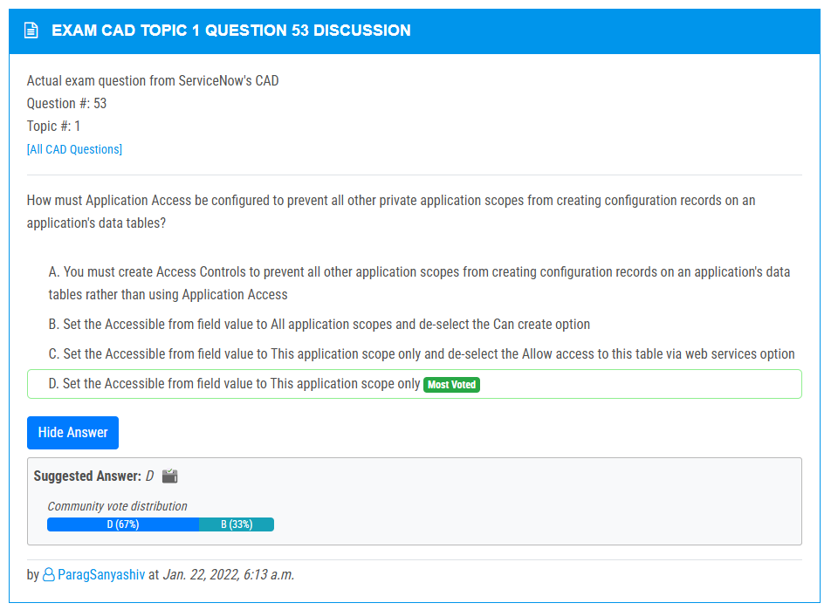

<https://www.examtopics.com/discussions/servicenow/view/111990-exam-cad-topic-1-question-44-discussion/>

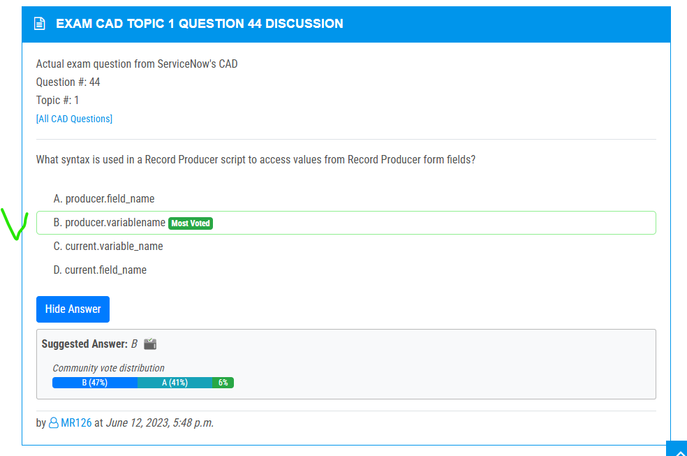

<https://www.examtopics.com/discussions/servicenow/view/77307-exam-cad-topic-1-question-9-discussion/>

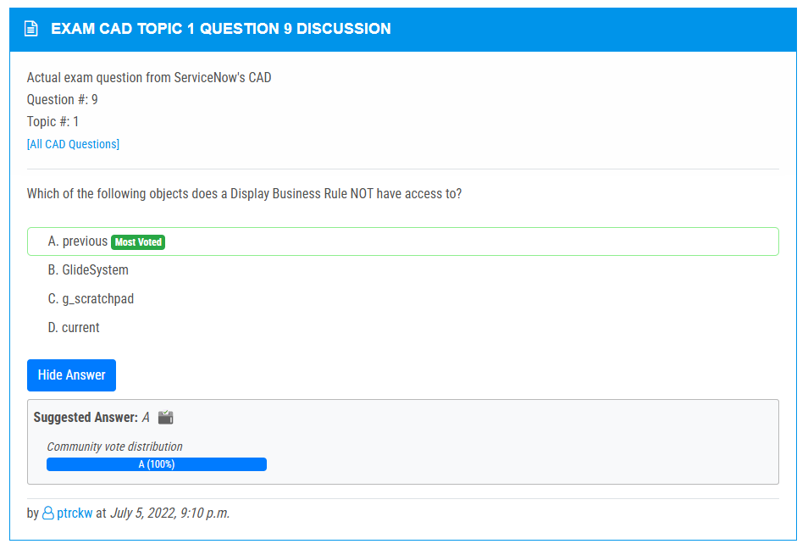

<https://www.examtopics.com/discussions/servicenow/view/91523-exam-cad-topic-1-question-103-discussion/>

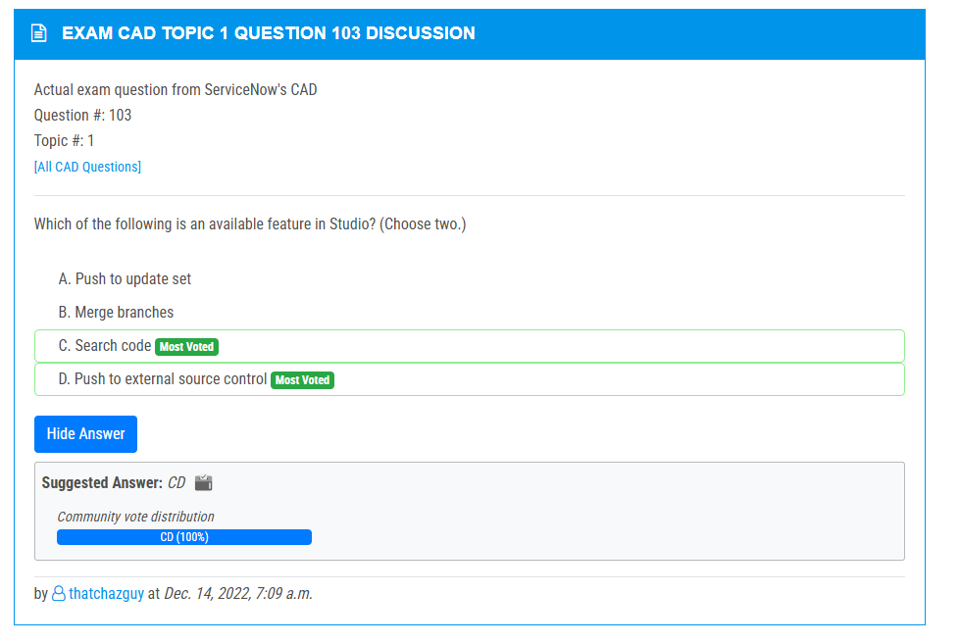

<https://www.examtopics.com/discussions/servicenow/view/64109-exam-cad-topic-1-question-10-discussion/>

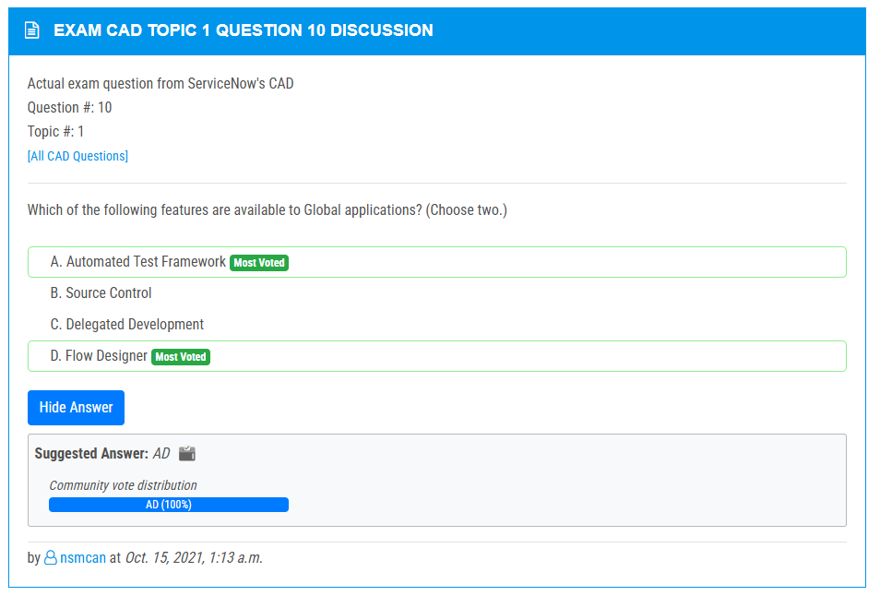

<https://www.examtopics.com/discussions/servicenow/view/71307-exam-cad-topic-1-question-4-discussion/>

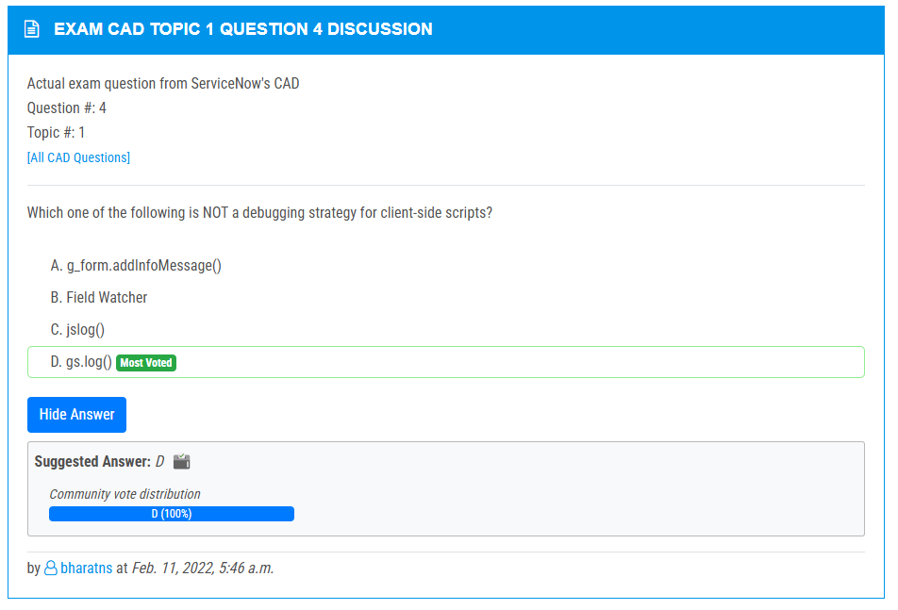

<https://www.examtopics.com/discussions/servicenow/view/64114-exam-cad-topic-1-question-18-discussion/>

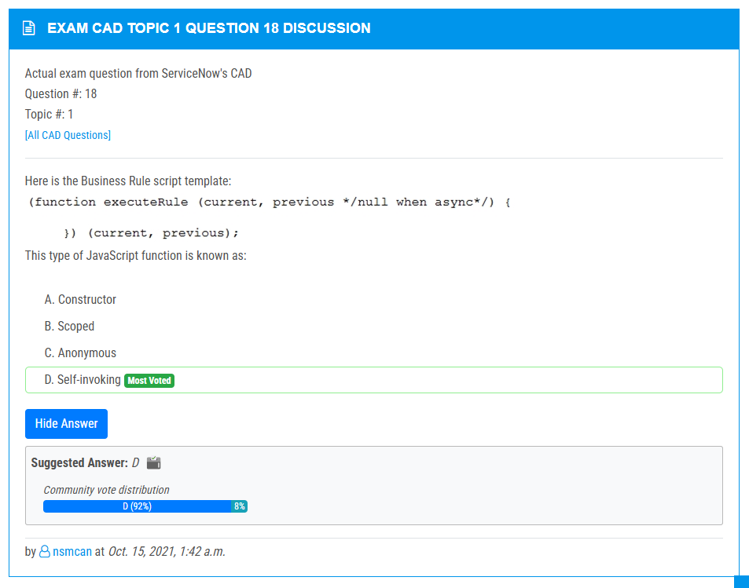

<https://www.examtopics.com/discussions/servicenow/view/70398-exam-cad-topic-1-question-60-discussion/>

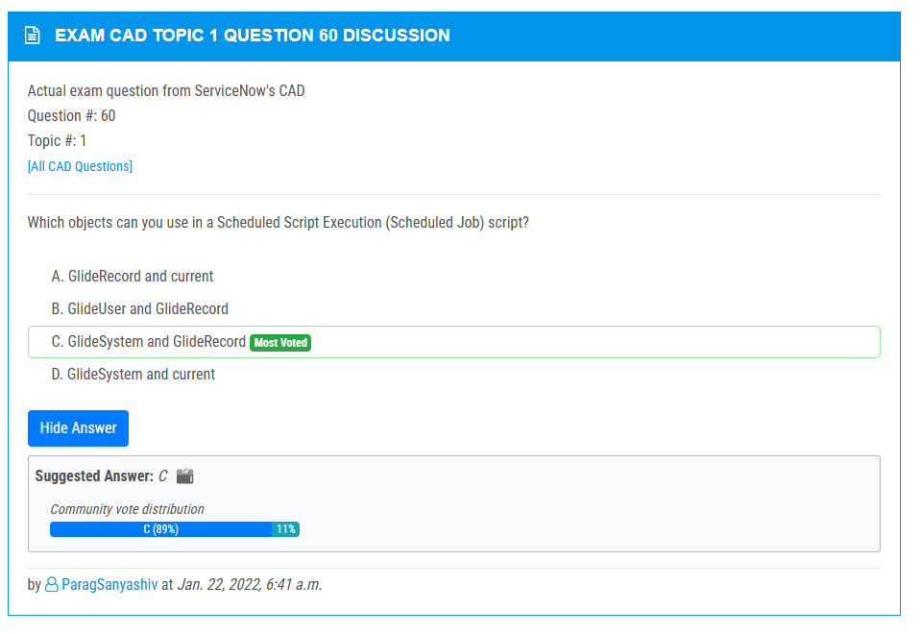

<https://www.examtopics.com/discussions/servicenow/view/64119-exam-cad-topic-1-question-31-discussion/>

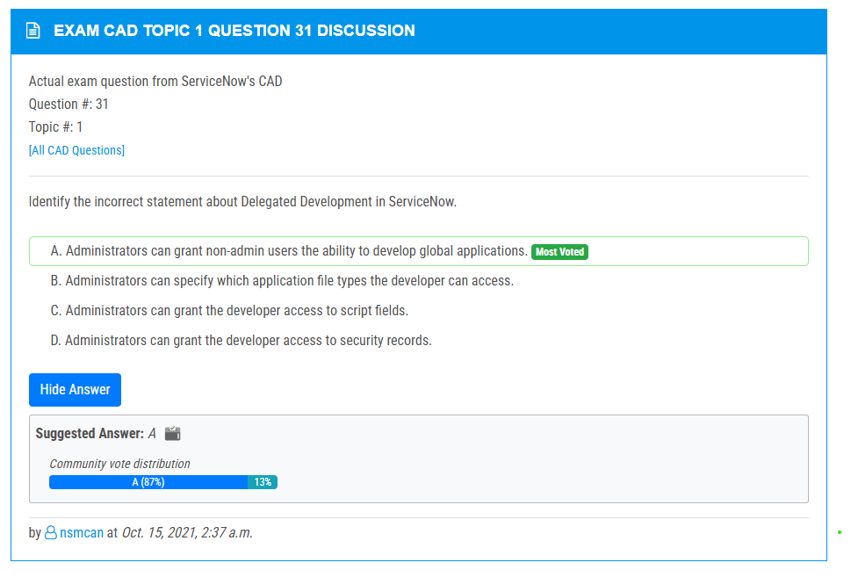

<https://www.examtopics.com/discussions/servicenow/view/70395-exam-cad-topic-1-question-54-discussion/>

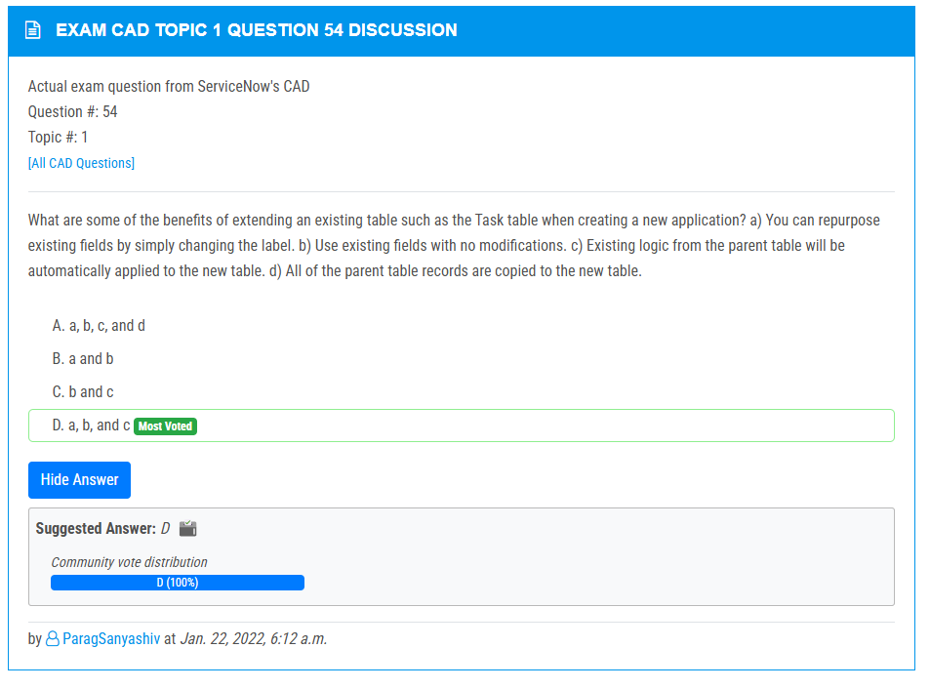

<https://www.examtopics.com/discussions/servicenow/view/92618-exam-cad-topic-1-question-24-discussion/>

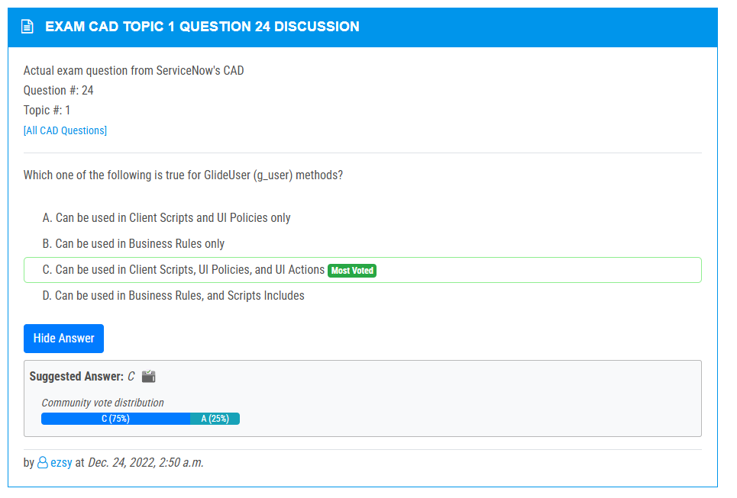

<https://www.examtopics.com/discussions/servicenow/view/64123-exam-cad-topic-1-question-37-discussion/>

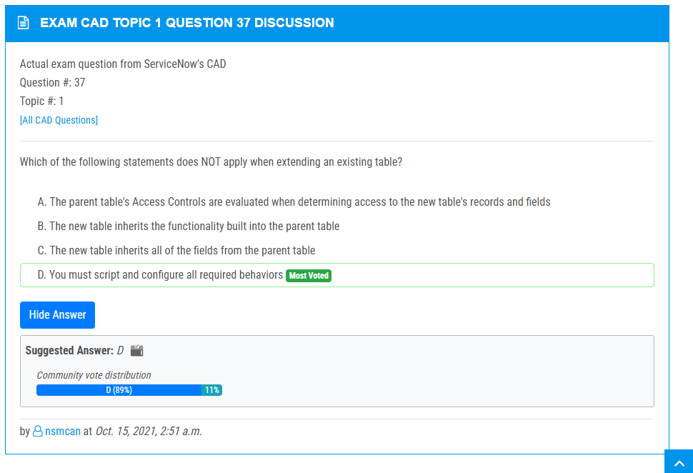

<https://www.examtopics.com/discussions/servicenow/view/103450-exam-cad-topic-1-question-125-discussion/>

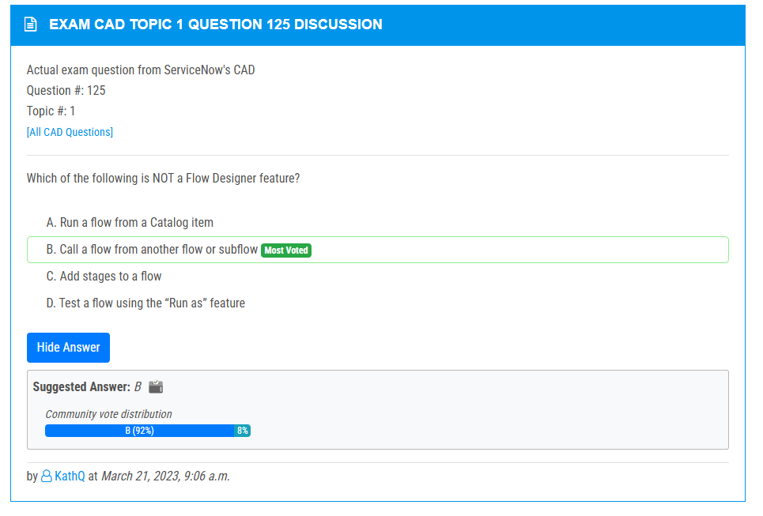

<https://www.examtopics.com/discussions/servicenow/view/90629-exam-cad-topic-1-question-116-discussion/>

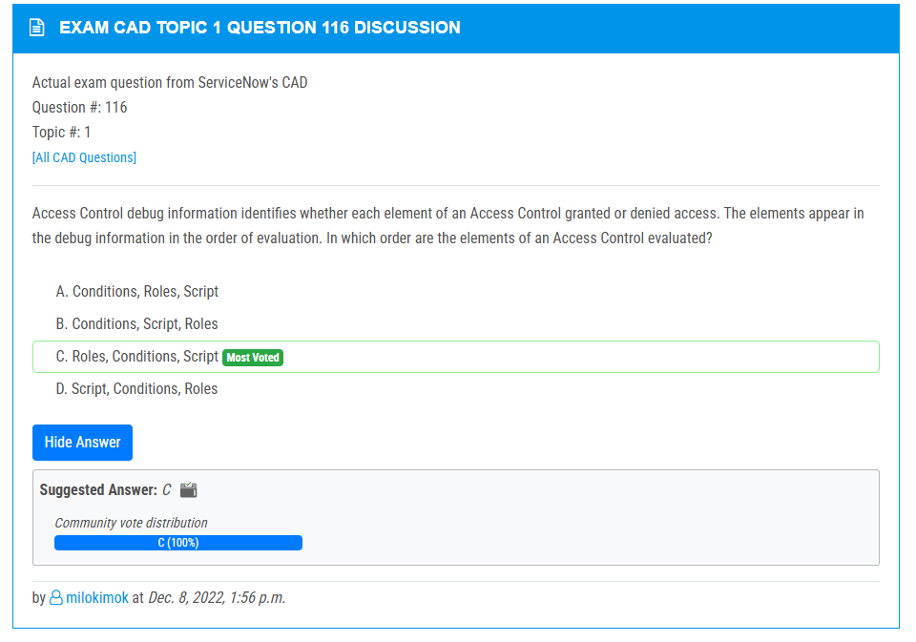

<https://www.examtopics.com/discussions/servicenow/view/70397-exam-cad-topic-1-question-59-discussion/>

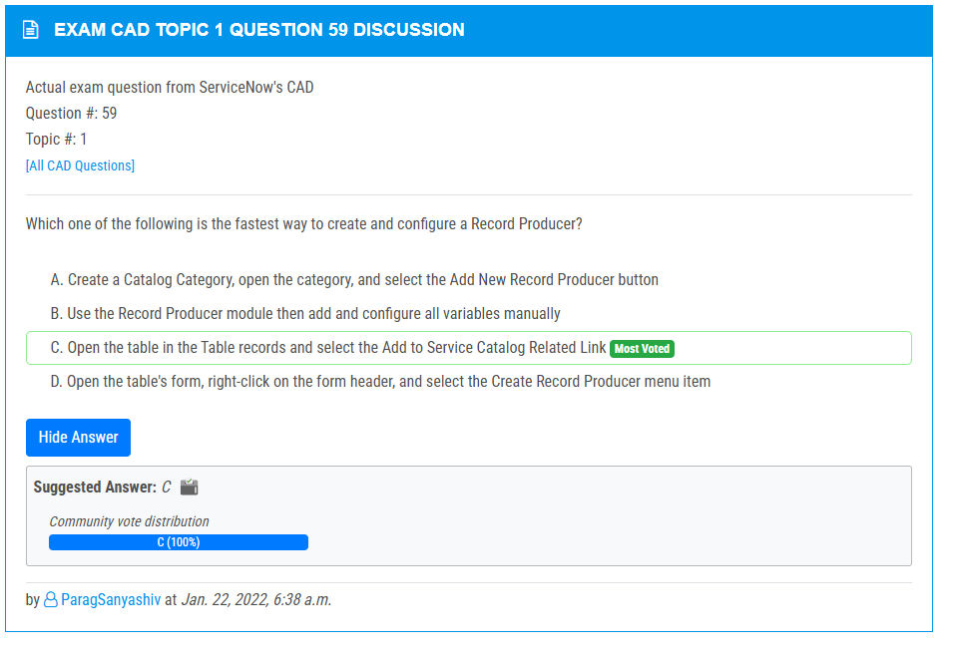

<https://www.examtopics.com/discussions/servicenow/view/66877-exam-cad-topic-1-question-3-discussion/>

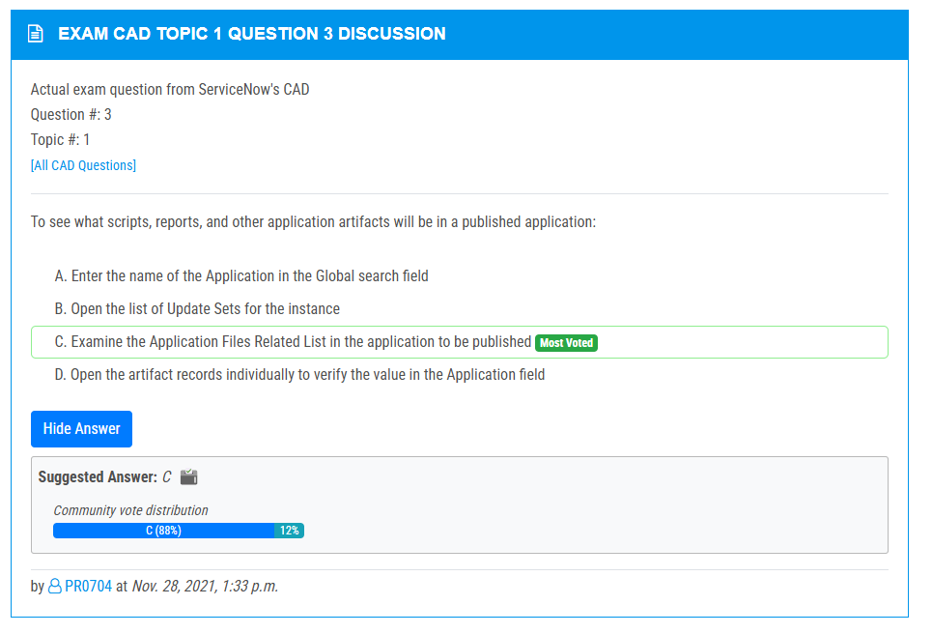

<https://www.examtopics.com/discussions/servicenow/view/90958-exam-cad-topic-1-question-102-discussion/>

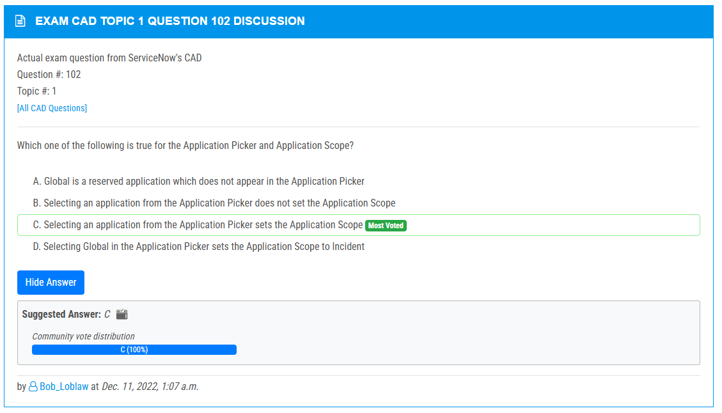

<https://www.examtopics.com/discussions/servicenow/view/121051-exam-cad-topic-1-question-32-discussion/>

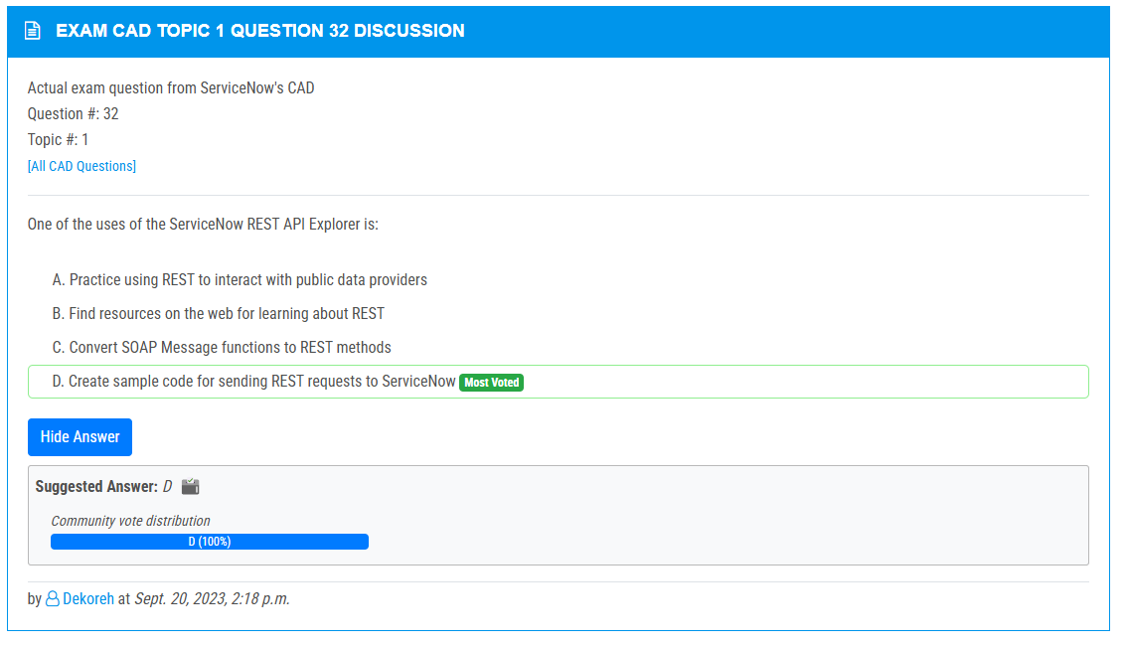

<https://www.examtopics.com/discussions/servicenow/view/141226-exam-cad-topic-1-question-139-discussion/>

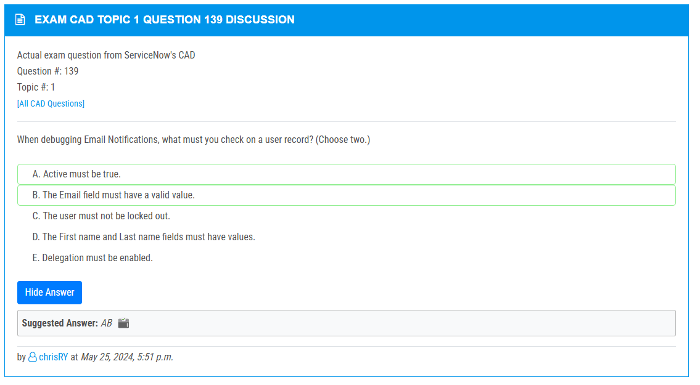

<https://www.examtopics.com/discussions/servicenow/view/70401-exam-cad-topic-1-question-72-discussion/>

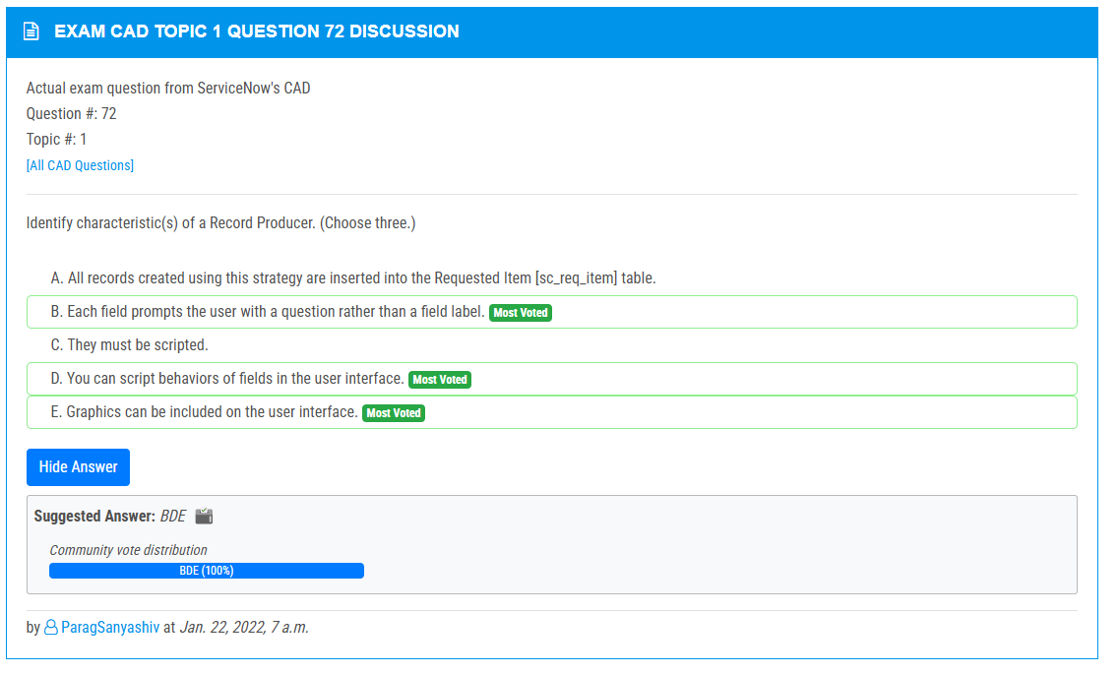

<https://www.examtopics.com/discussions/servicenow/view/90728-exam-cad-topic-1-question-38-discussion/>

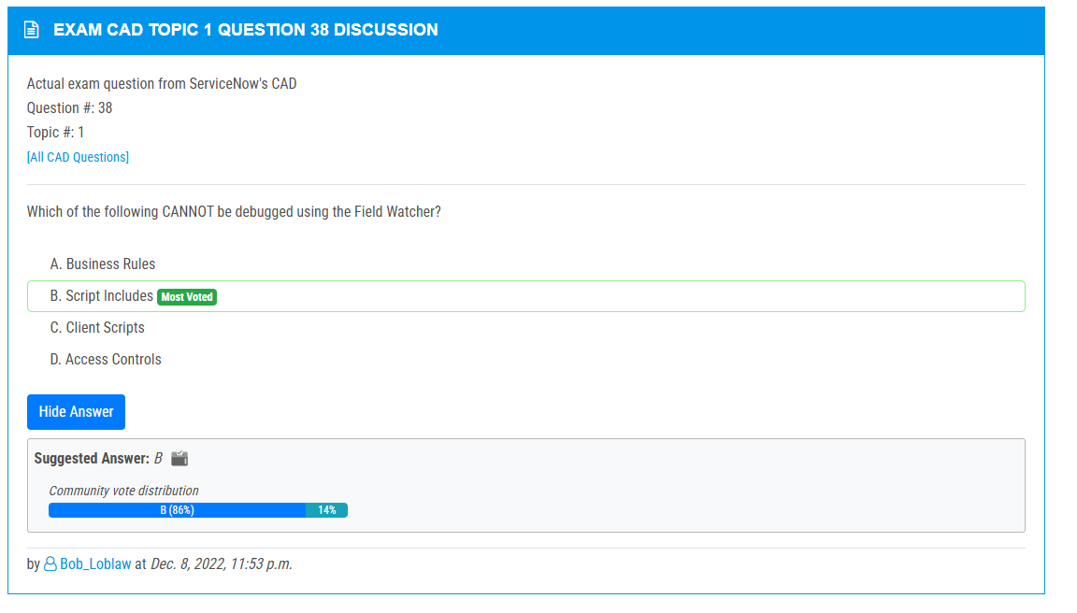

<https://www.examtopics.com/discussions/servicenow/view/90725-exam-cad-topic-1-question-21-discussion/>

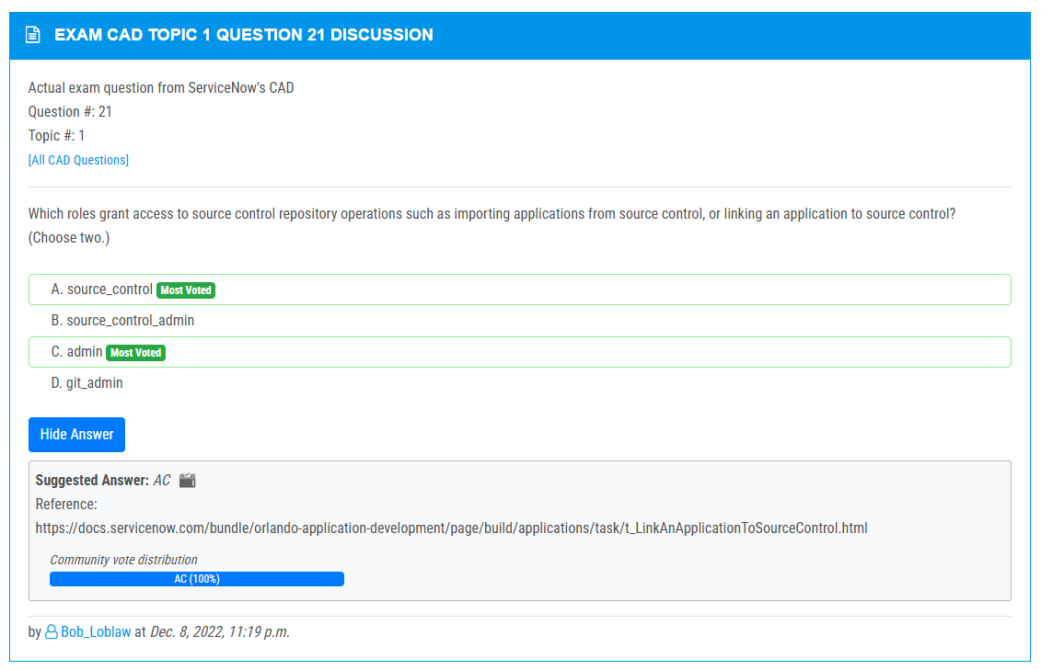

<https://www.examtopics.com/discussions/servicenow/view/70404-exam-cad-topic-1-question-79-discussion/>

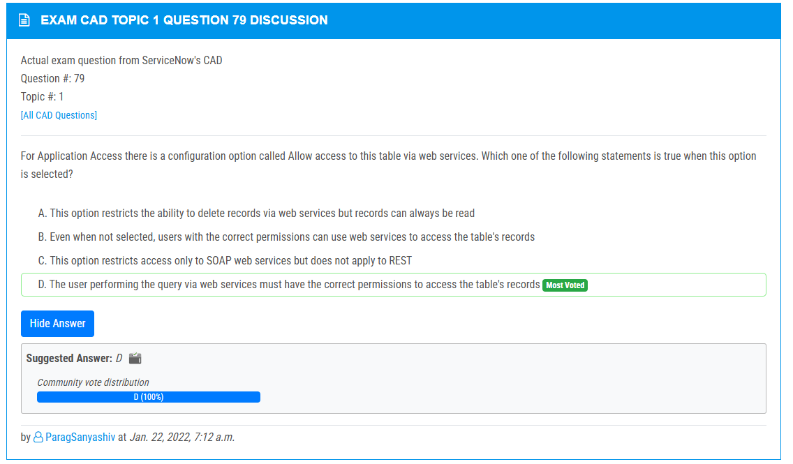

<https://www.examtopics.com/discussions/servicenow/view/111148-exam-cad-topic-1-question-87-discussion/>

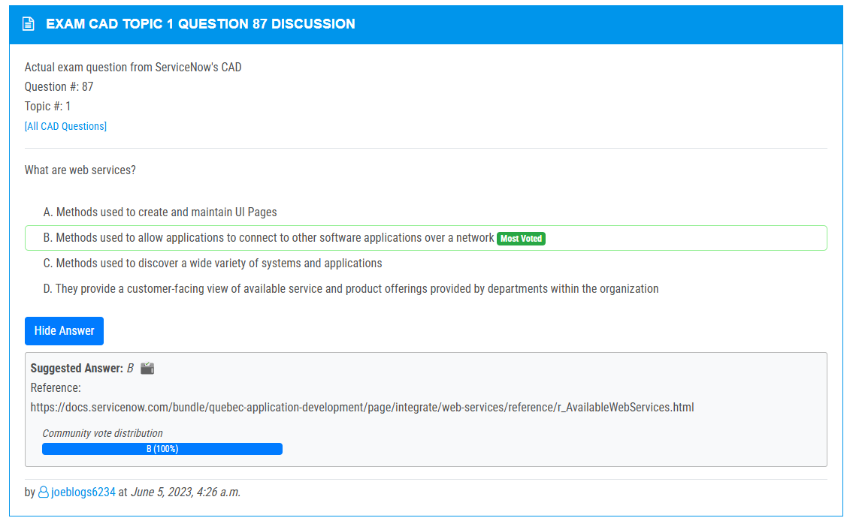

<https://www.examtopics.com/discussions/servicenow/view/108148-exam-cad-topic-1-question-71-discussion/>

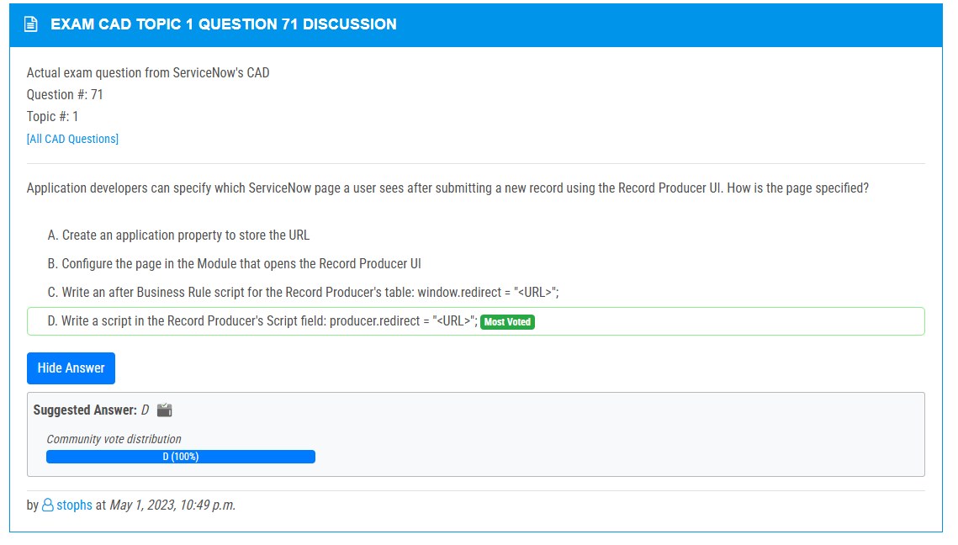

<https://www.examtopics.com/discussions/servicenow/view/93502-exam-cad-topic-1-question-69-discussion/>

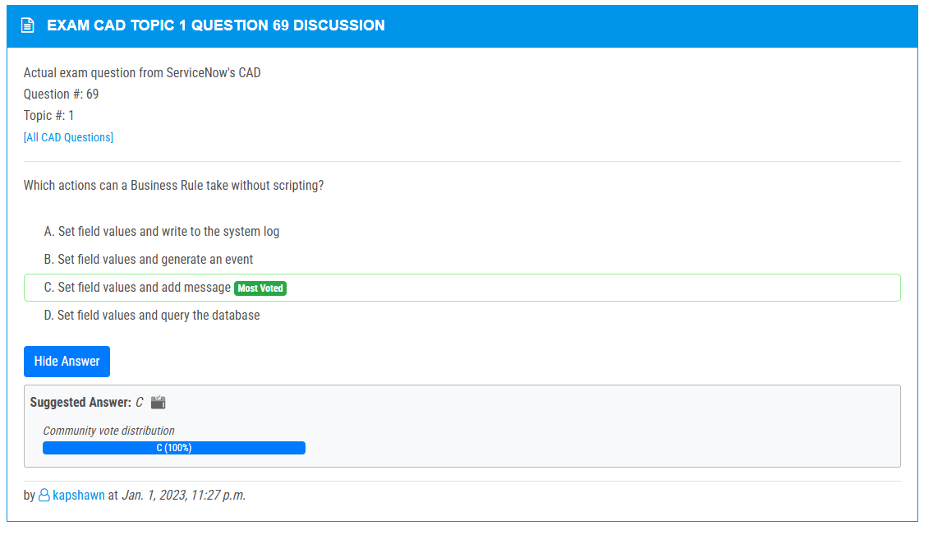

<https://www.examtopics.com/discussions/servicenow/view/70400-exam-cad-topic-1-question-62-discussion/>

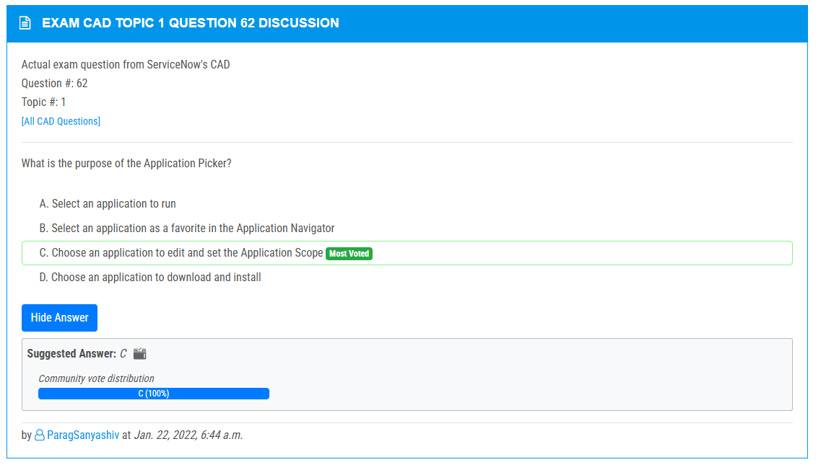

<https://www.examtopics.com/discussions/servicenow/view/108151-exam-cad-topic-1-question-58-discussion/>

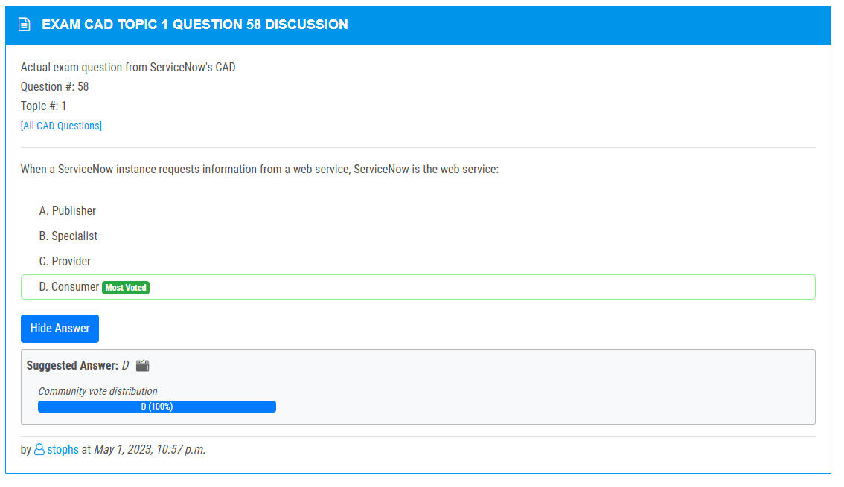

<https://www.examtopics.com/discussions/servicenow/view/141055-exam-cad-topic-1-question-136-discussion/>

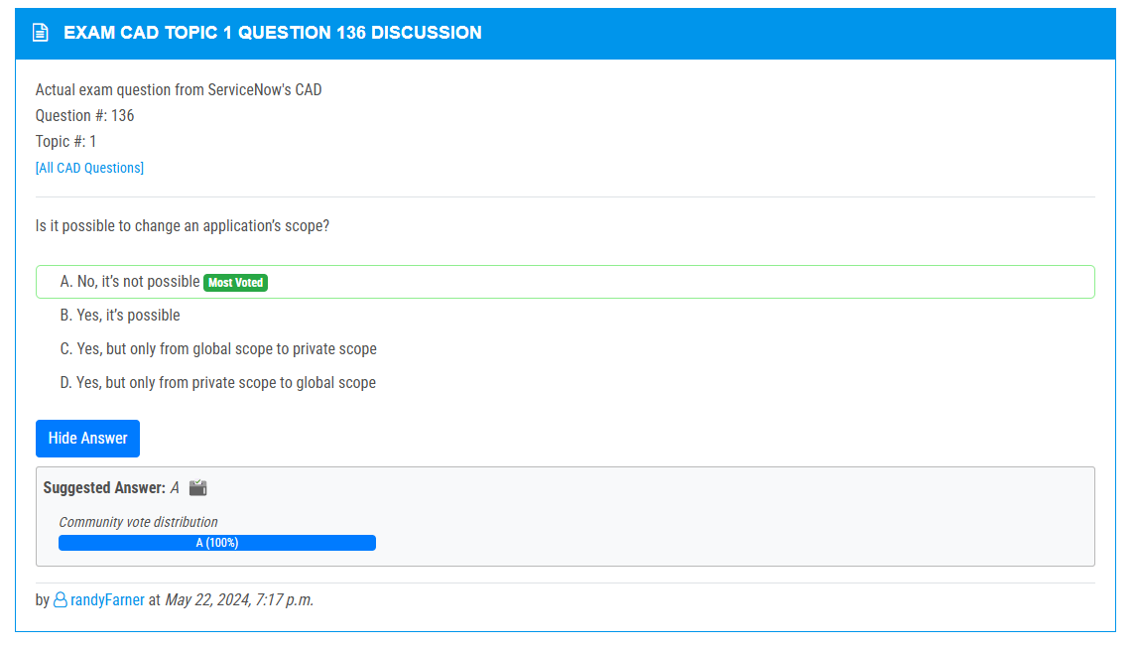

<https://www.examtopics.com/discussions/servicenow/view/90961-exam-cad-topic-1-question-107-discussion/>

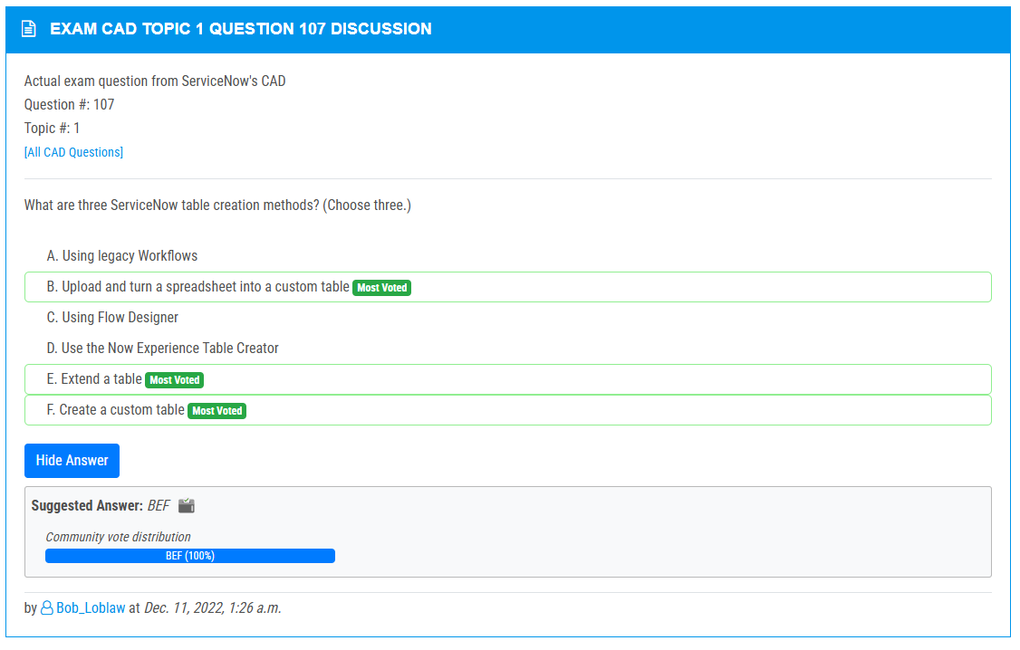

<https://www.examtopics.com/discussions/servicenow/view/144760-exam-cad-topic-1-question-135-discussion/>

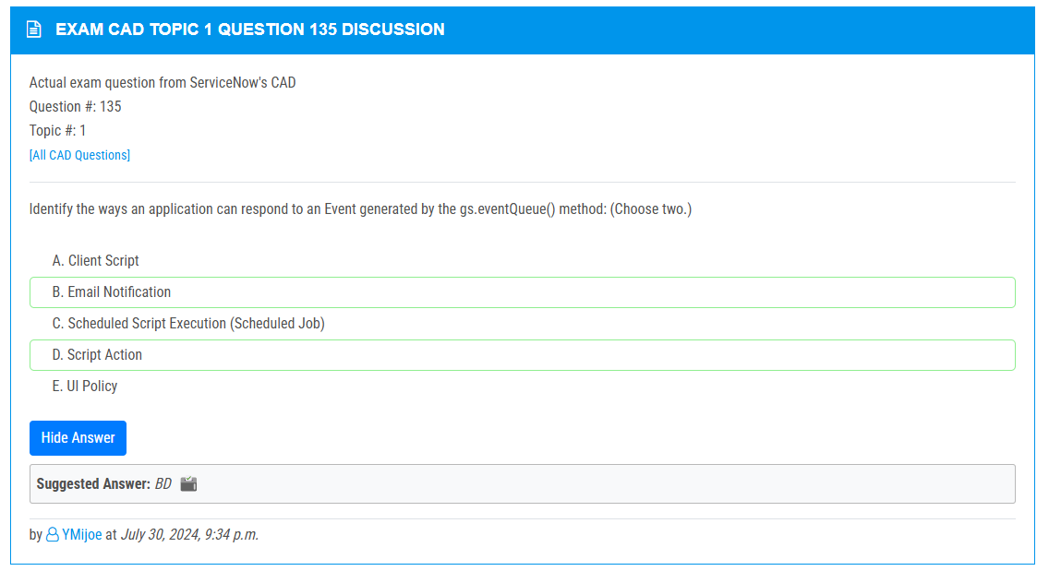

<https://www.examtopics.com/discussions/servicenow/view/90639-exam-cad-topic-1-question-120-discussion/>

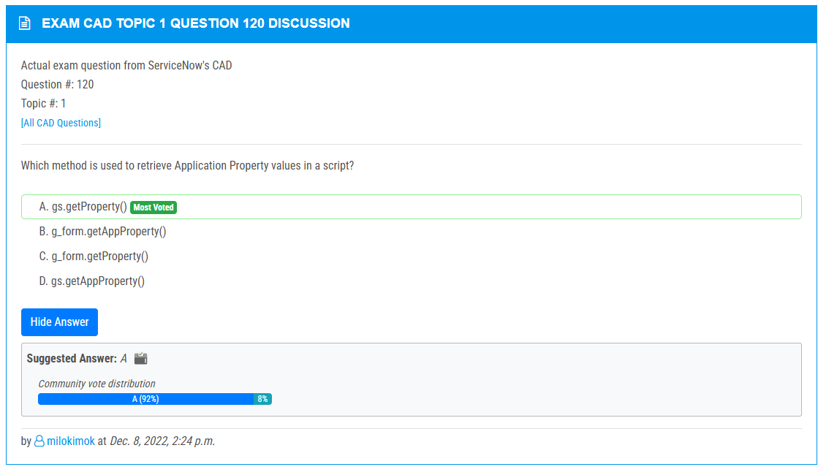

<https://www.examtopics.com/discussions/servicenow/view/90966-exam-cad-topic-1-question-118-discussion/>

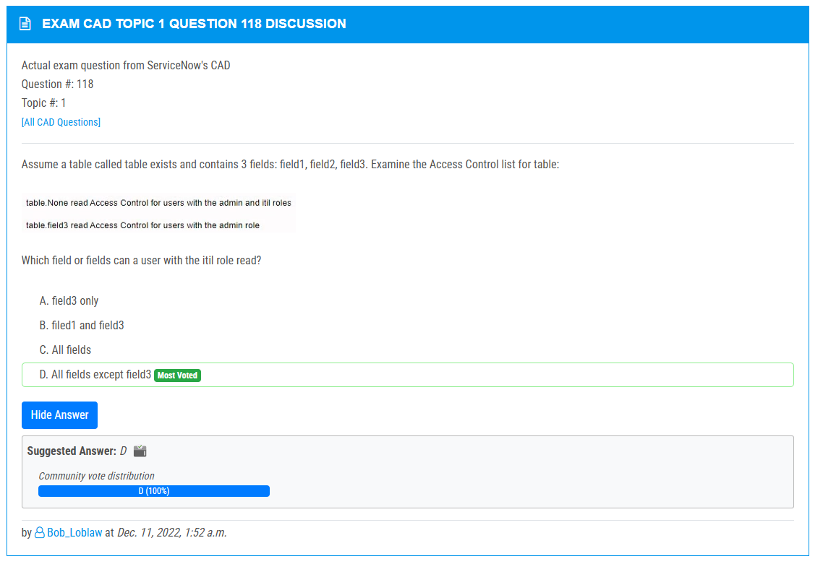

<https://www.examtopics.com/discussions/servicenow/view/90628-exam-cad-topic-1-question-115-discussion/>

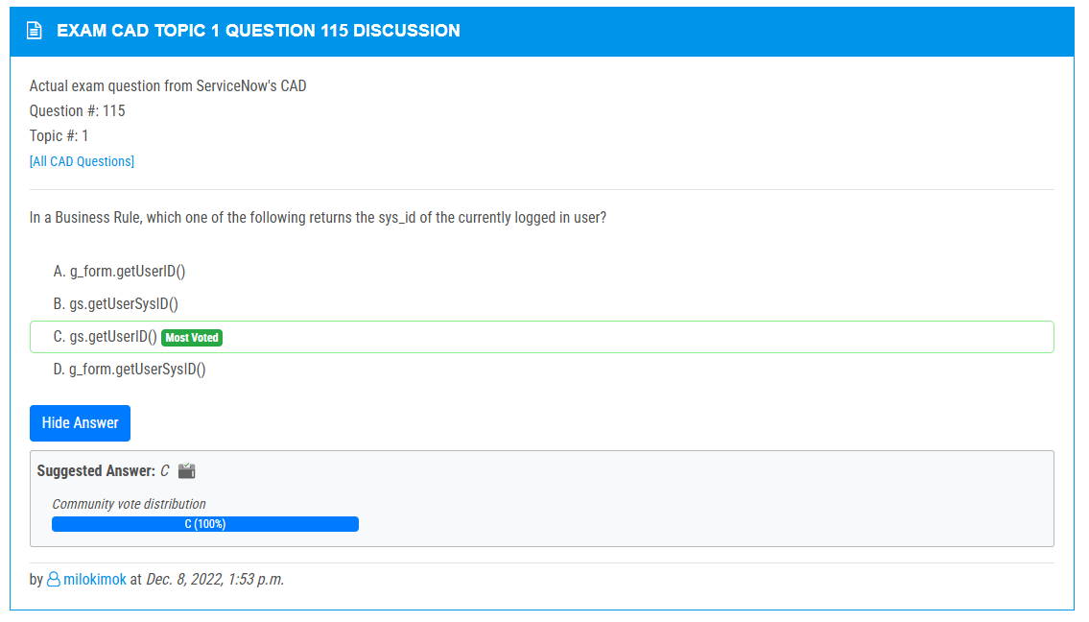

<https://www.examtopics.com/discussions/servicenow/view/108095-exam-cad-topic-1-question-114-discussion/>

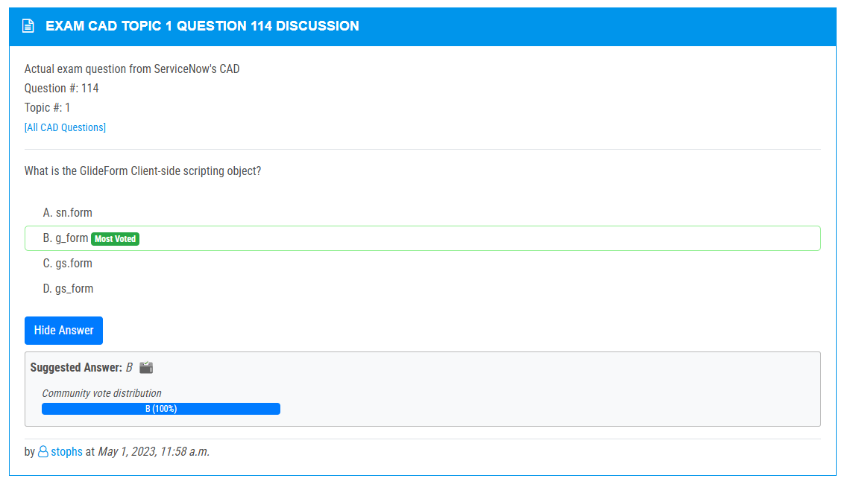

<https://www.examtopics.com/discussions/servicenow/view/90964-exam-cad-topic-1-question-112-discussion/>

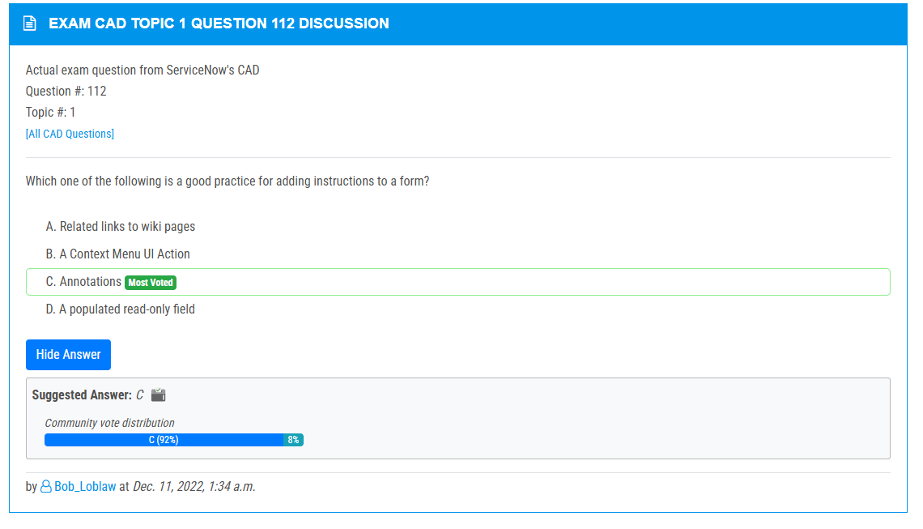

<https://www.examtopics.com/discussions/servicenow/view/108096-exam-cad-topic-1-question-111-discussion/>

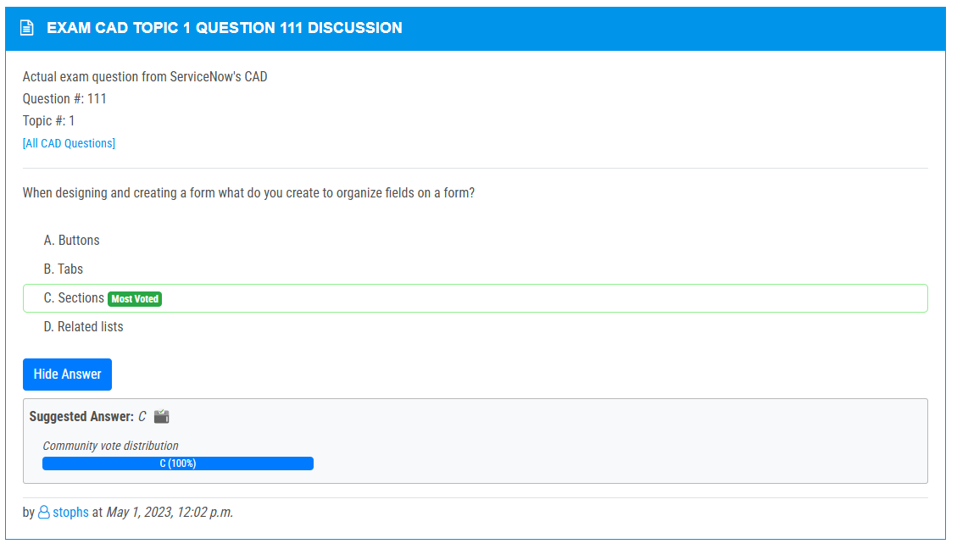

<https://www.examtopics.com/discussions/servicenow/view/108097-exam-cad-topic-1-question-110-discussion/>

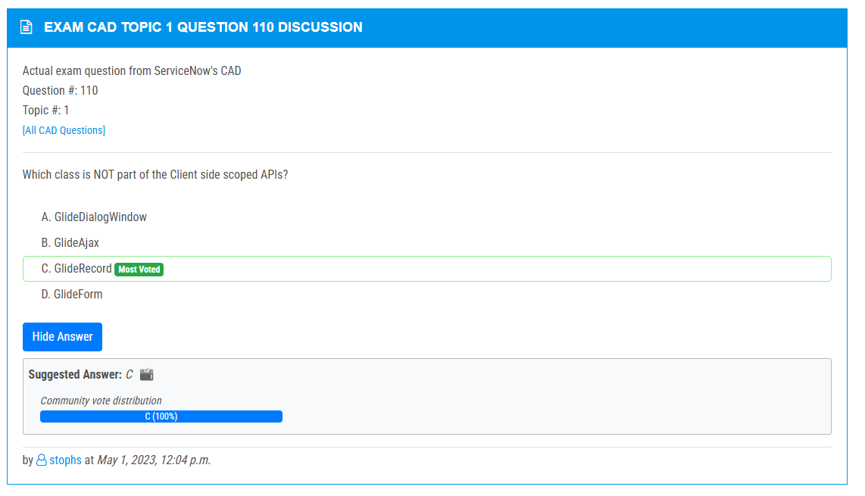

<https://www.examtopics.com/discussions/servicenow/view/91080-exam-cad-topic-1-question-109-discussion/>

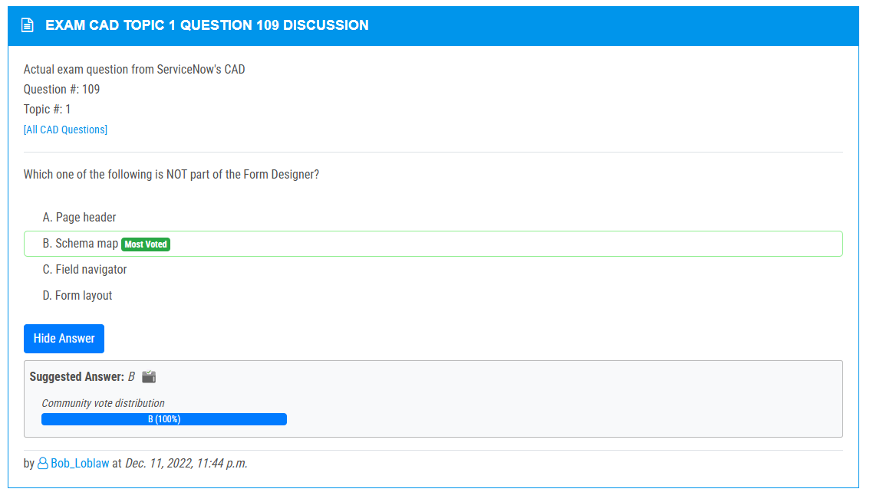

<https://www.examtopics.com/discussions/servicenow/view/98368-exam-cad-topic-1-question-106-discussion/>

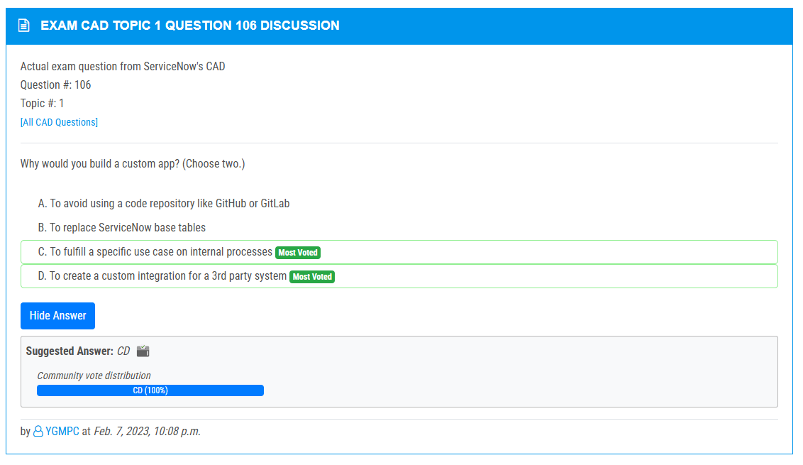

<https://www.examtopics.com/discussions/servicenow/view/108101-exam-cad-topic-1-question-105-discussion/>

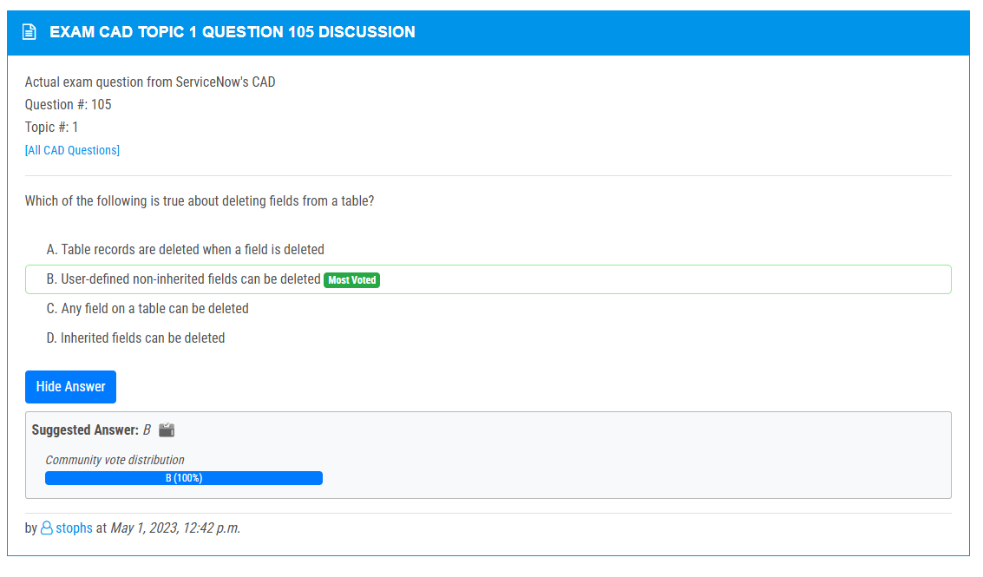

<https://www.examtopics.com/discussions/servicenow/view/90960-exam-cad-topic-1-question-104-discussion/>

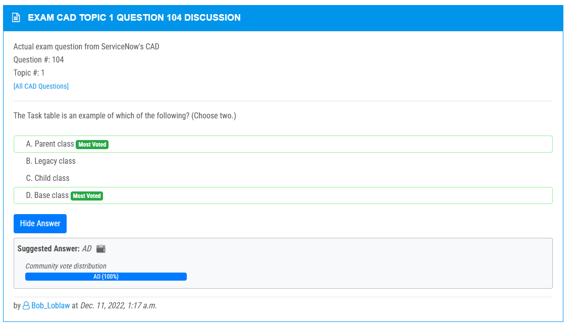

<https://www.examtopics.com/discussions/servicenow/view/108103-exam-cad-topic-1-question-101-discussion/>

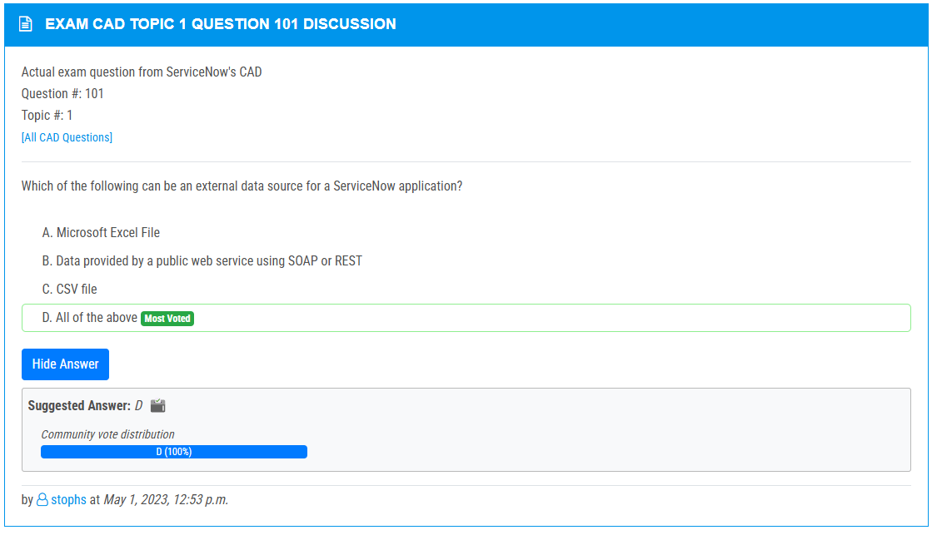

<https://www.examtopics.com/discussions/servicenow/view/108104-exam-cad-topic-1-question-99-discussion/>

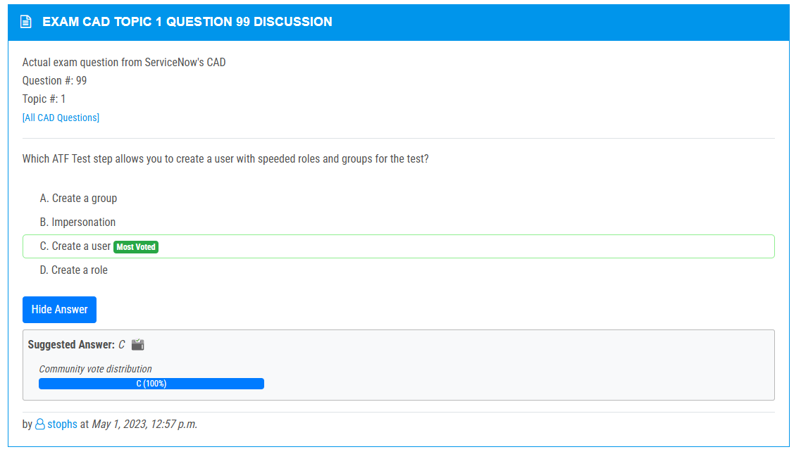

<https://www.examtopics.com/discussions/servicenow/view/89582-exam-cad-topic-1-question-97-discussion/>

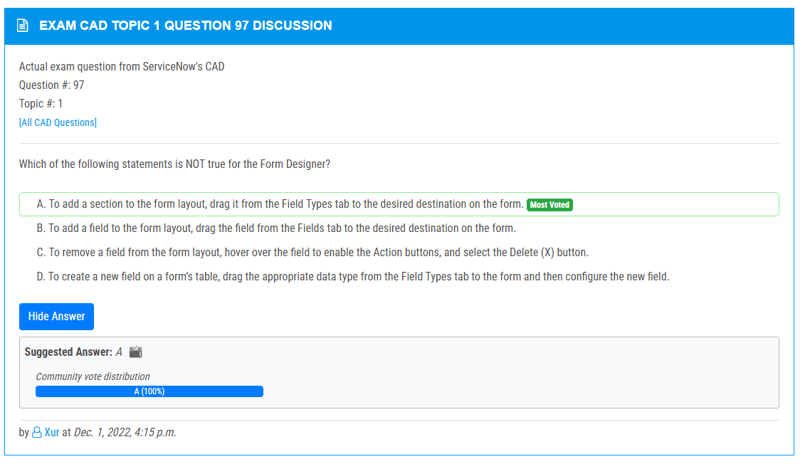

<https://www.examtopics.com/discussions/servicenow/view/108105-exam-cad-topic-1-question-96-discussion/>

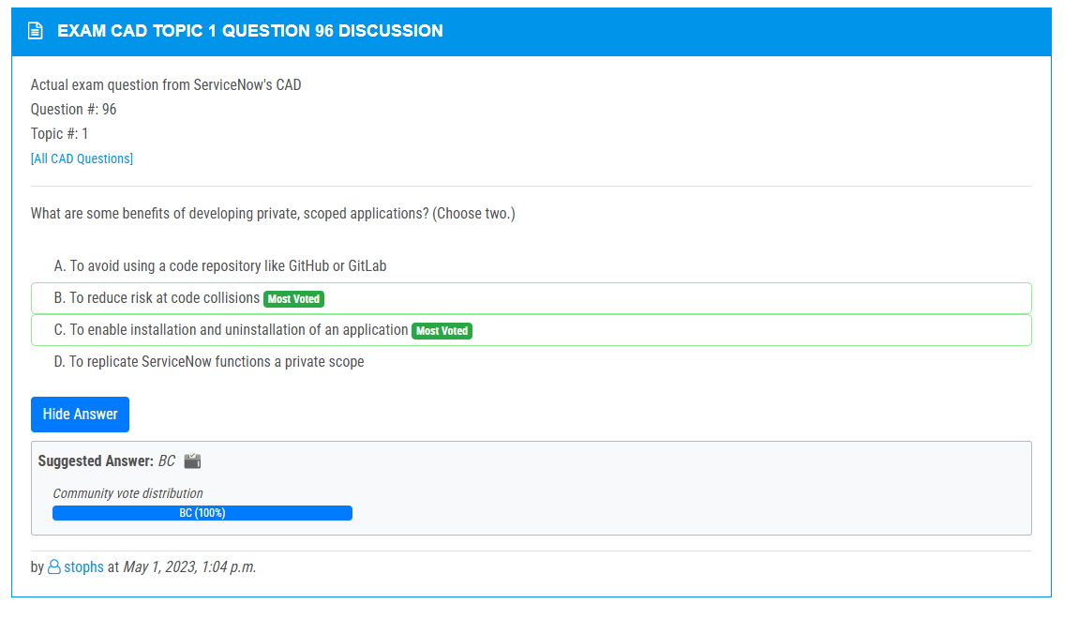

<https://www.examtopics.com/discussions/servicenow/view/89683-exam-cad-topic-1-question-94-discussion/>

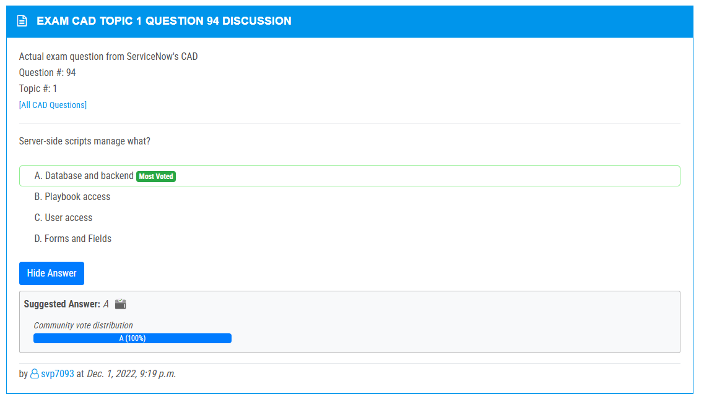

<https://www.examtopics.com/discussions/servicenow/view/89679-exam-cad-topic-1-question-93-discussion/>

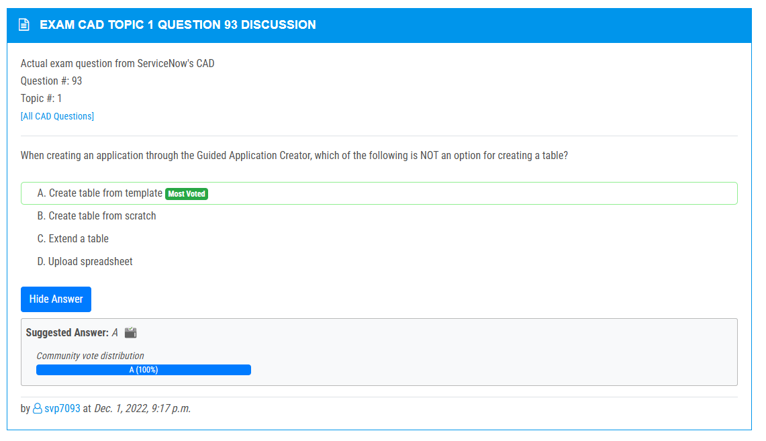

<https://www.examtopics.com/discussions/servicenow/view/125047-exam-cad-topic-1-question-92-discussion/>

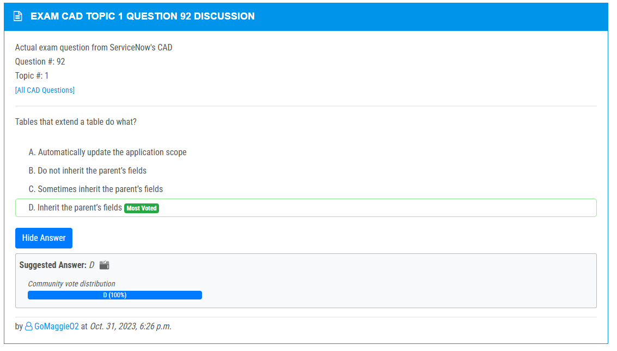

<https://www.examtopics.com/discussions/servicenow/view/108108-exam-cad-topic-1-question-91-discussion/>

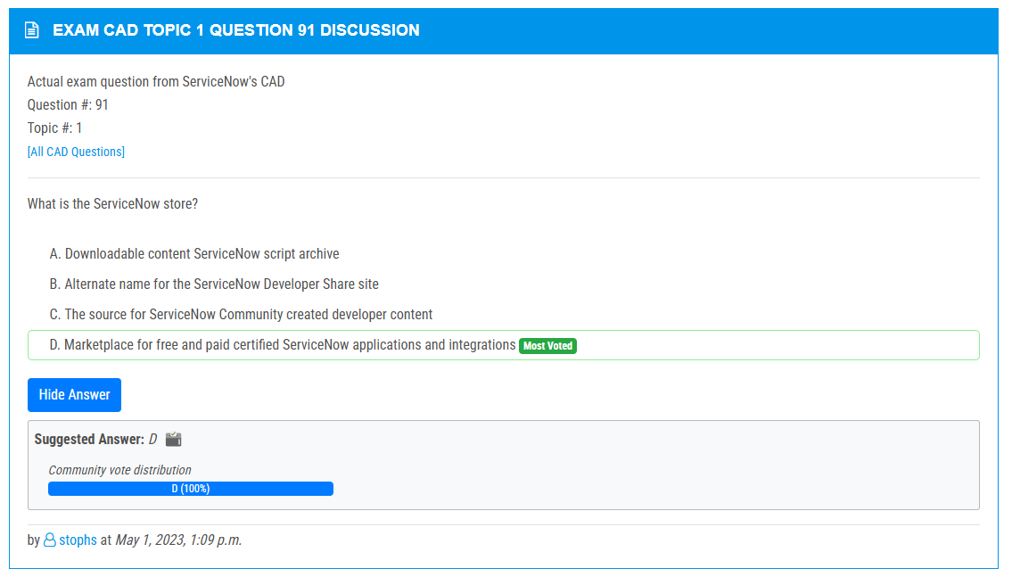

<https://www.examtopics.com/discussions/servicenow/view/70406-exam-cad-topic-1-question-89-discussion/>

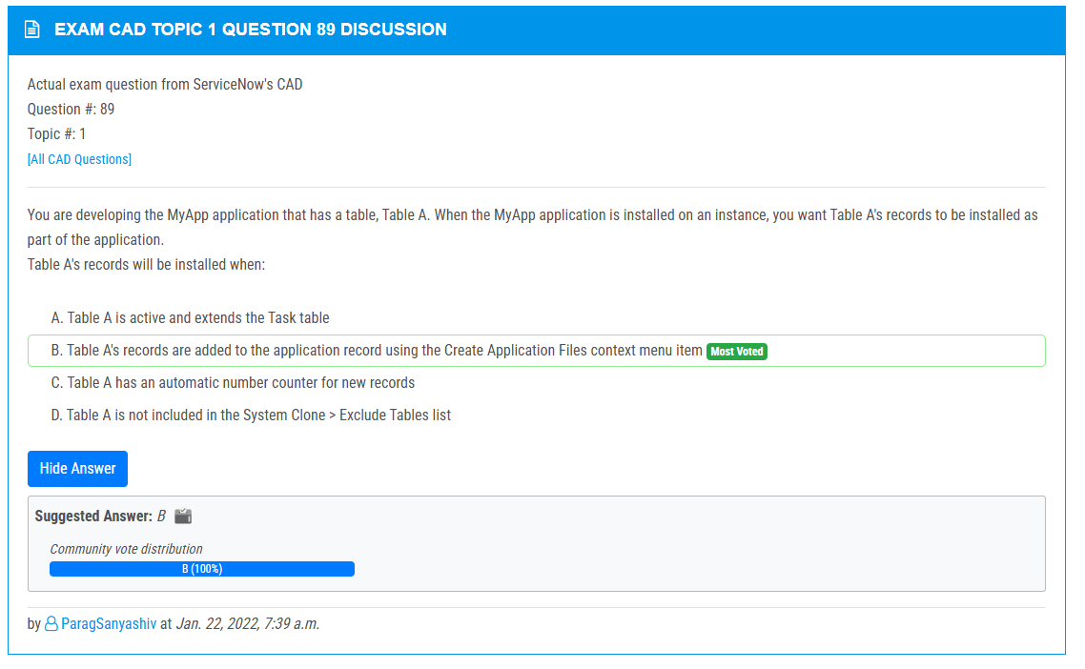

<https://www.examtopics.com/discussions/servicenow/view/107167-exam-cad-topic-1-question-88-discussion/>

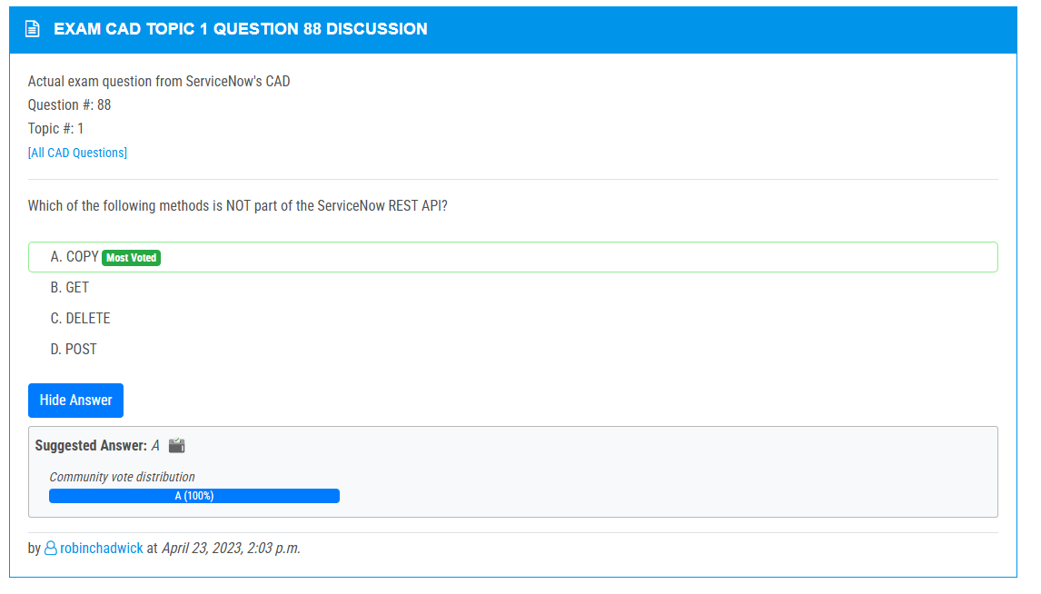

<https://www.examtopics.com/discussions/servicenow/view/111148-exam-cad-topic-1-question-87-discussion/>

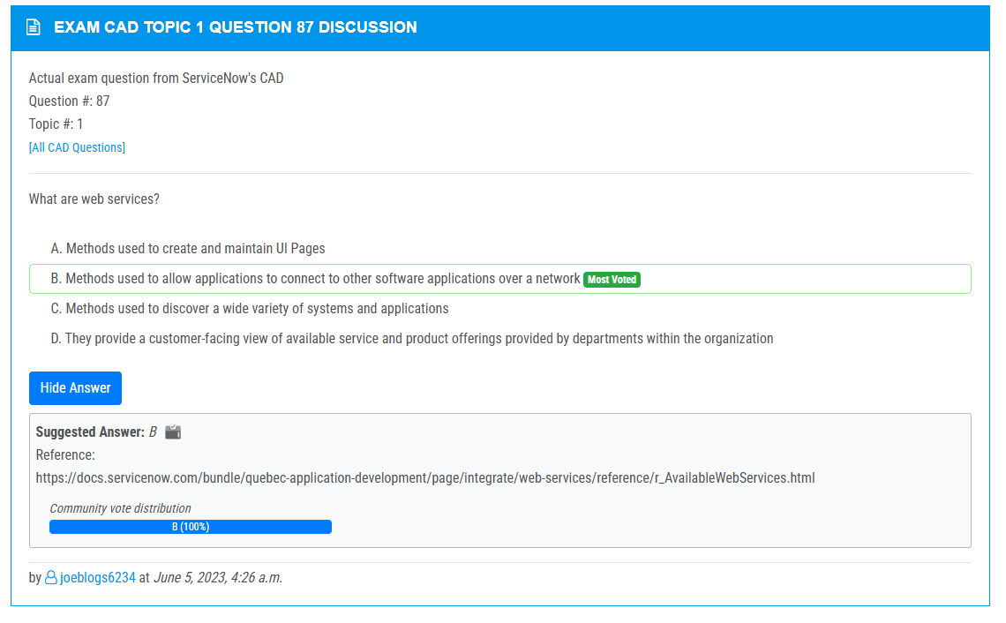

<https://www.examtopics.com/discussions/servicenow/view/73402-exam-cad-topic-1-question-85-discussion/>

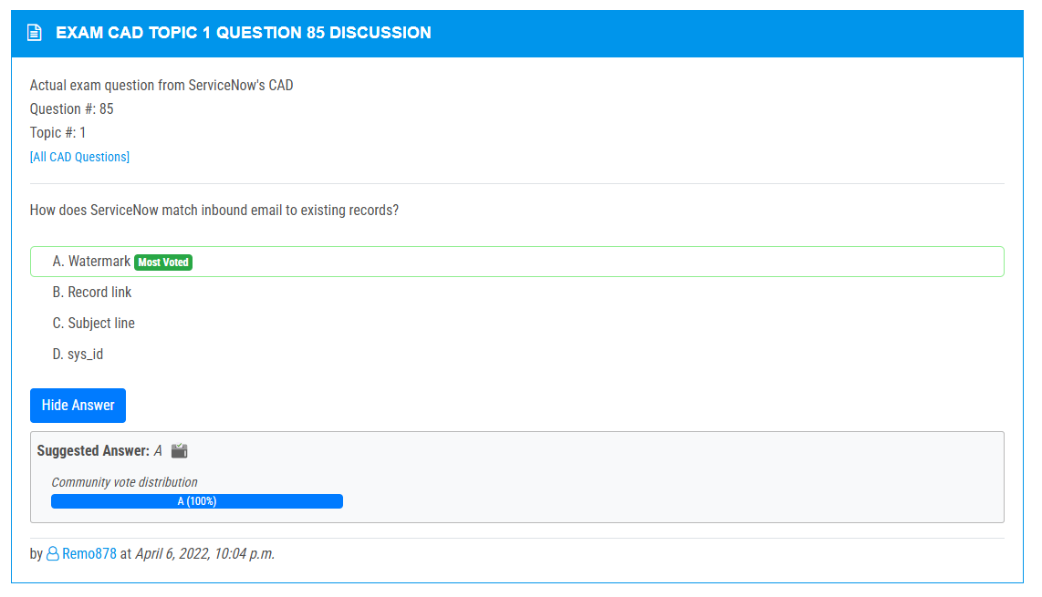

<https://www.examtopics.com/discussions/servicenow/view/73401-exam-cad-topic-1-question-84-discussion/>

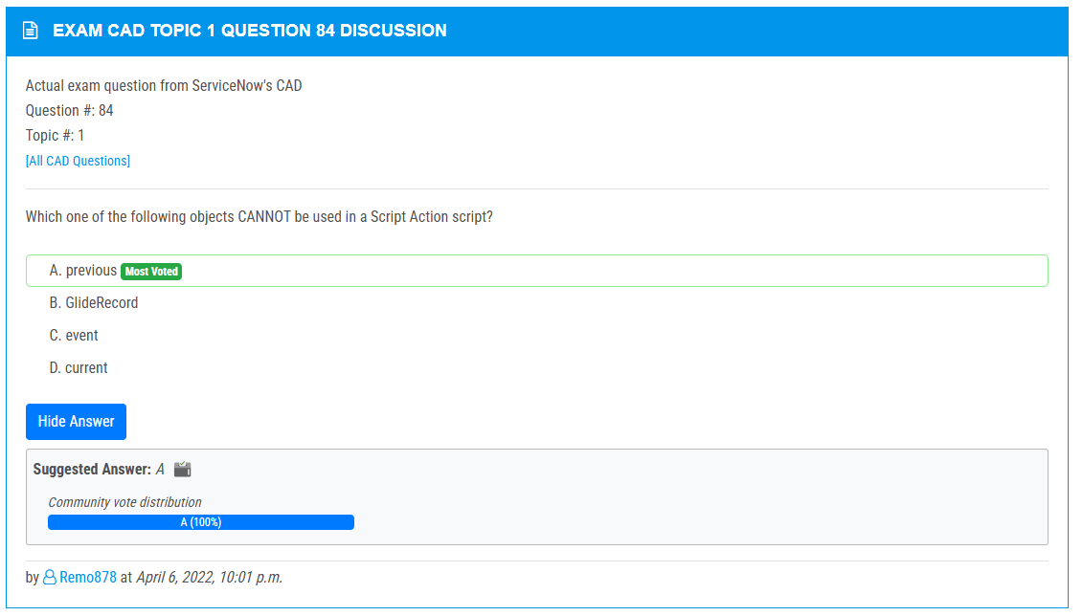

<https://www.examtopics.com/discussions/servicenow/view/70405-exam-cad-topic-1-question-83-discussion/>

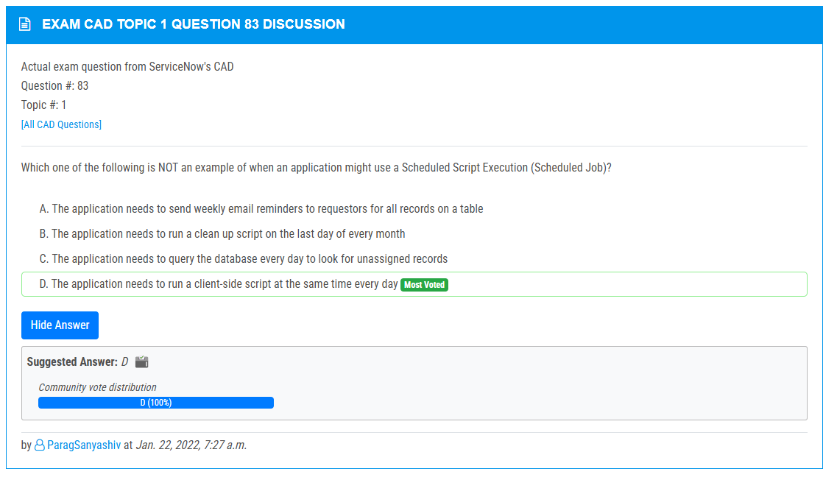

<https://www.examtopics.com/discussions/servicenow/view/124893-exam-cad-topic-1-question-82-discussion/>

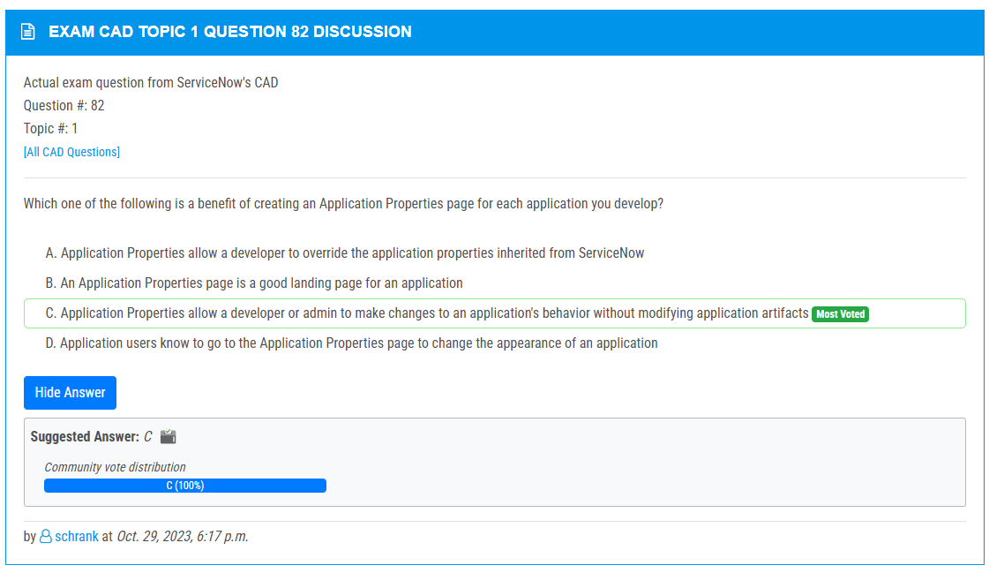

<https://www.examtopics.com/discussions/servicenow/view/97747-exam-cad-topic-1-question-81-discussion/>

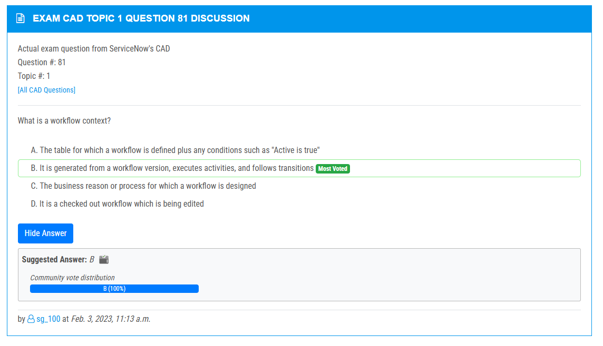

<https://www.examtopics.com/discussions/servicenow/view/102847-exam-cad-topic-1-question-78-discussion/>

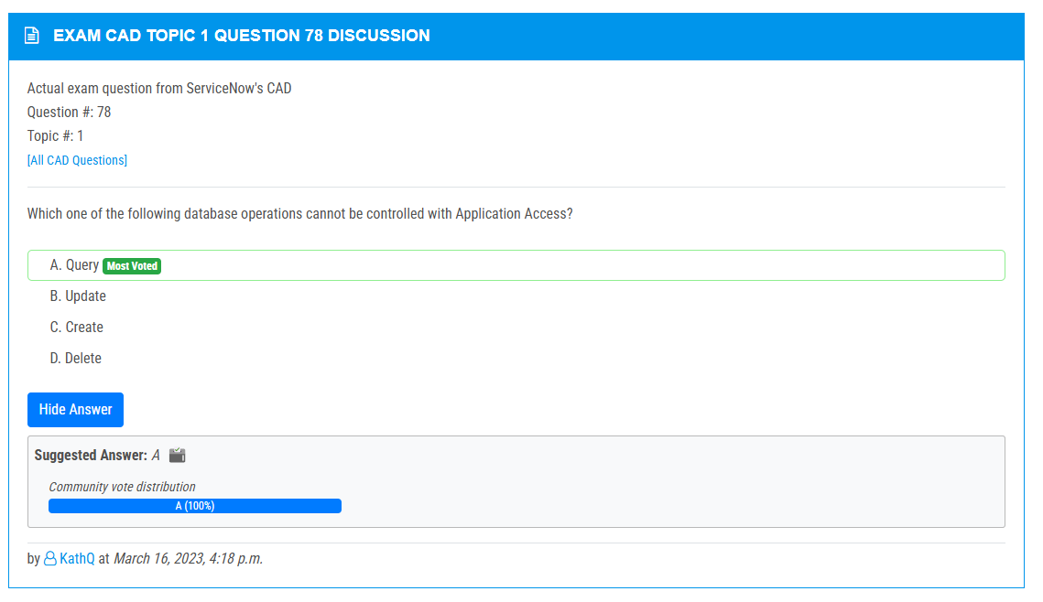

<https://www.examtopics.com/discussions/servicenow/view/108146-exam-cad-topic-1-question-77-discussion/>

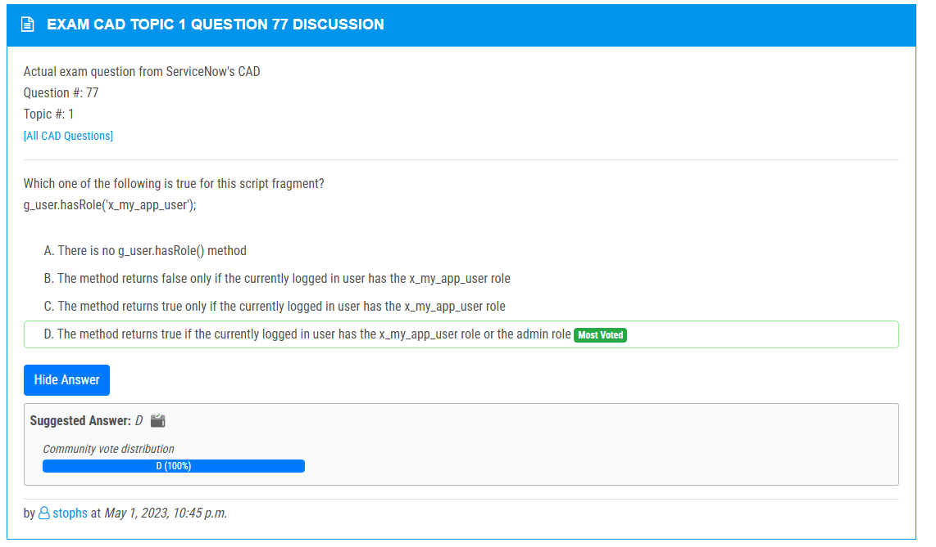

<https://www.examtopics.com/discussions/servicenow/view/73540-exam-cad-topic-1-question-75-discussion/>

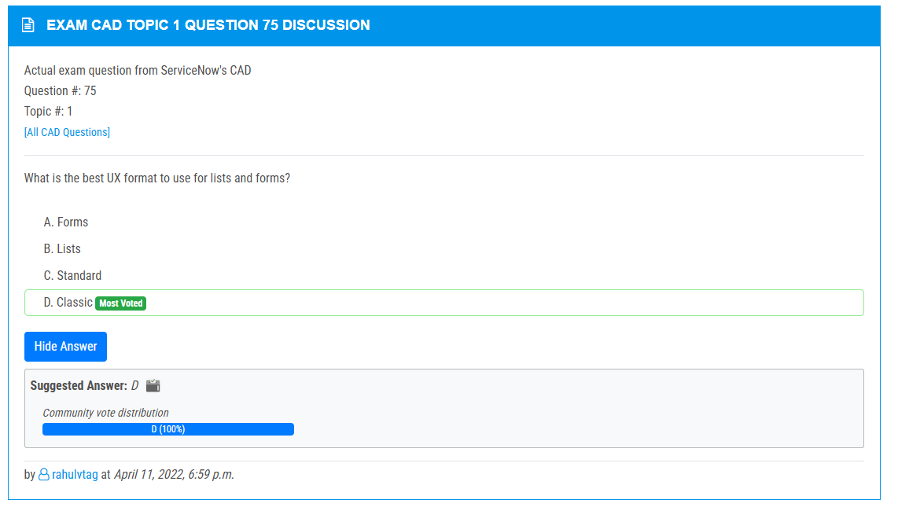

<https://www.examtopics.com/discussions/servicenow/view/108147-exam-cad-topic-1-question-73-discussion/>

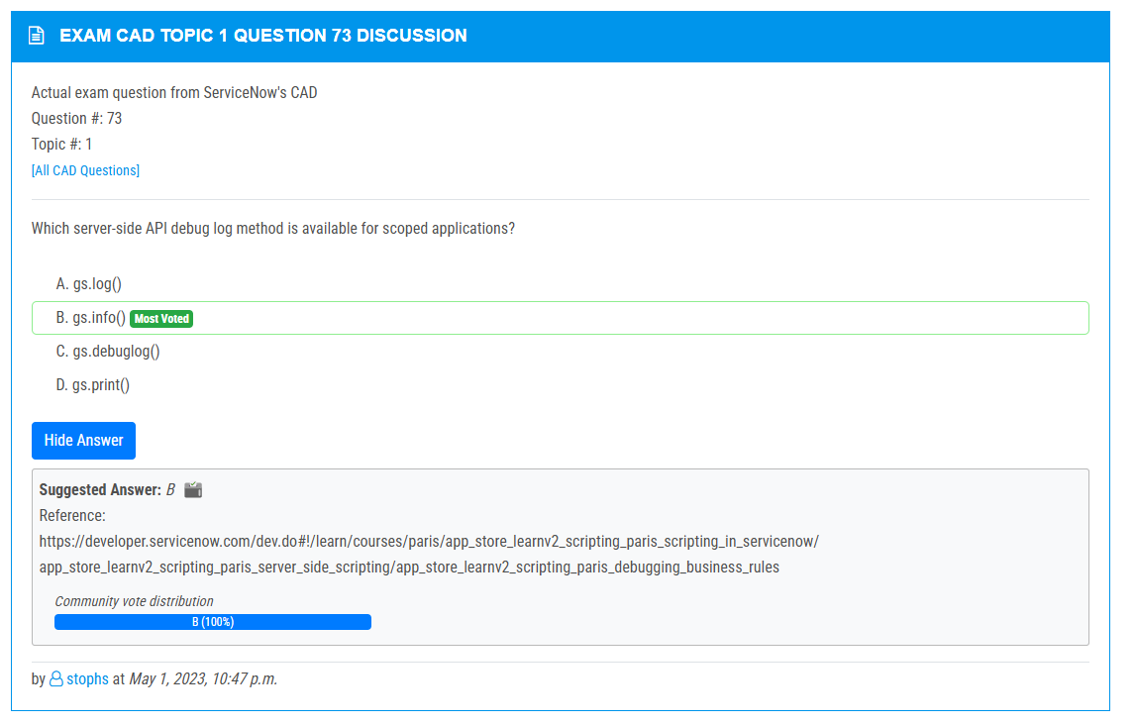

<https://www.examtopics.com/discussions/servicenow/view/108149-exam-cad-topic-1-question-70-discussion/>

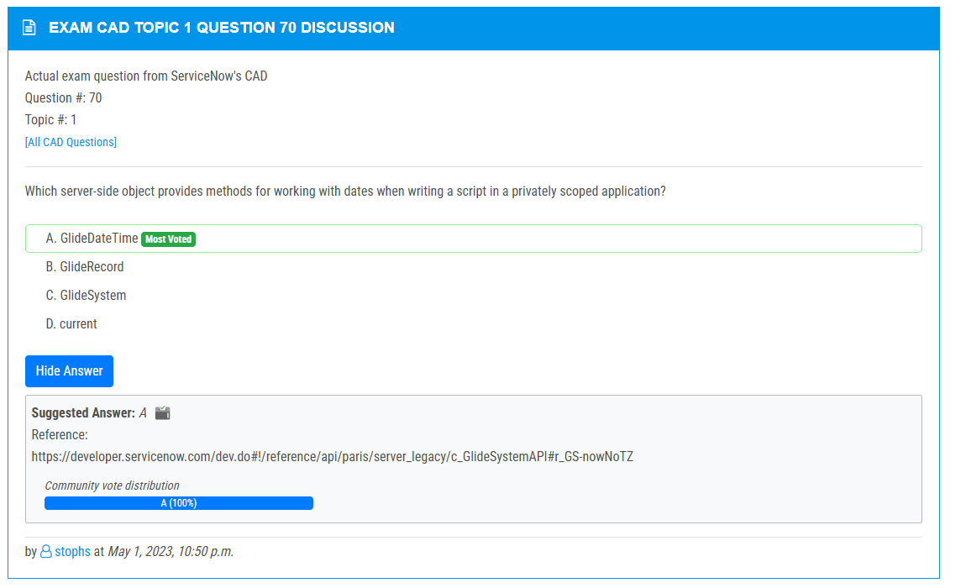

<https://www.examtopics.com/discussions/servicenow/view/87125-exam-cad-topic-1-question-68-discussion/>

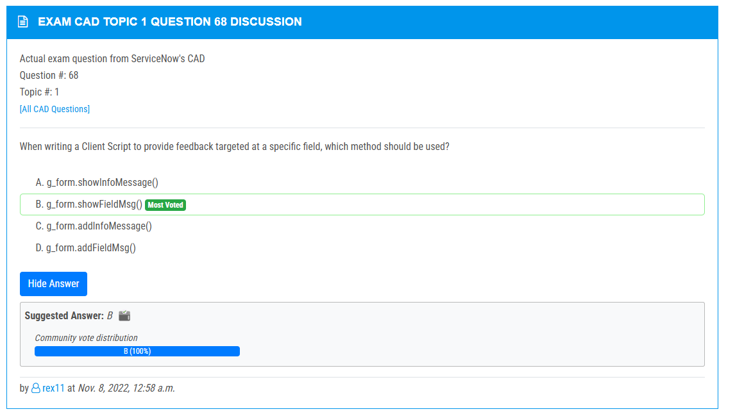

<https://www.examtopics.com/discussions/servicenow/view/91078-exam-cad-topic-1-question-67-discussion/>

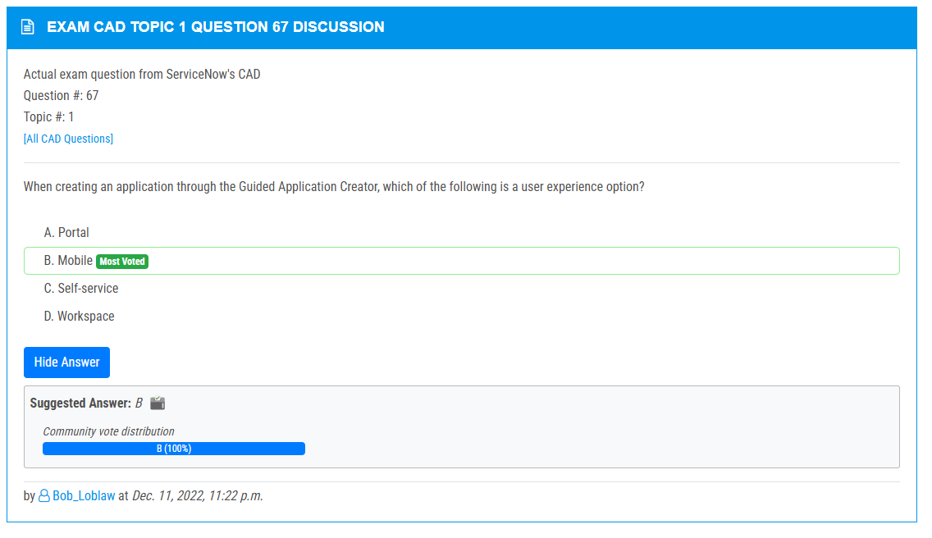

<https://www.examtopics.com/discussions/servicenow/view/91077-exam-cad-topic-1-question-66-discussion/>

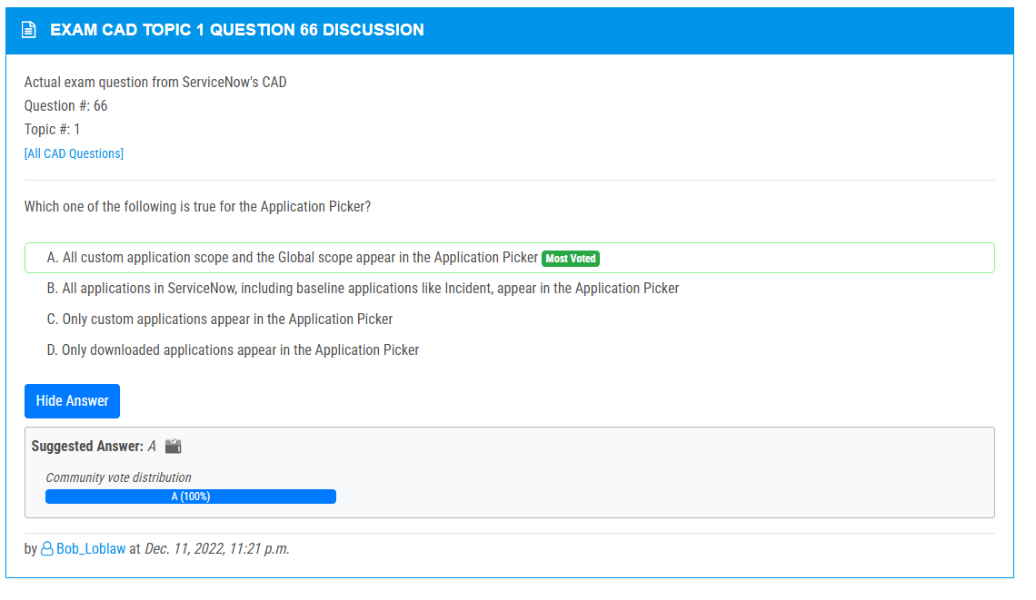

<https://www.examtopics.com/discussions/servicenow/view/144848-exam-cad-topic-1-question-142-discussion/>

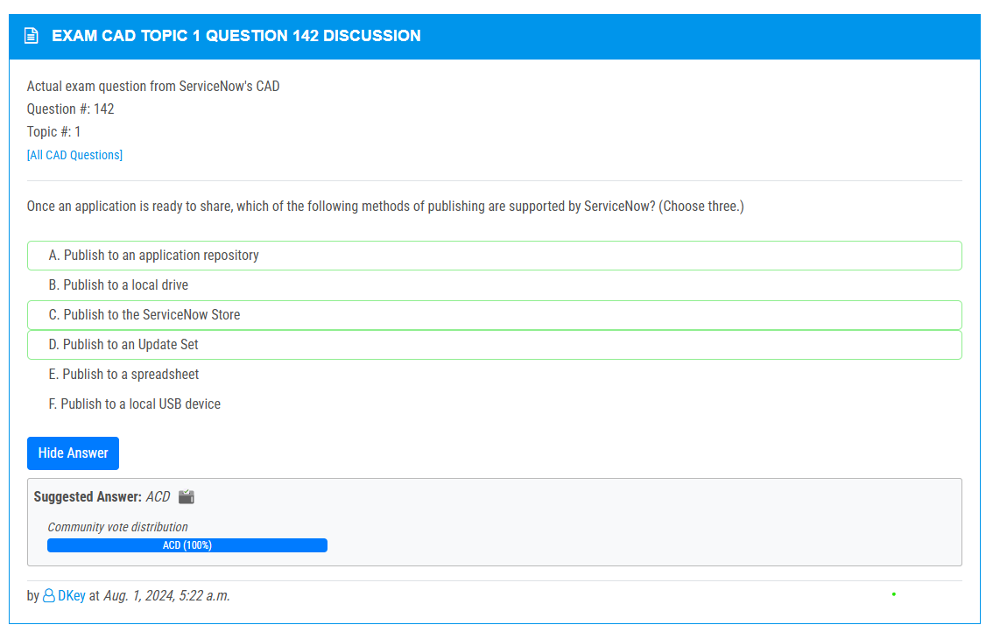

<https://www.examtopics.com/discussions/servicenow/view/64125-exam-cad-topic-1-question-40-discussion/>

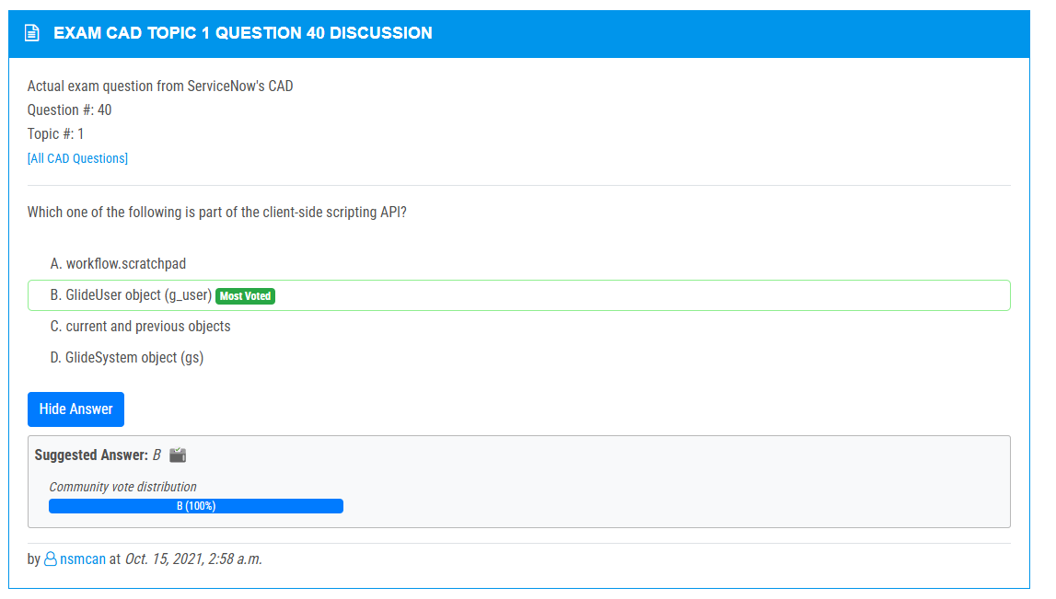

<https://www.examtopics.com/discussions/servicenow/view/133292-exam-cad-topic-1-question-150-discussion/>

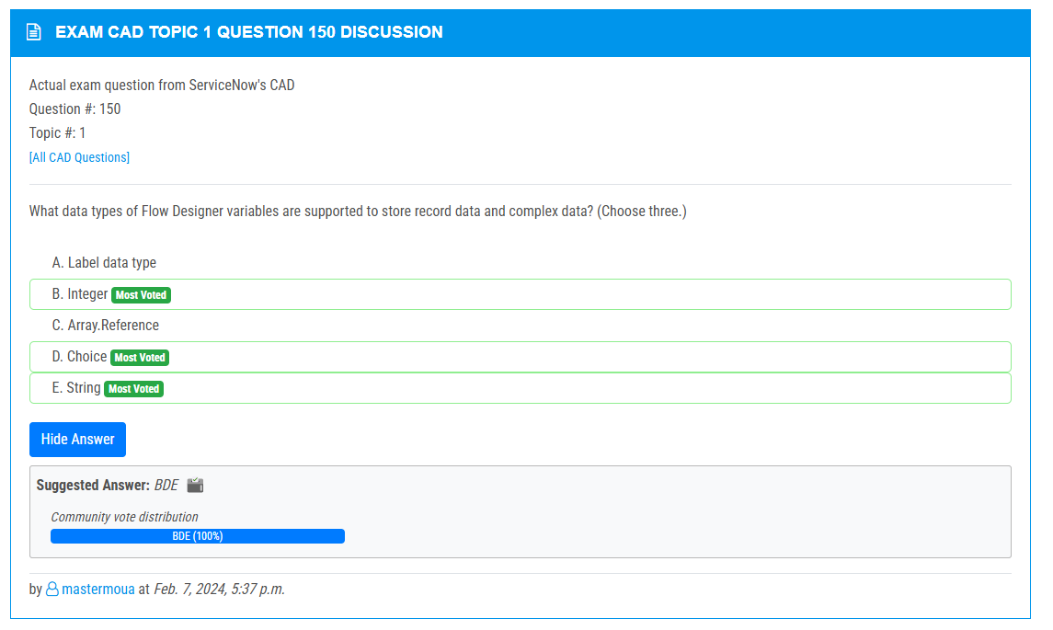

<https://www.examtopics.com/discussions/servicenow/view/143726-exam-cad-topic-1-question-138-discussion/>

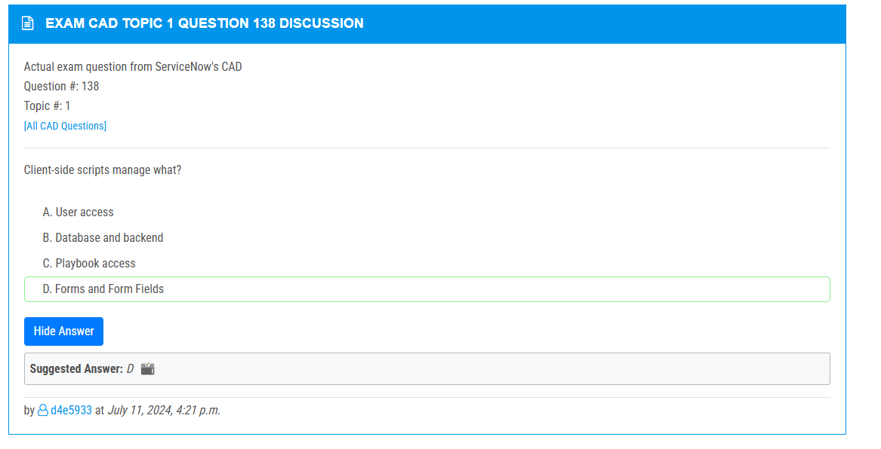

<https://www.examtopics.com/discussions/servicenow/view/90637-exam-cad-topic-1-question-119-discussion/>

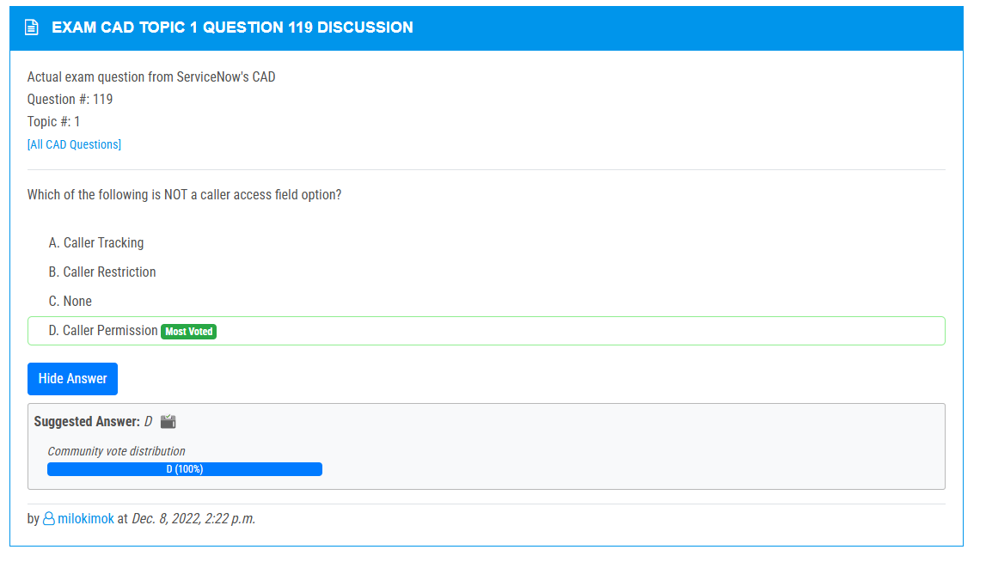

<https://www.examtopics.com/discussions/servicenow/view/107786-exam-cad-topic-1-question-26-discussion/>

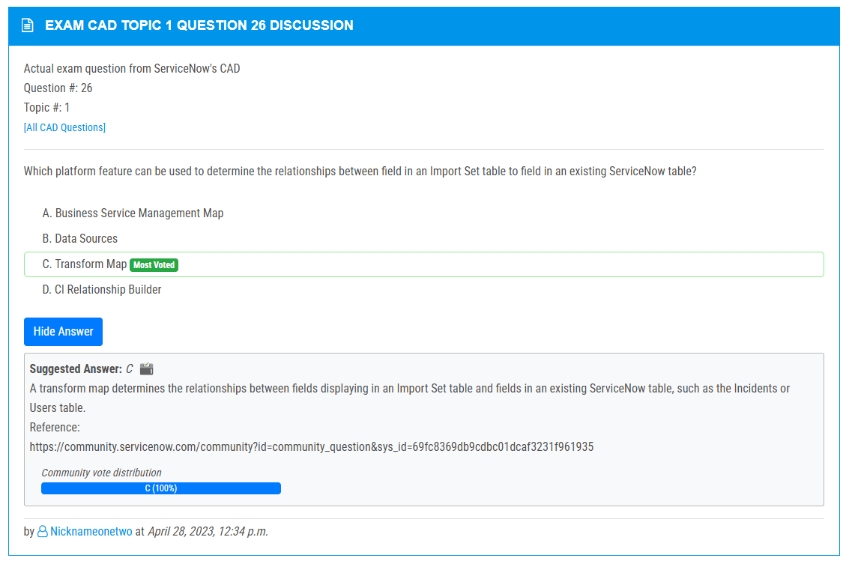

<https://www.examtopics.com/discussions/servicenow/view/68154-exam-cad-topic-1-question-48-discussion/>

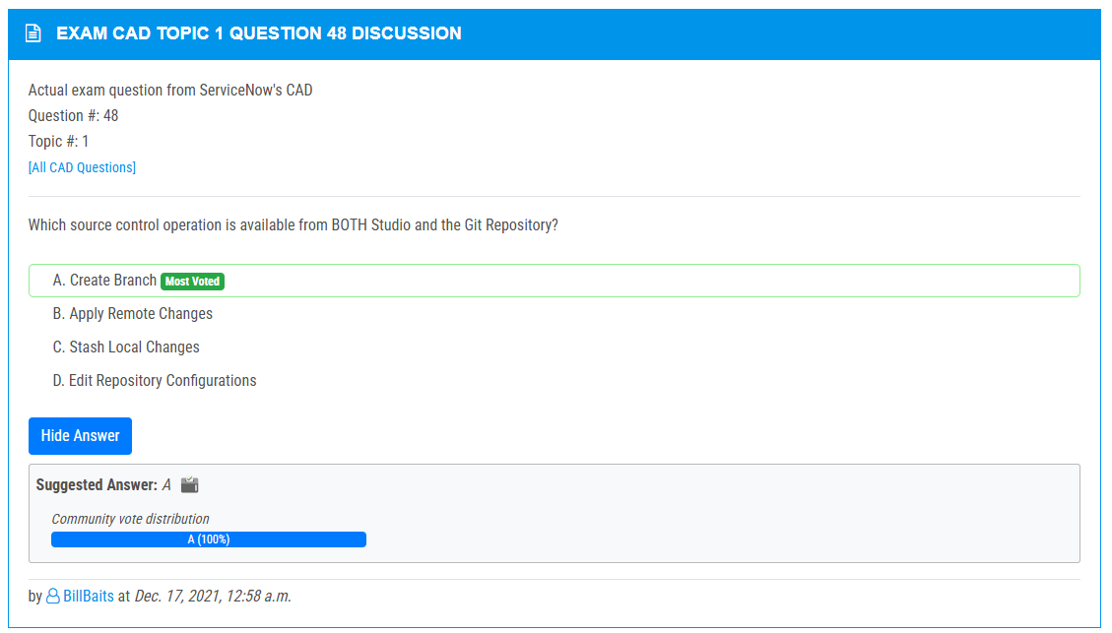

<https://www.examtopics.com/discussions/servicenow/view/70402-exam-cad-topic-1-question-74-discussion/>

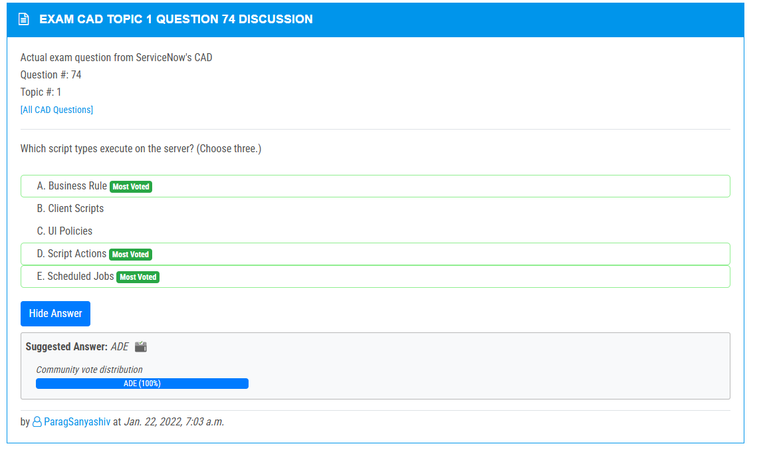

<https://www.examtopics.com/discussions/servicenow/view/87480-exam-cad-topic-1-question-15-discussion/>

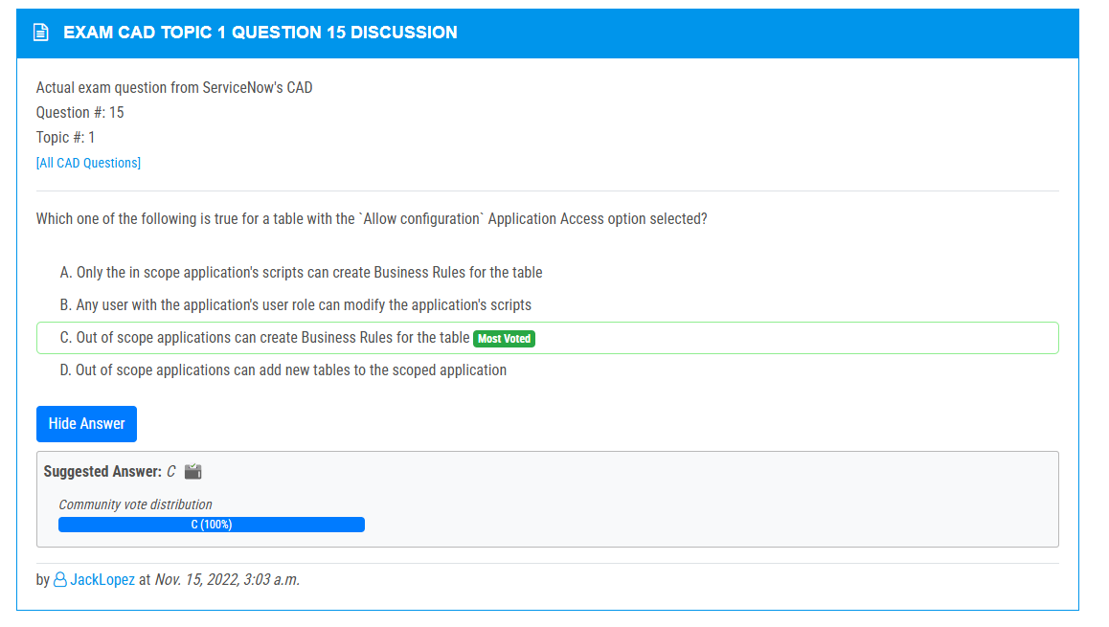

<https://www.examtopics.com/discussions/servicenow/view/87480-exam-cad-topic-1-question-15-discussion/>

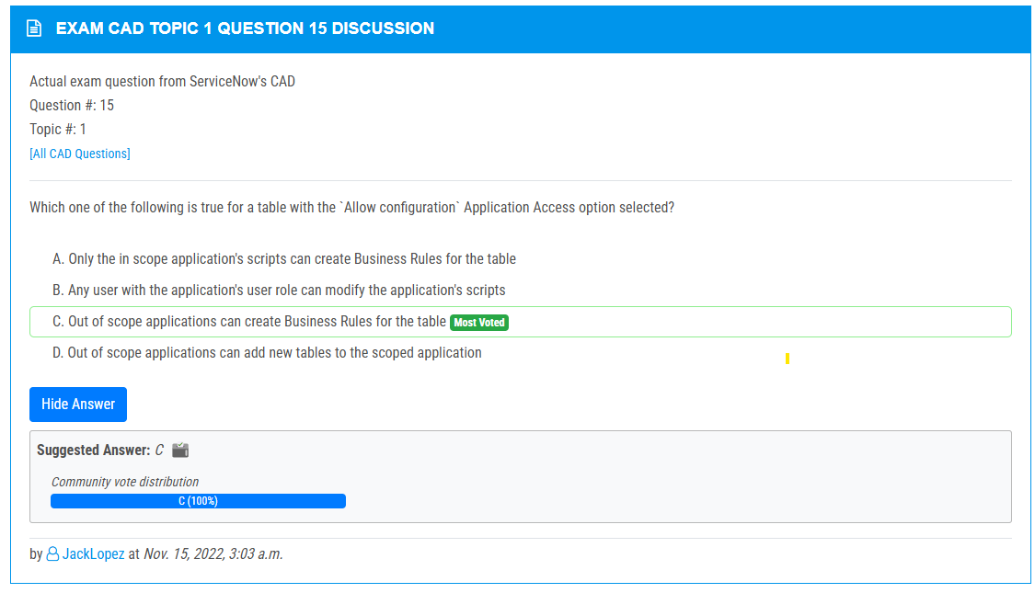

<https://www.examtopics.com/discussions/servicenow/view/64105-exam-cad-topic-1-question-45-discussion/>

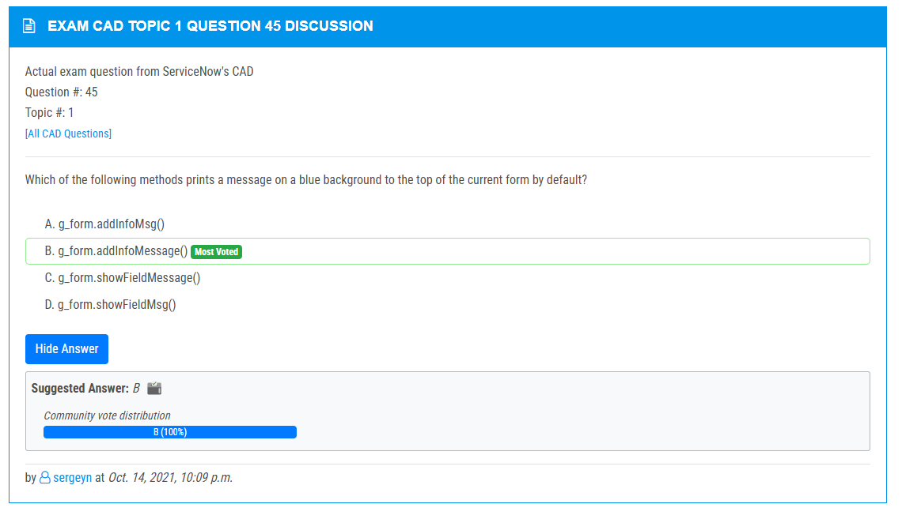

<https://www.examtopics.com/discussions/servicenow/view/77514-exam-cad-topic-1-question-42-discussion/>

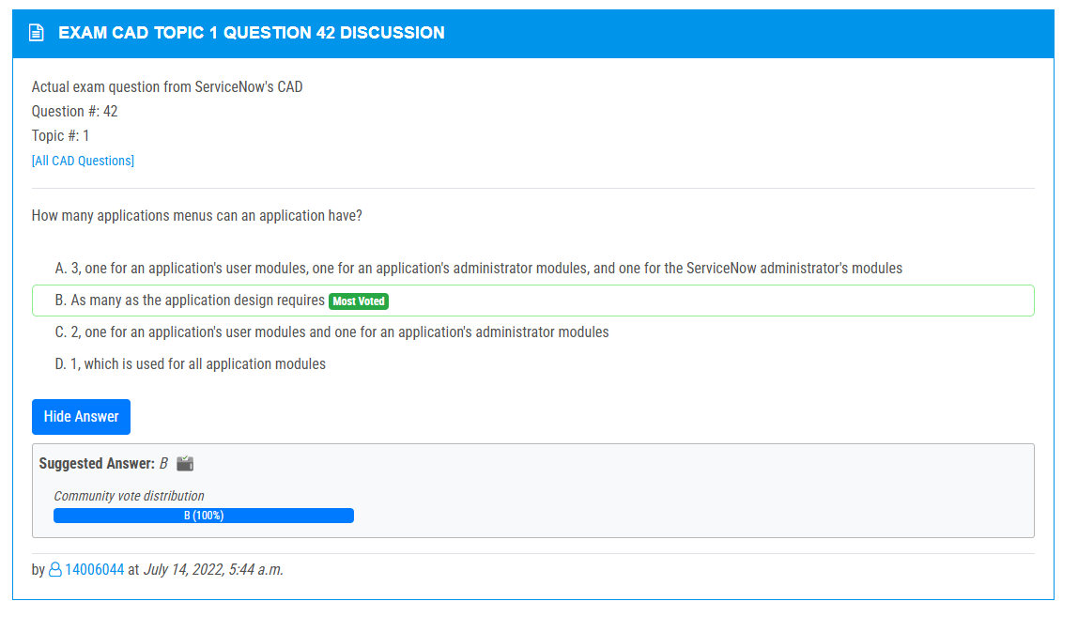

<https://www.examtopics.com/discussions/servicenow/view/118523-exam-cad-topic-1-question-41-discussion/>

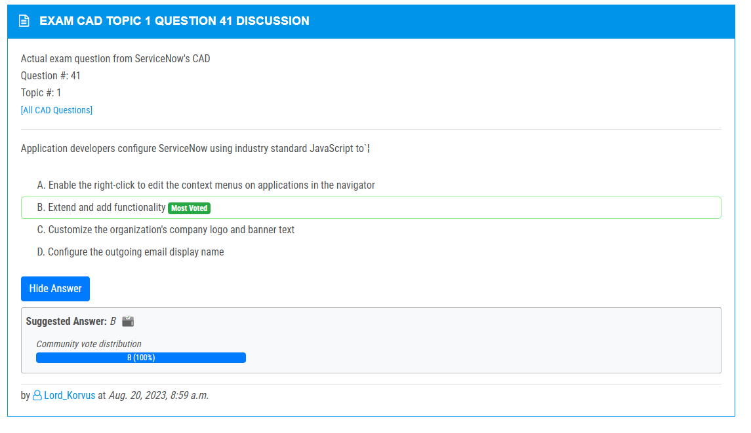

<https://www.examtopics.com/discussions/servicenow/view/110068-exam-cad-topic-1-question-36-discussion/>

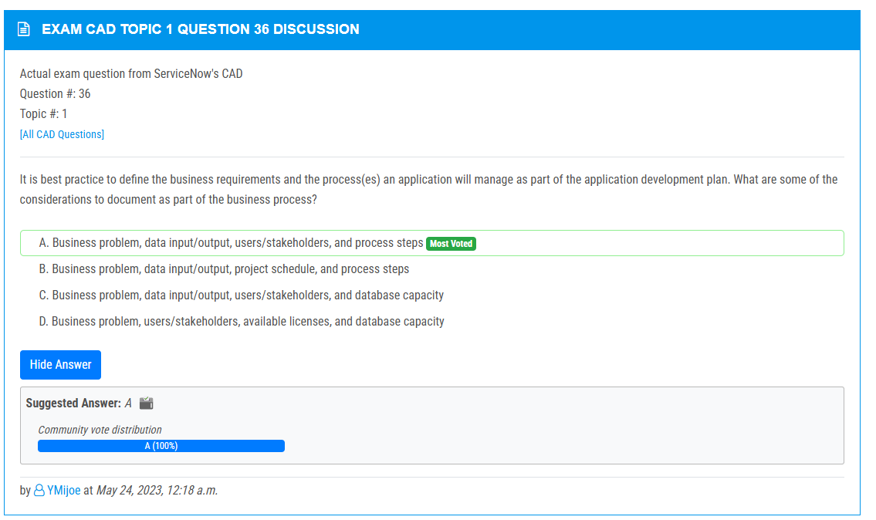

<https://www.examtopics.com/discussions/servicenow/view/107928-exam-cad-topic-1-question-27-discussion/>

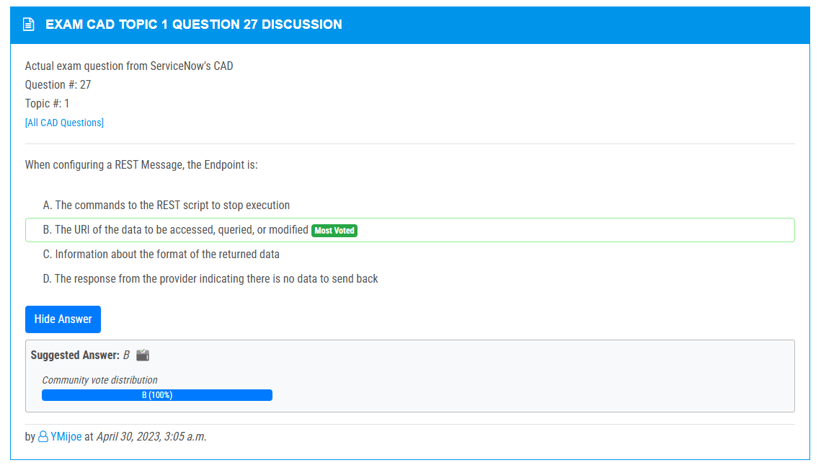

<https://www.examtopics.com/discussions/servicenow/view/91076-exam-cad-topic-1-question-65-discussion/>

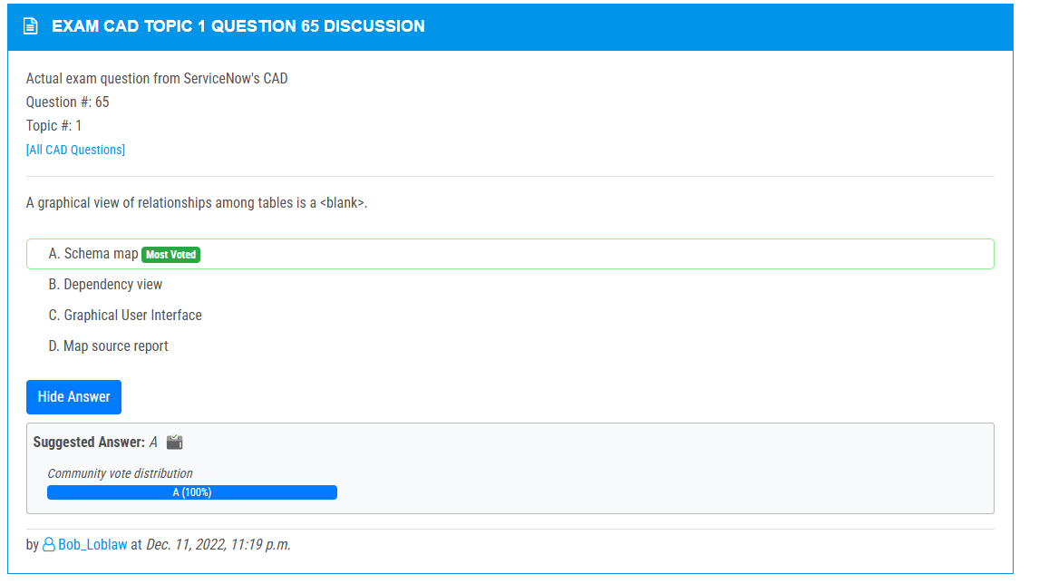

<https://www.examtopics.com/discussions/servicenow/view/90873-exam-cad-topic-1-question-90-discussion/>

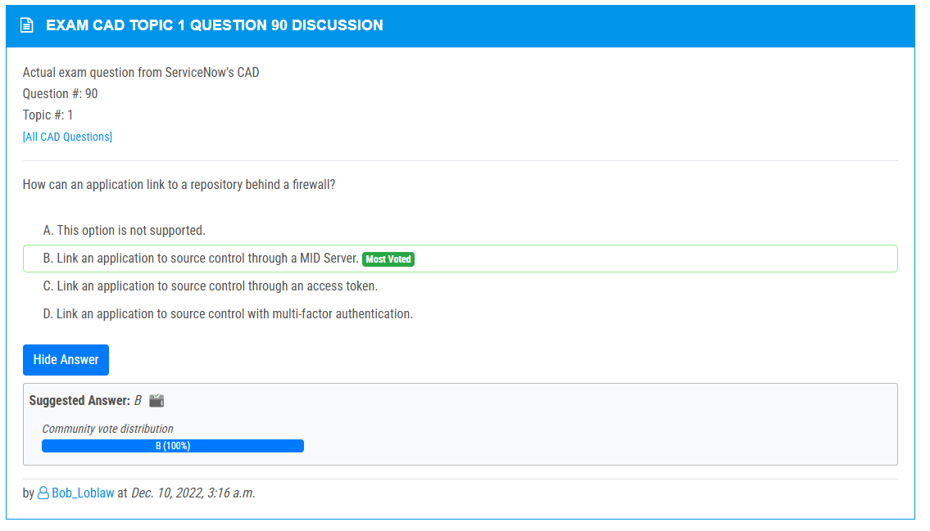

<https://www.examtopics.com/discussions/servicenow/view/90874-exam-cad-topic-1-question-6-discussion/>

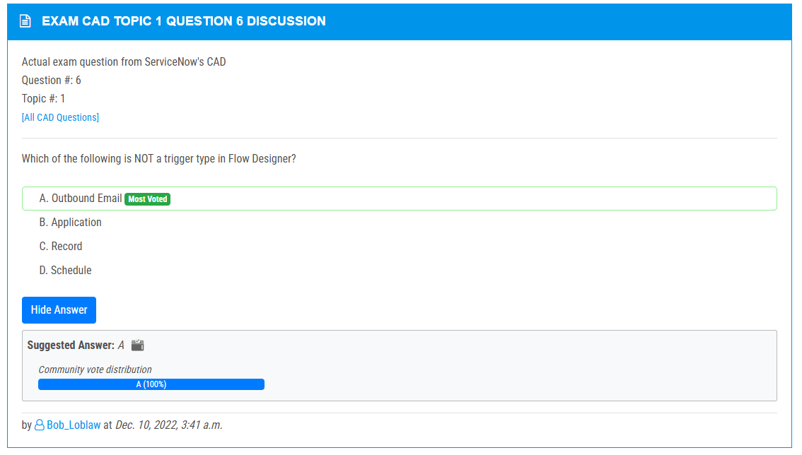

<https://www.examtopics.com/discussions/servicenow/view/108150-exam-cad-topic-1-question-64-discussion/>

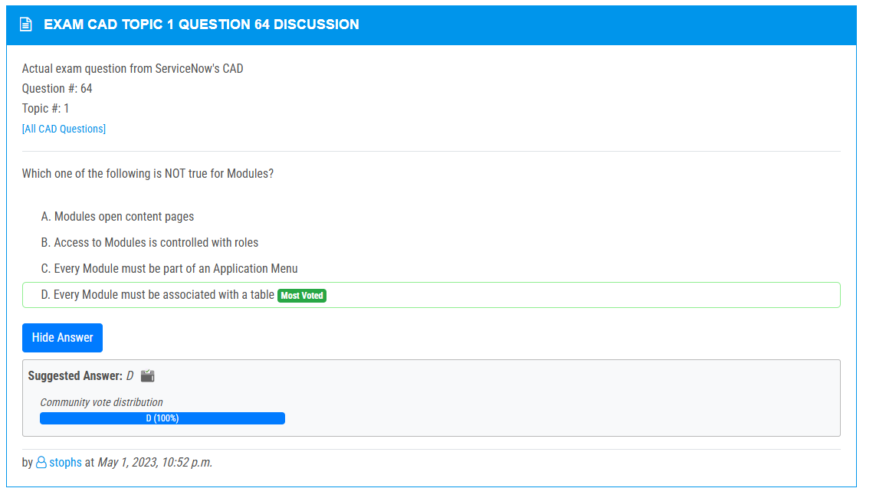

<https://www.examtopics.com/discussions/servicenow/view/122940-exam-cad-topic-1-question-56-discussion/>

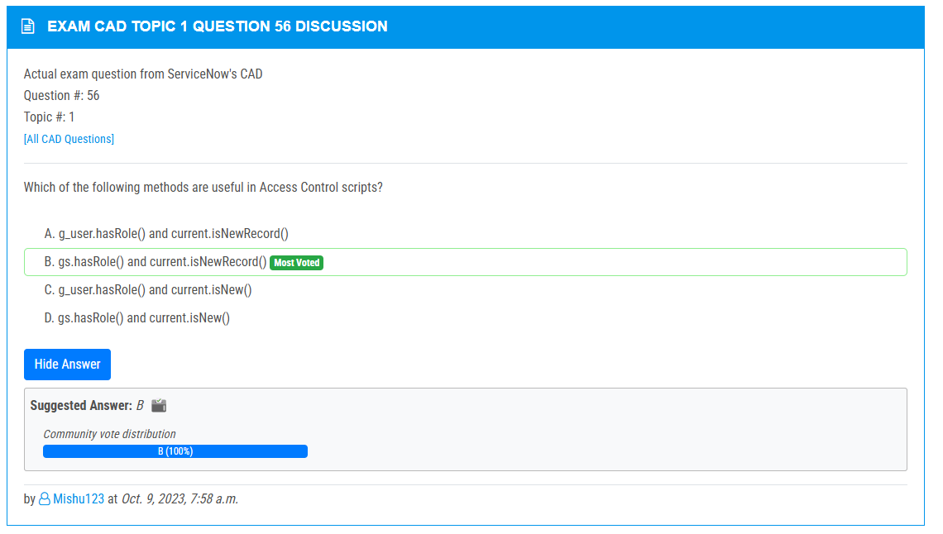

<https://www.examtopics.com/discussions/servicenow/view/73087-exam-cad-topic-1-question-51-discussion/>

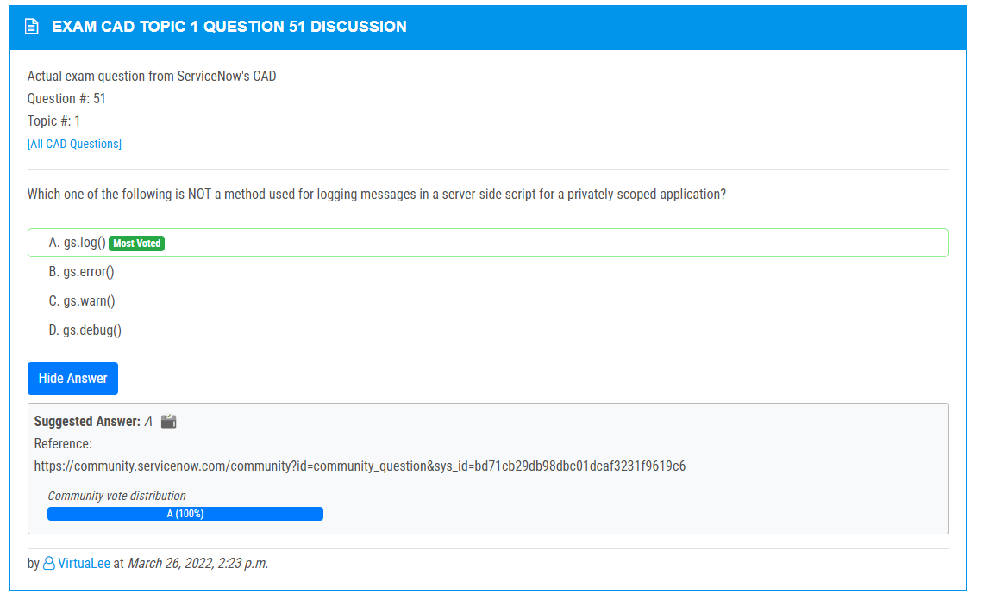

<https://www.examtopics.com/discussions/servicenow/view/130612-exam-cad-topic-1-question-49-discussion/>

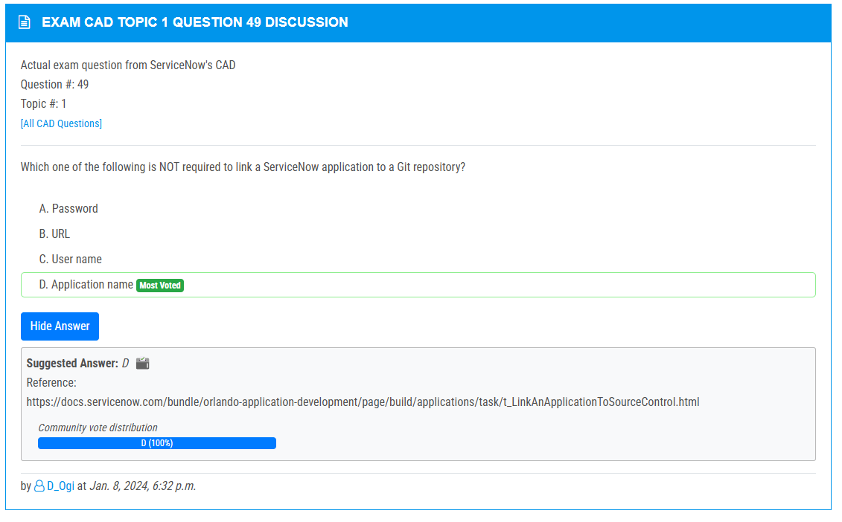

<https://www.examtopics.com/discussions/servicenow/view/64116-exam-cad-topic-1-question-25-discussion/>

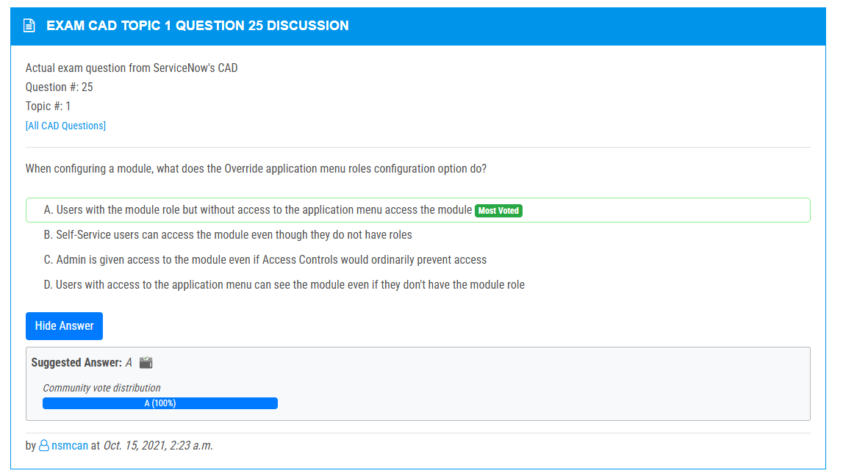

<https://www.examtopics.com/discussions/servicenow/view/64115-exam-cad-topic-1-question-23-discussion/>

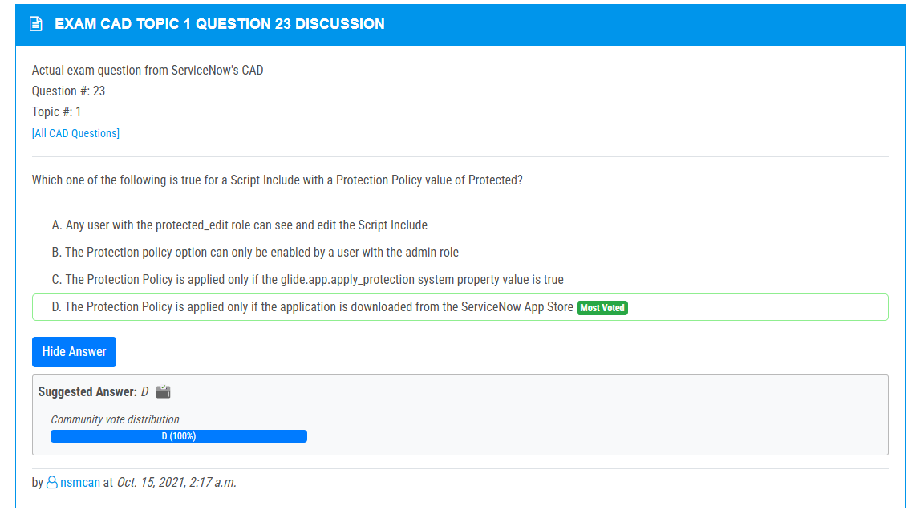

<https://www.examtopics.com/discussions/servicenow/view/70399-exam-cad-topic-1-question-61-discussion/>

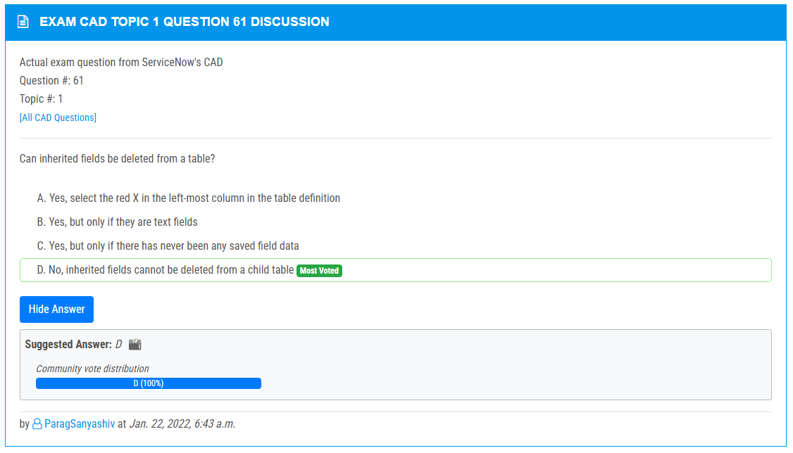

<https://www.examtopics.com/discussions/servicenow/view/73399-exam-cad-topic-1-question-63-discussion/>

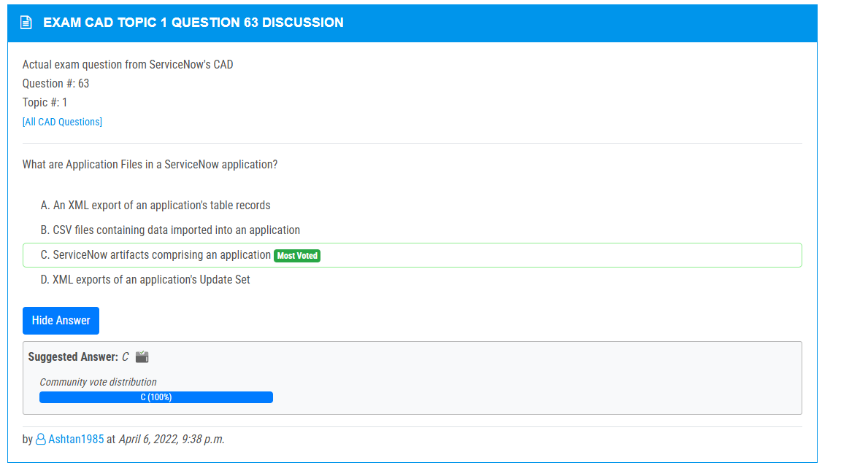

<https://www.examtopics.com/discussions/servicenow/view/66604-exam-cad-topic-1-question-50-discussion/>

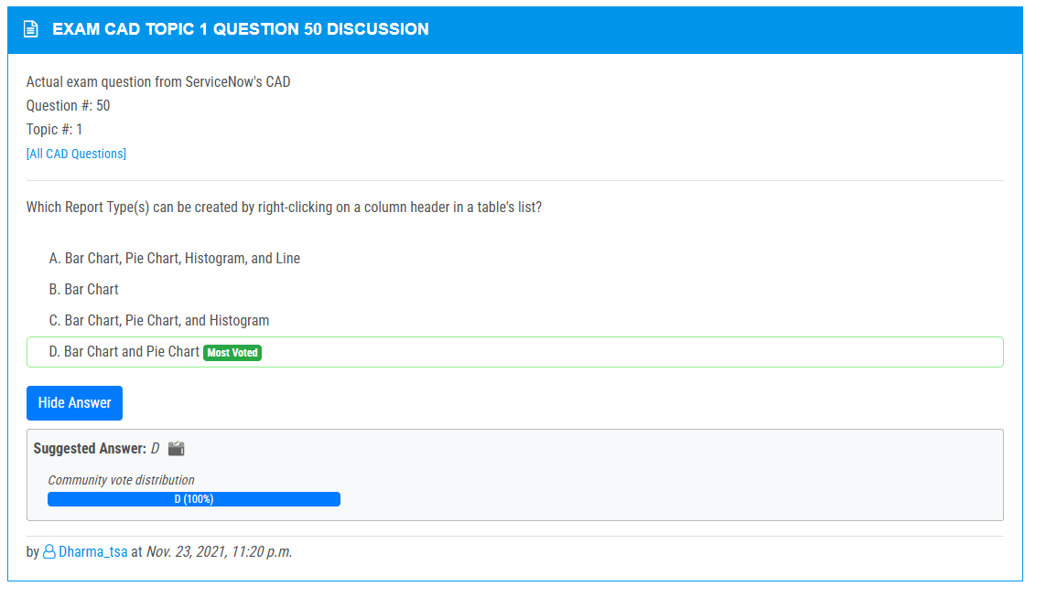

<https://www.examtopics.com/discussions/servicenow/view/73174-exam-cad-topic-1-question-46-discussion/>

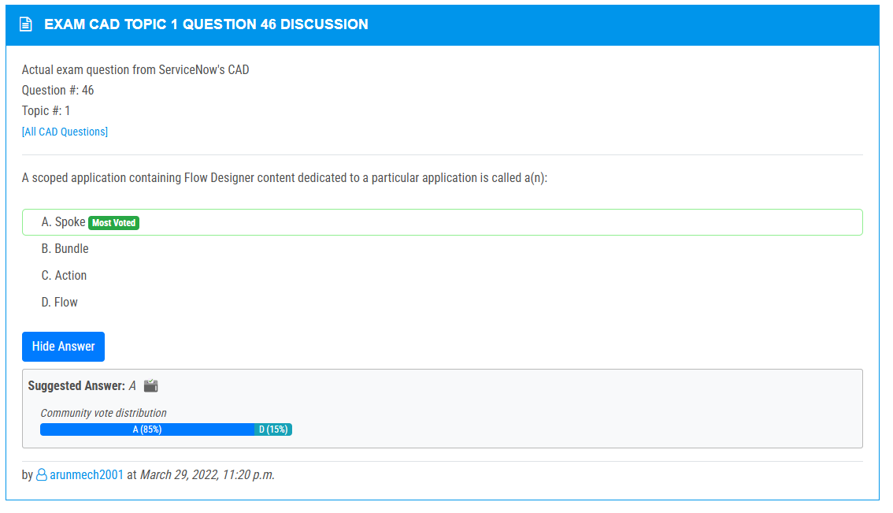

<https://www.examtopics.com/discussions/servicenow/view/107699-exam-cad-topic-1-question-43-discussion/>

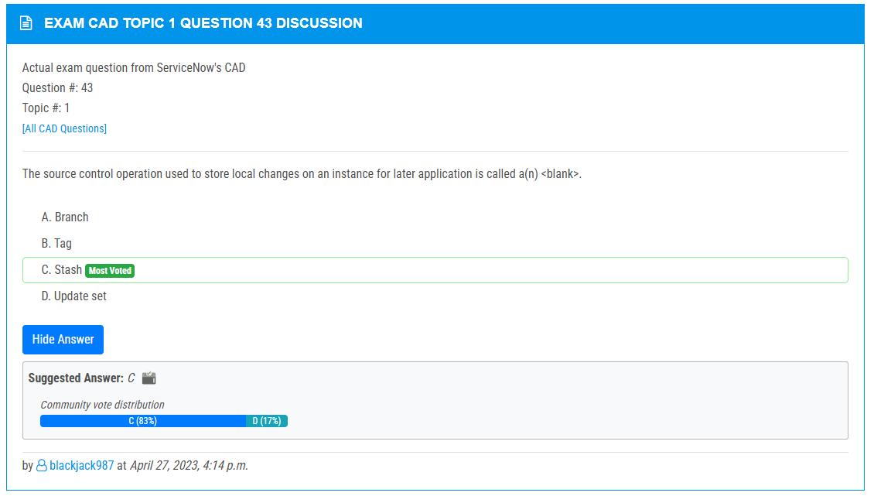

<https://www.examtopics.com/discussions/servicenow/view/147002-exam-cad-topic-1-question-140-discussion/>

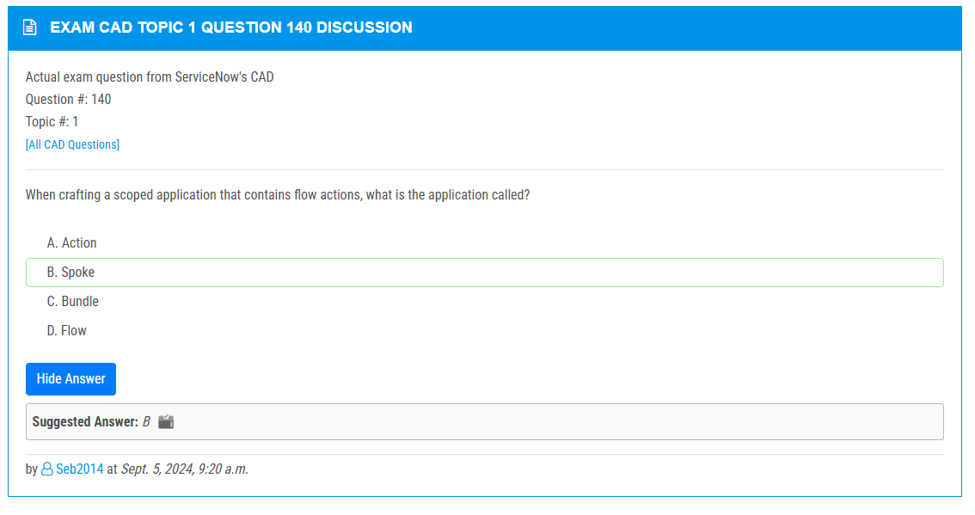

<https://www.examtopics.com/discussions/servicenow/view/98213-exam-cad-topic-1-question-123-discussion/>

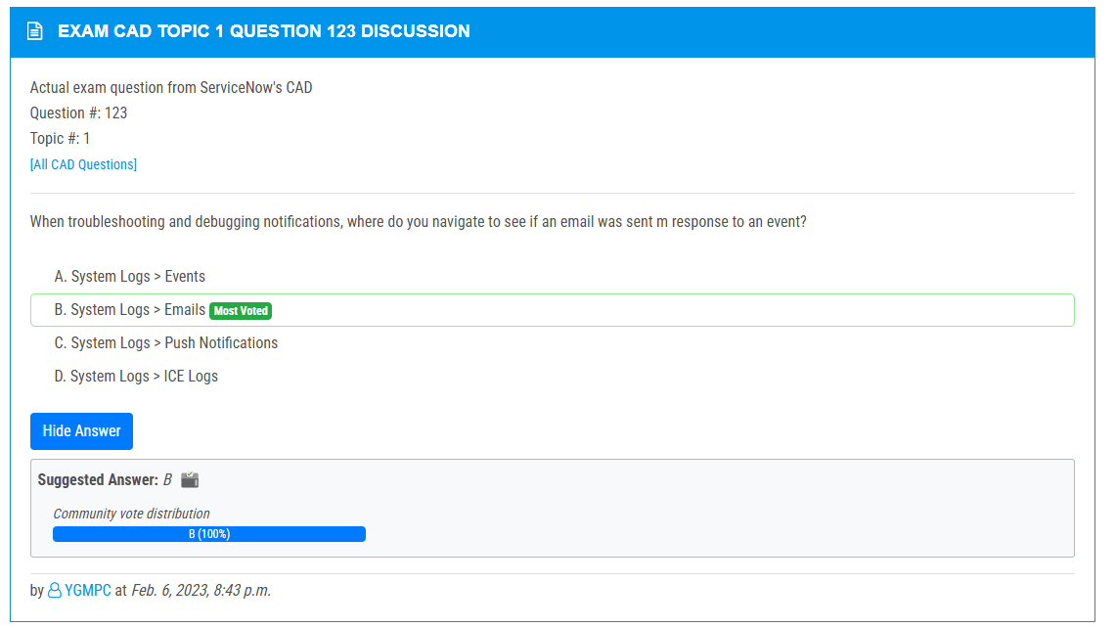

<https://www.examtopics.com/discussions/servicenow/view/64417-exam-cad-topic-1-question-39-discussion/>

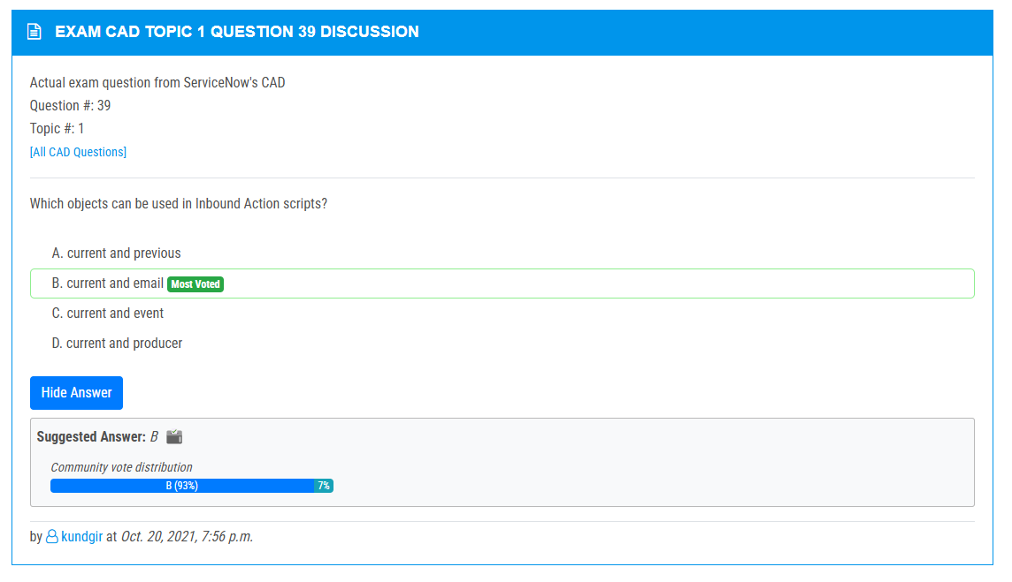

<https://www.examtopics.com/discussions/servicenow/view/92619-exam-cad-topic-1-question-52-discussion/>

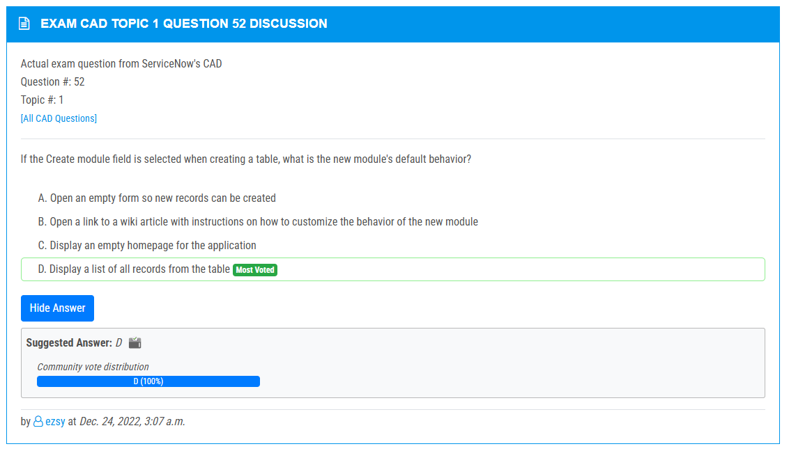

<https://www.examtopics.com/discussions/servicenow/view/82736-exam-cad-topic-1-question-1-discussion/>

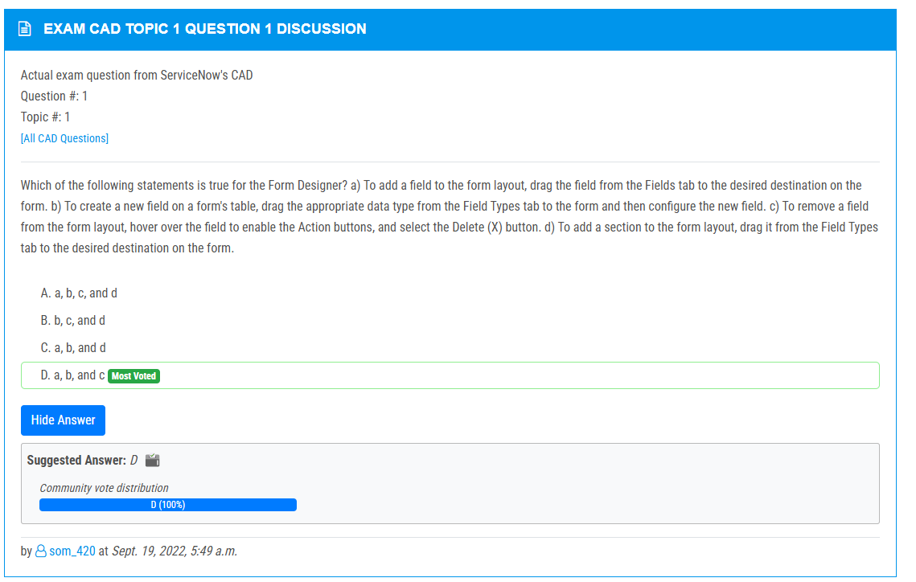

<https://www.examtopics.com/discussions/servicenow/view/92063-exam-cad-topic-1-question-129-discussion/>

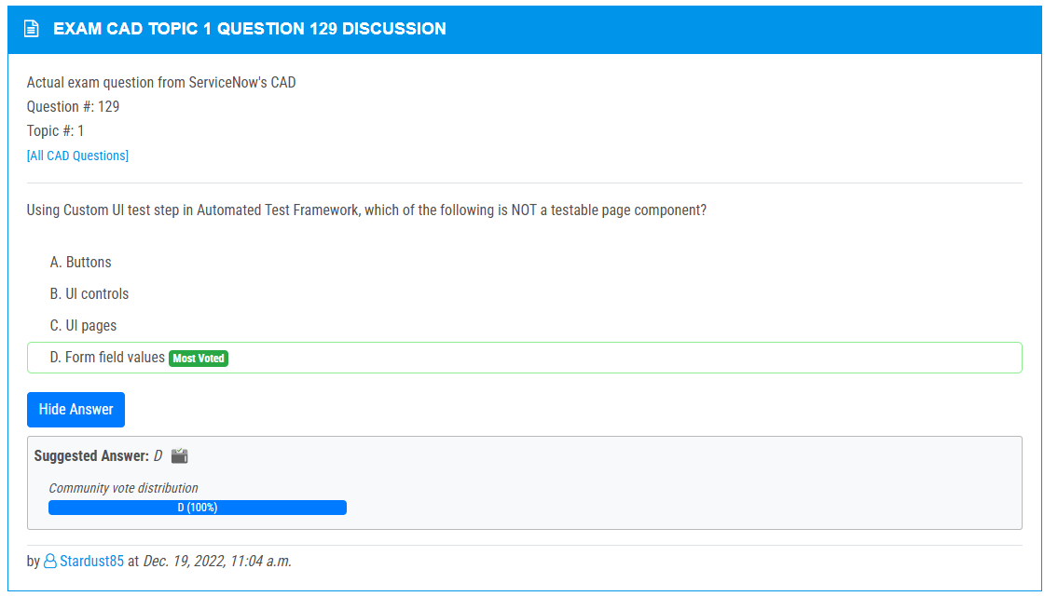

<https://www.examtopics.com/discussions/servicenow/view/134155-exam-cad-topic-1-question-132-discussion/>

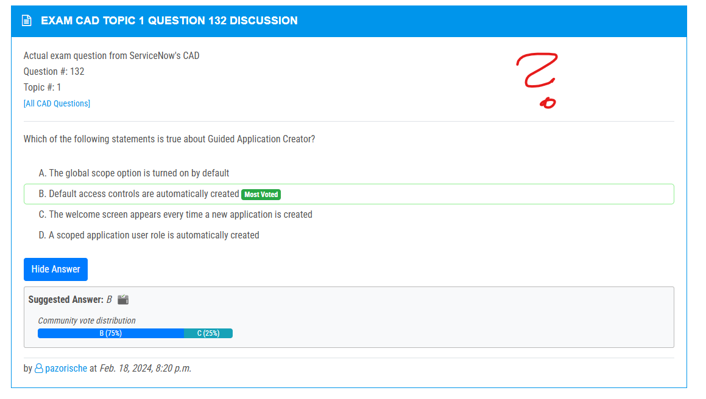

<https://www.examtopics.com/discussions/servicenow/view/90963-exam-cad-topic-1-question-108-discussion/>

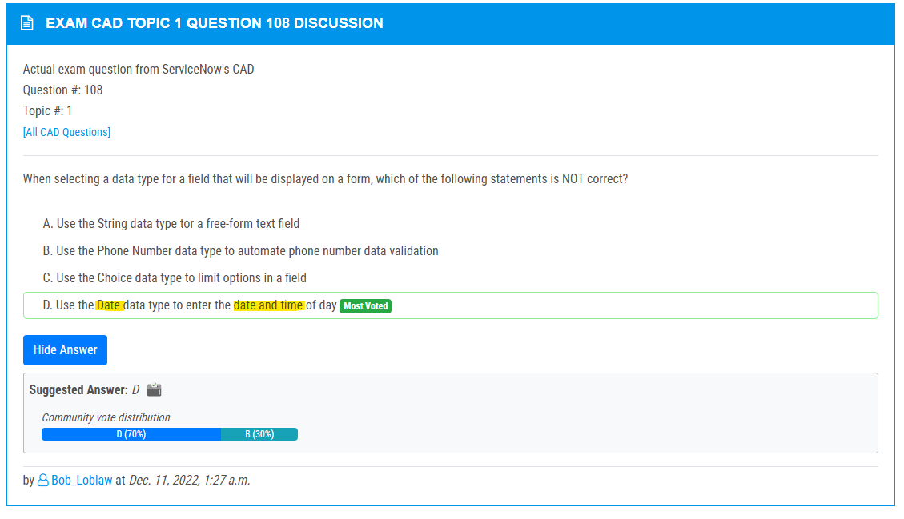

<https://www.examtopics.com/discussions/servicenow/view/92050-exam-cad-topic-1-question-121-discussion/>

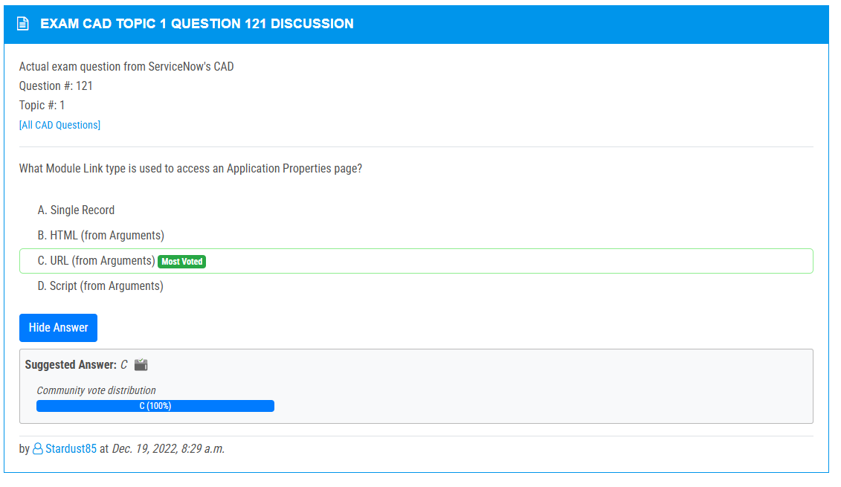

<https://www.examtopics.com/discussions/servicenow/view/90965-exam-cad-topic-1-question-113-discussion/>

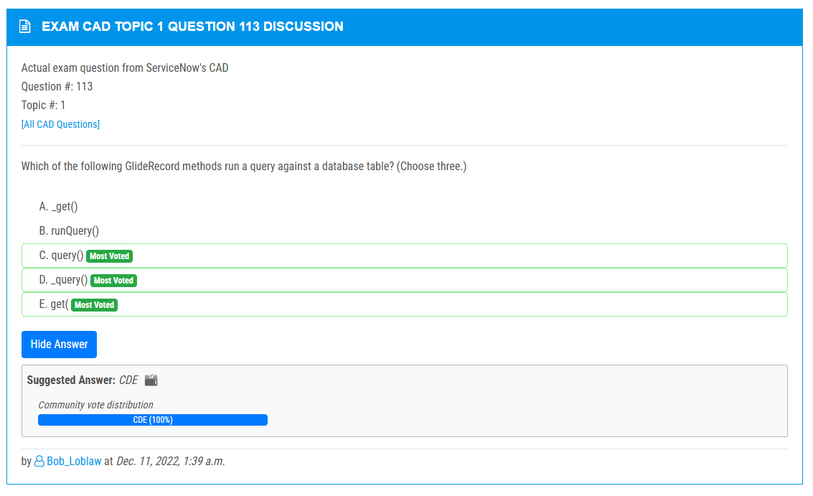

<https://www.examtopics.com/discussions/servicenow/view/64118-exam-cad-topic-1-question-29-discussion/>

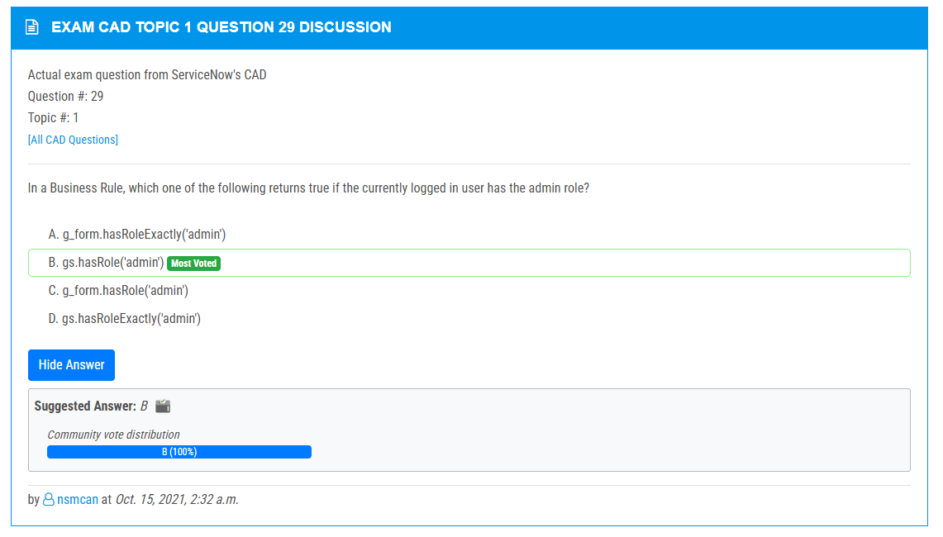

<https://www.examtopics.com/discussions/servicenow/view/90801-exam-cad-topic-1-question-122-discussion/>

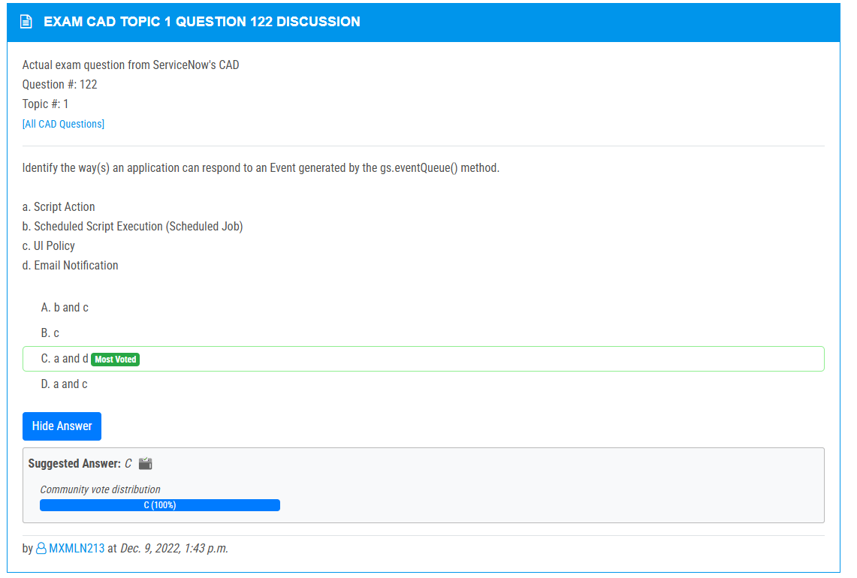

<https://www.examtopics.com/discussions/servicenow/view/143609-exam-cad-topic-1-question-130-discussion/>

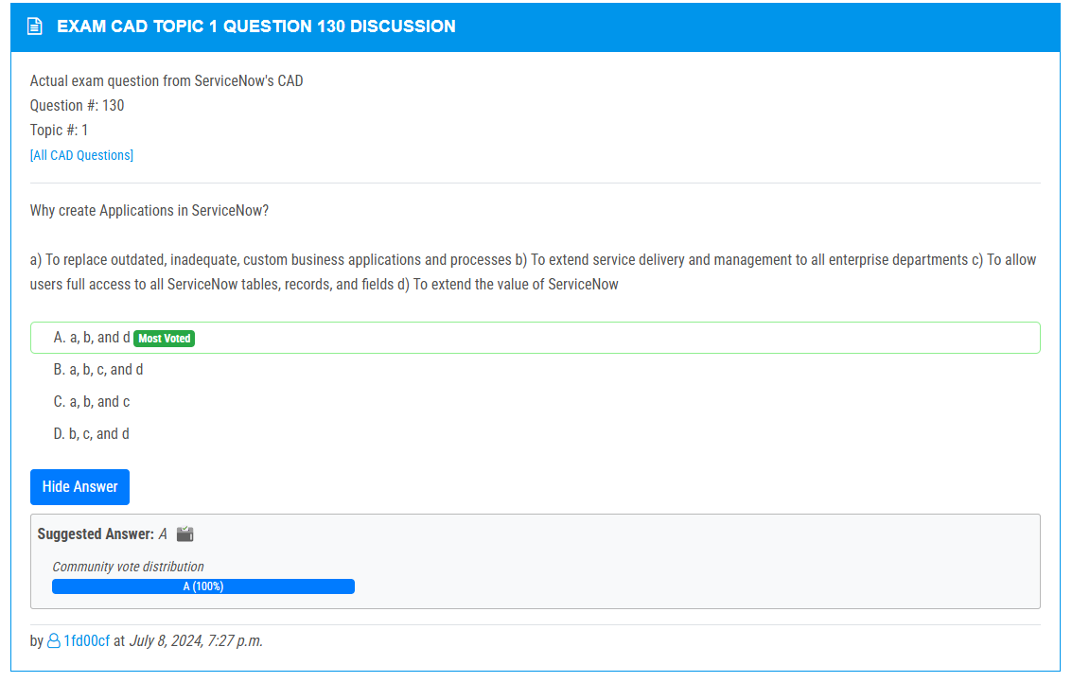

<https://www.examtopics.com/discussions/servicenow/view/64122-exam-cad-topic-1-question-35-discussion/>

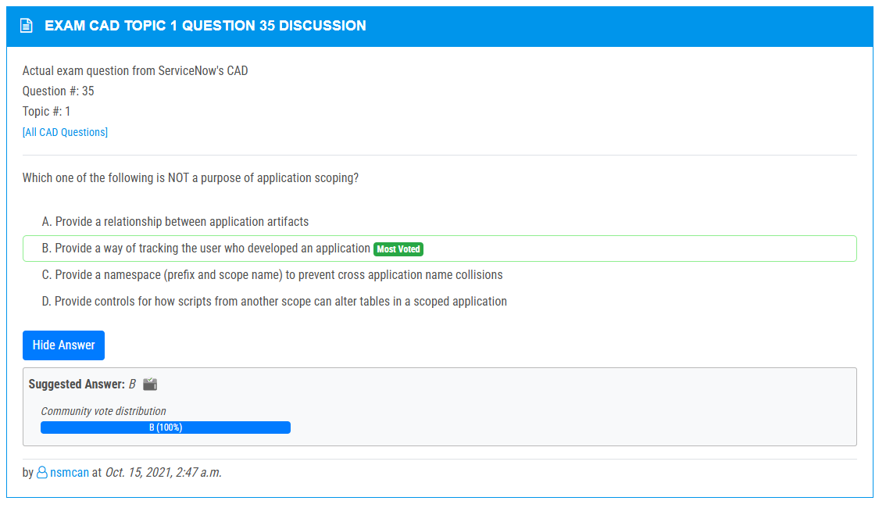

<https://www.examtopics.com/discussions/servicenow/view/133290-exam-cad-topic-1-question-151-discussion/>

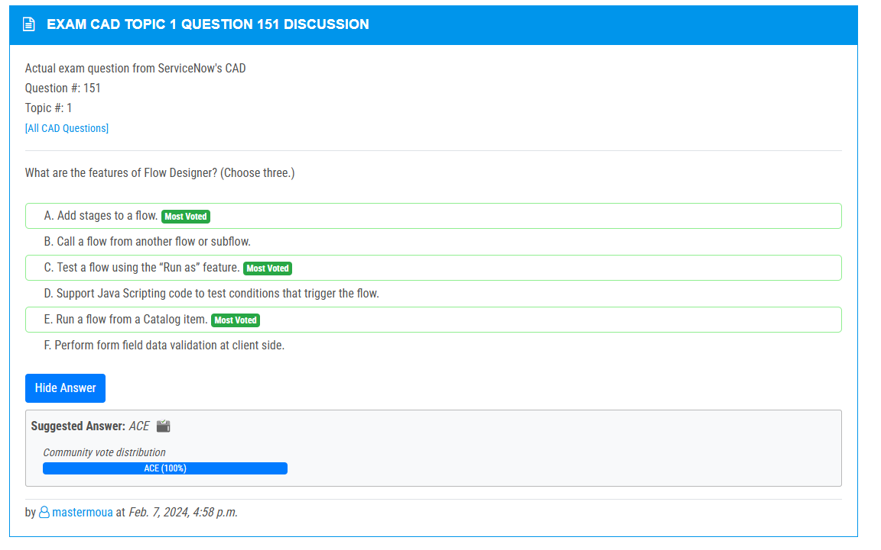

<https://www.examtopics.com/discussions/servicenow/view/61951-exam-cad-topic-1-question-19-discussion/>

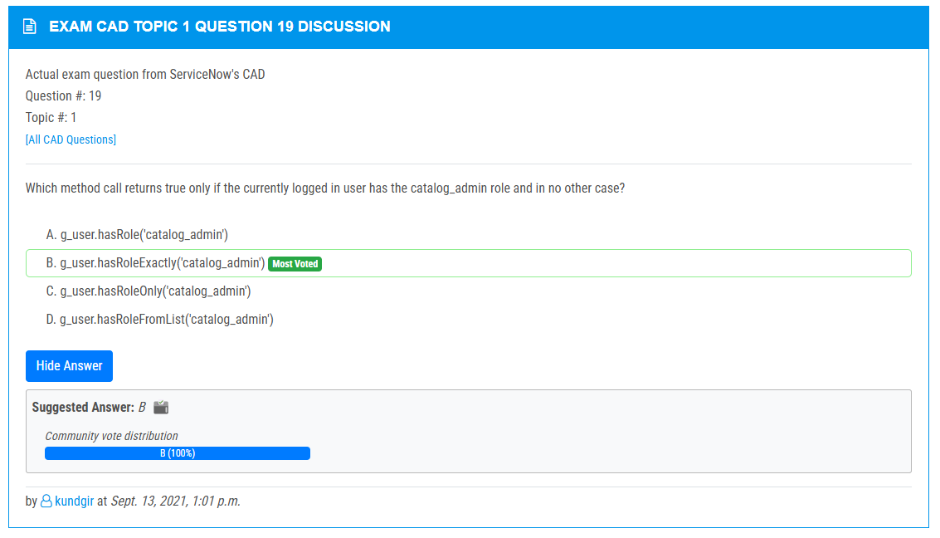

<https://www.examtopics.com/discussions/servicenow/view/65700-exam-cad-topic-1-question-80-discussion/>

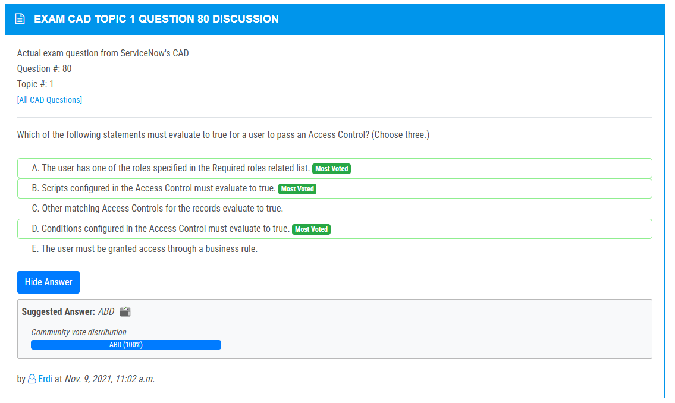

<https://www.examtopics.com/discussions/servicenow/view/64117-exam-cad-topic-1-question-28-discussion/>

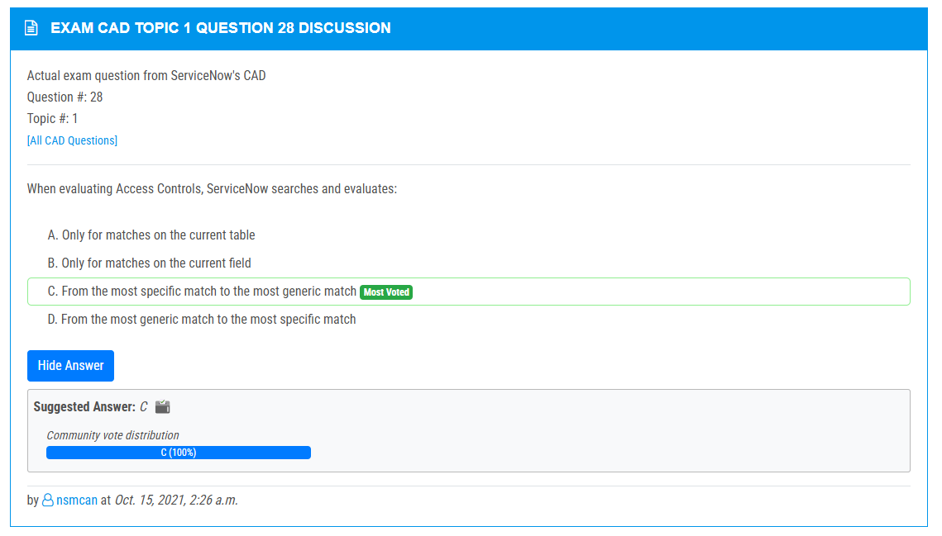

<https://www.examtopics.com/discussions/servicenow/view/144813-exam-cad-topic-1-question-141-discussion/>

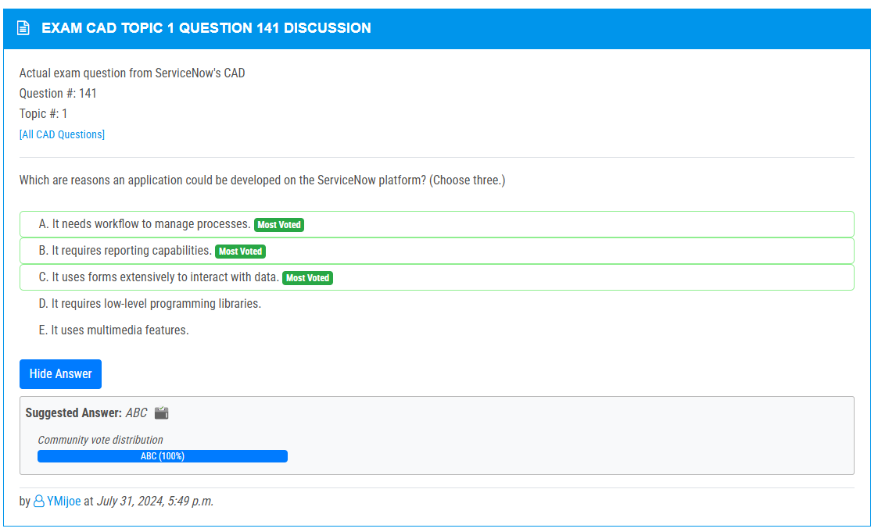

<https://www.examtopics.com/discussions/servicenow/view/137271-exam-cad-topic-1-question-134-discussion/>

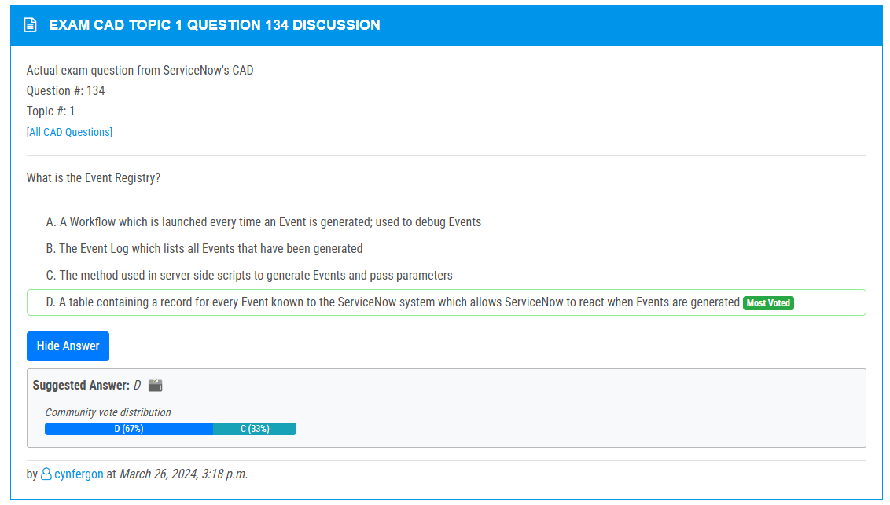

<https://www.examtopics.com/discussions/servicenow/view/137269-exam-cad-topic-1-question-133-discussion/>

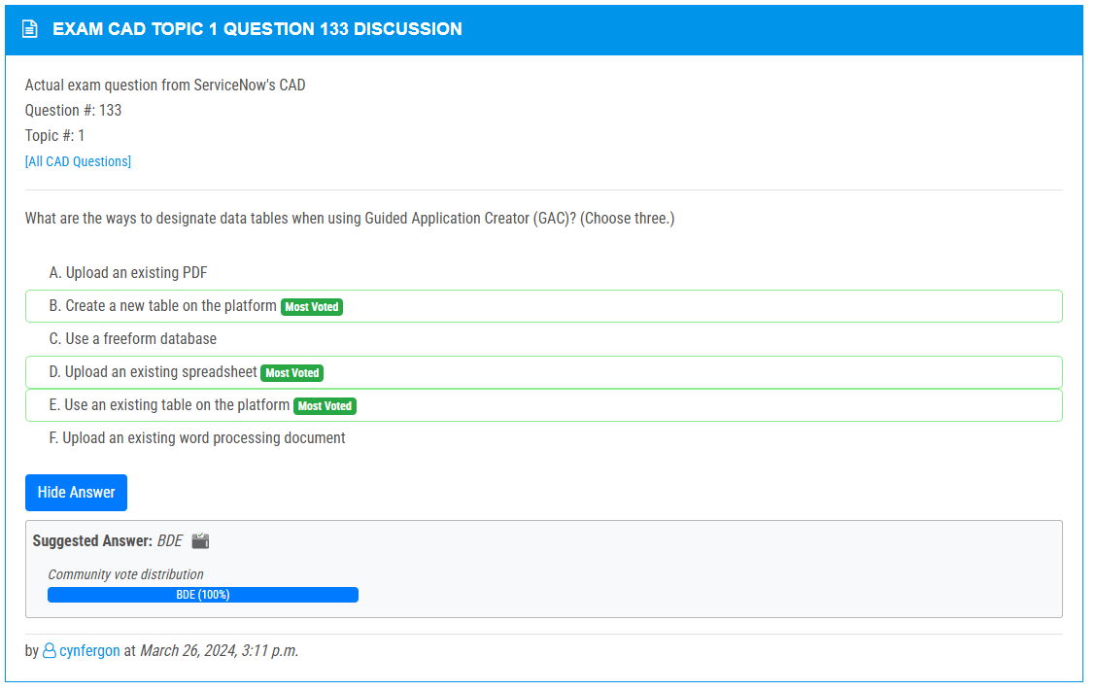

<https://www.examtopics.com/discussions/servicenow/view/91633-exam-cad-topic-1-question-131-discussion/>

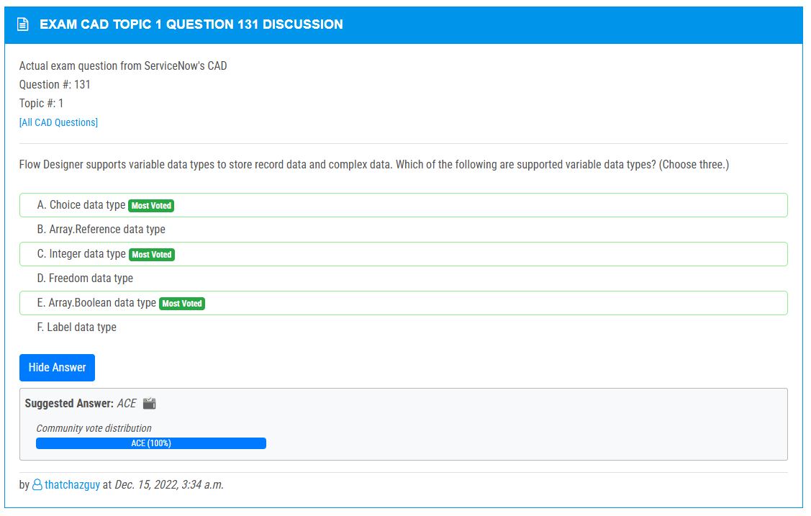

<https://www.examtopics.com/discussions/servicenow/view/89689-exam-cad-topic-1-question-98-discussion/>

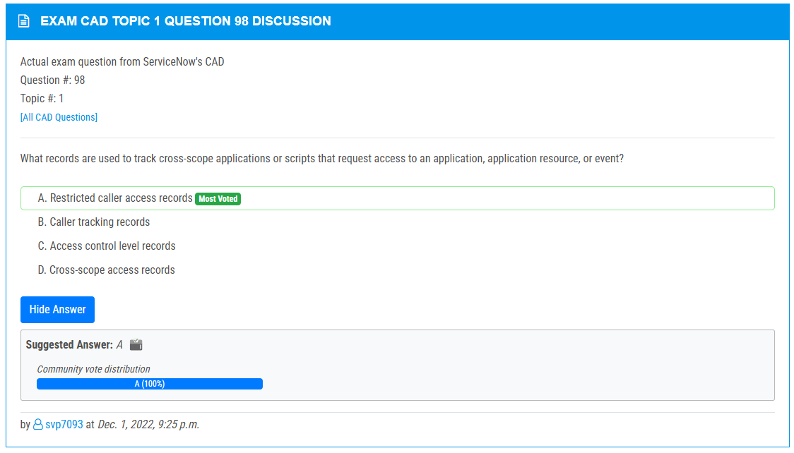

<https://www.examtopics.com/discussions/servicenow/view/107702-exam-cad-topic-1-question-57-discussion/>

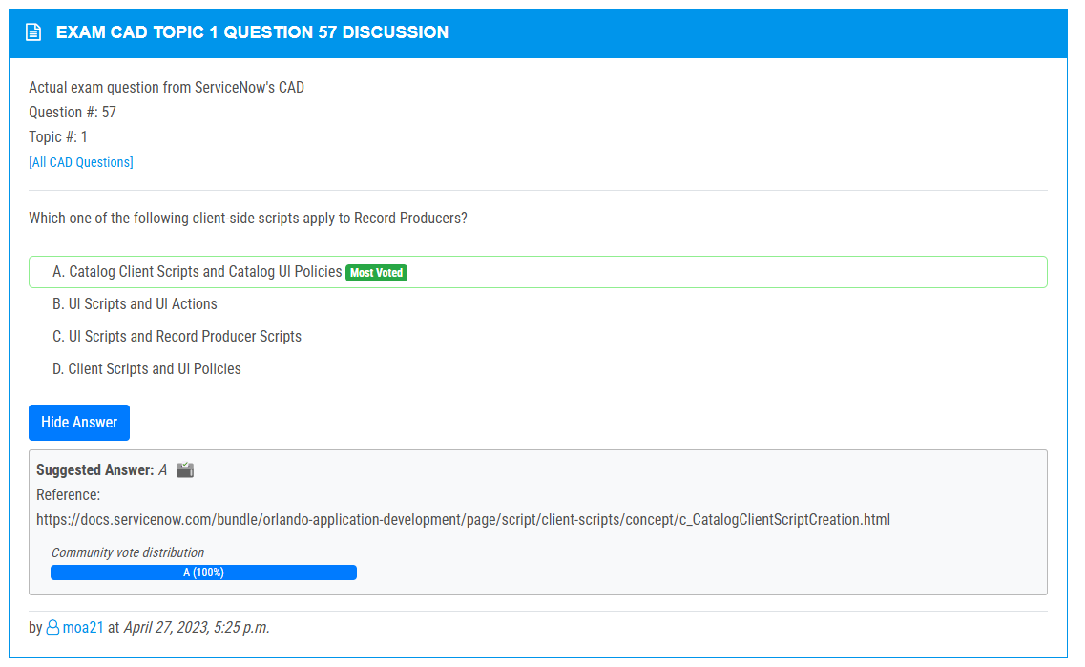

<https://www.examtopics.com/discussions/servicenow/view/64126-exam-cad-topic-1-question-47-discussion/>

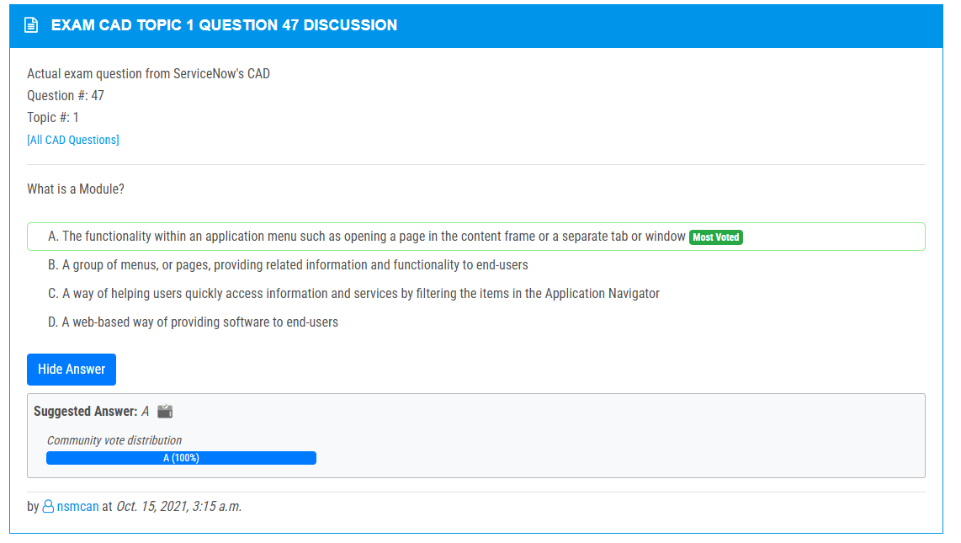

<https://www.examtopics.com/discussions/servicenow/view/90973-exam-cad-topic-1-question-128-discussion/>

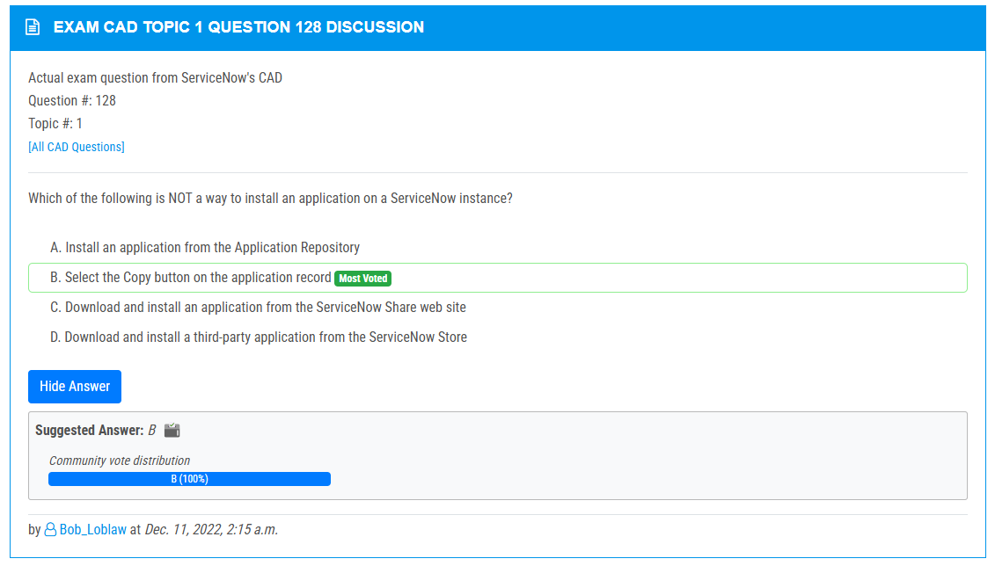

<https://www.examtopics.com/discussions/servicenow/view/102949-exam-cad-topic-1-question-16-discussion/>

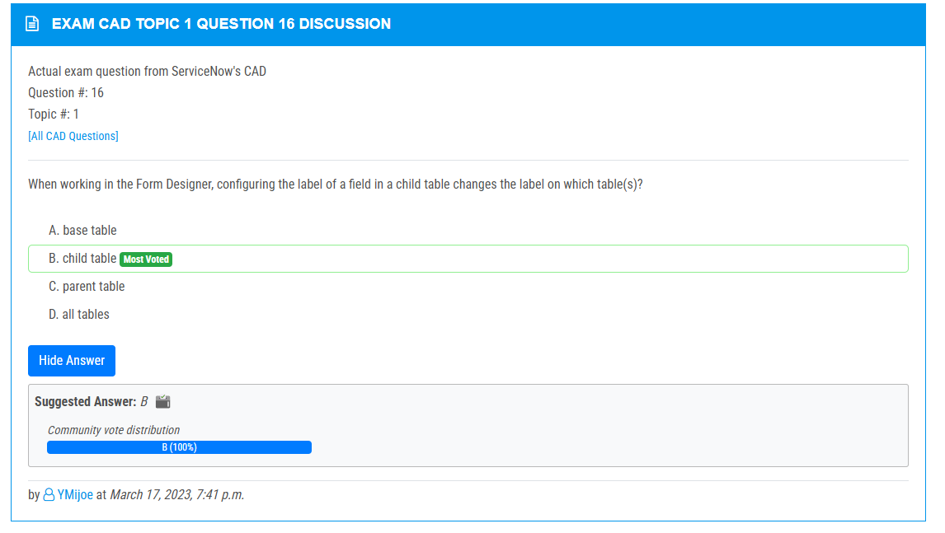

<https://www.examtopics.com/discussions/servicenow/view/108176-exam-cad-topic-1-question-30-discussion/>

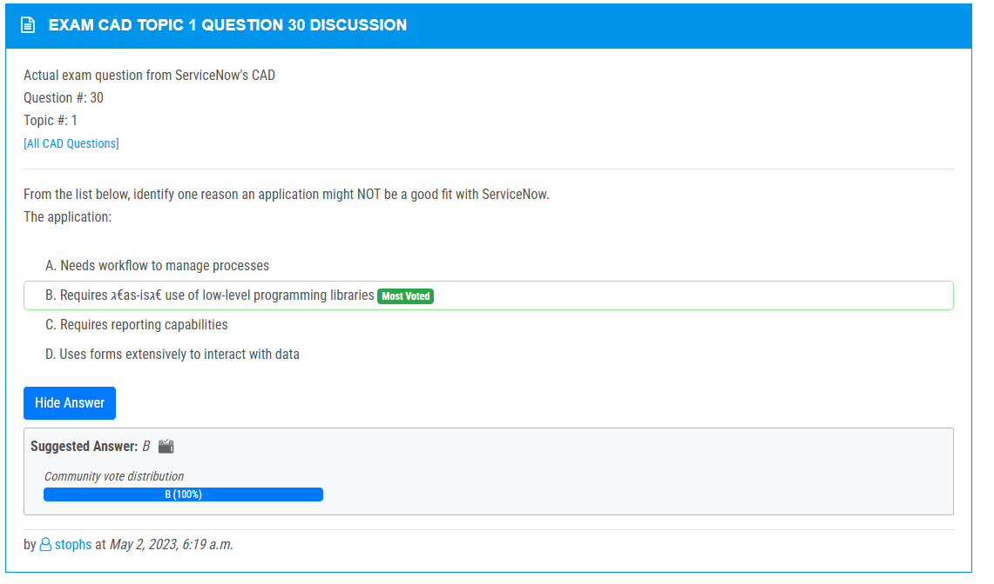

<https://www.examtopics.com/discussions/servicenow/view/108094-exam-cad-topic-1-question-117-discussion/>

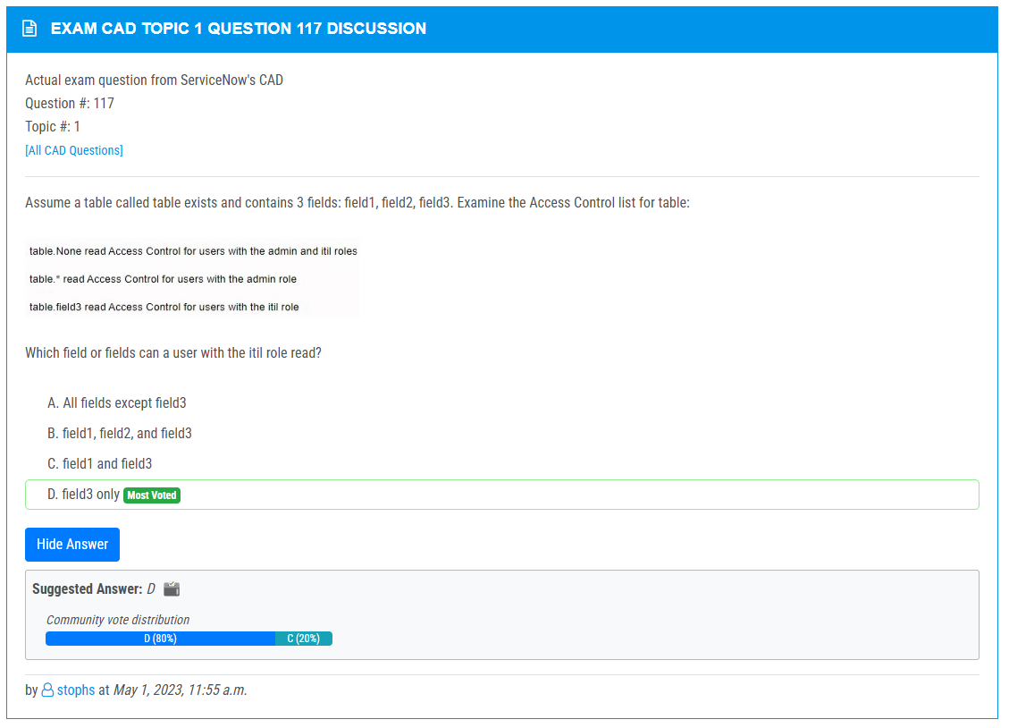

<https://www.examtopics.com/discussions/servicenow/view/108091-exam-cad-topic-1-question-127-discussion/>

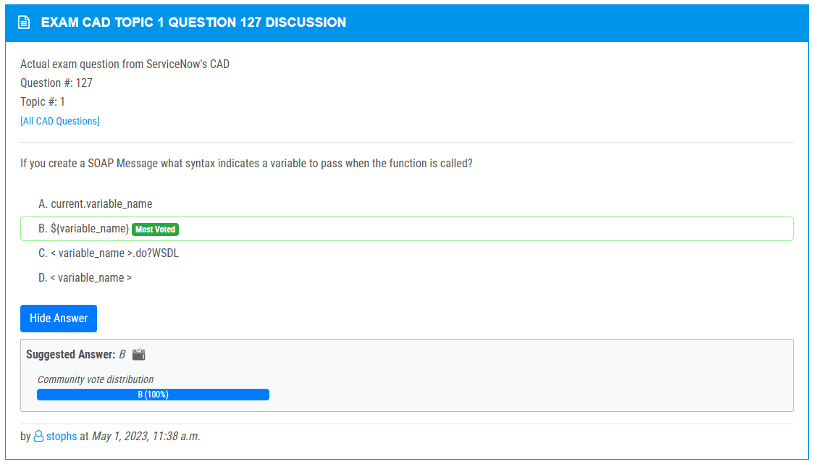

<https://www.examtopics.com/discussions/servicenow/view/108092-exam-cad-topic-1-question-126-discussion/>

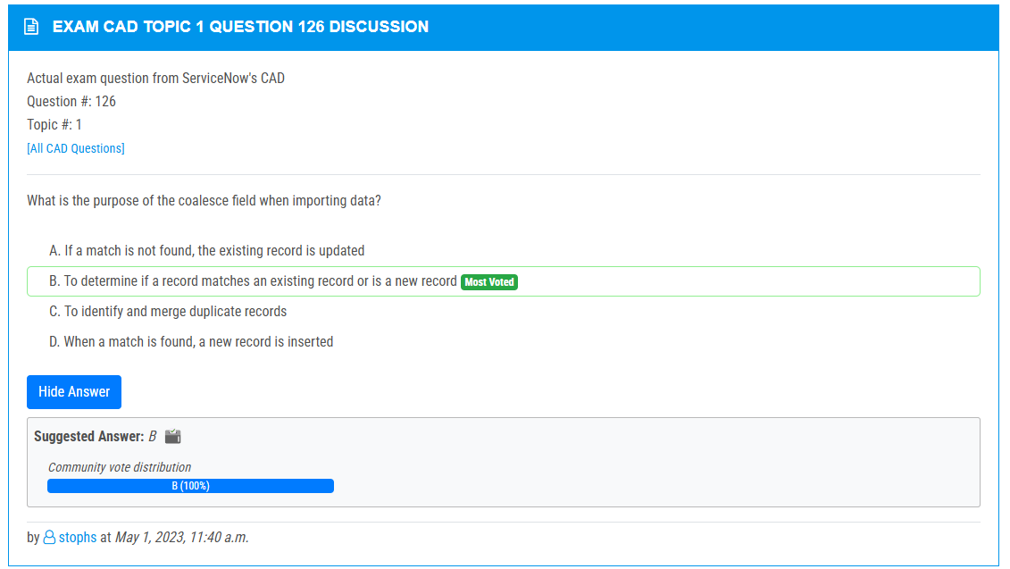

<https://www.examtopics.com/discussions/servicenow/view/90972-exam-cad-topic-1-question-124-discussion/>

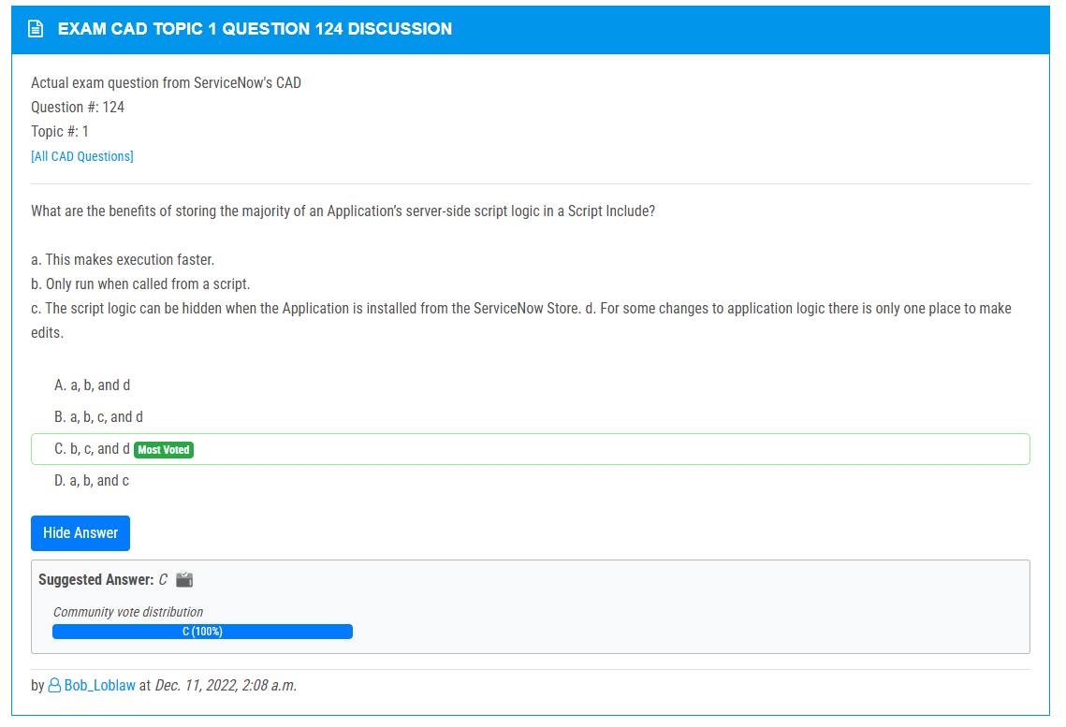

<https://www.examtopics.com/discussions/servicenow/view/102859-exam-cad-topic-1-question-20-discussion/>

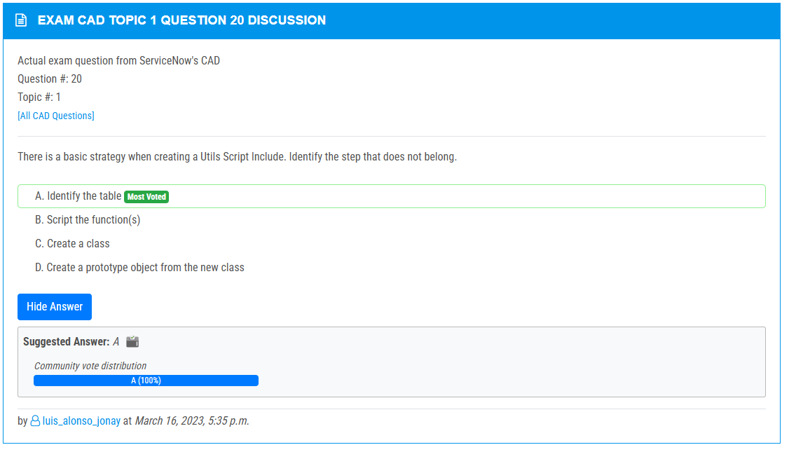

<https://www.examtopics.com/discussions/servicenow/view/82737-exam-cad-topic-1-question-2-discussion/>

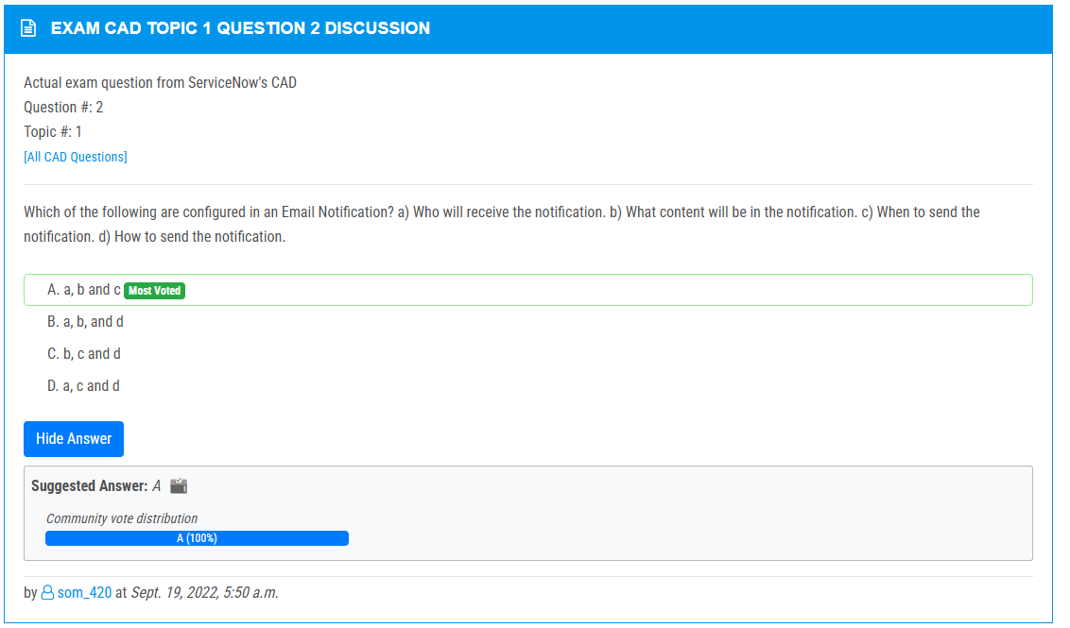

<https://www.examtopics.com/discussions/servicenow/view/91079-exam-cad-topic-1-question-100-discussion/>

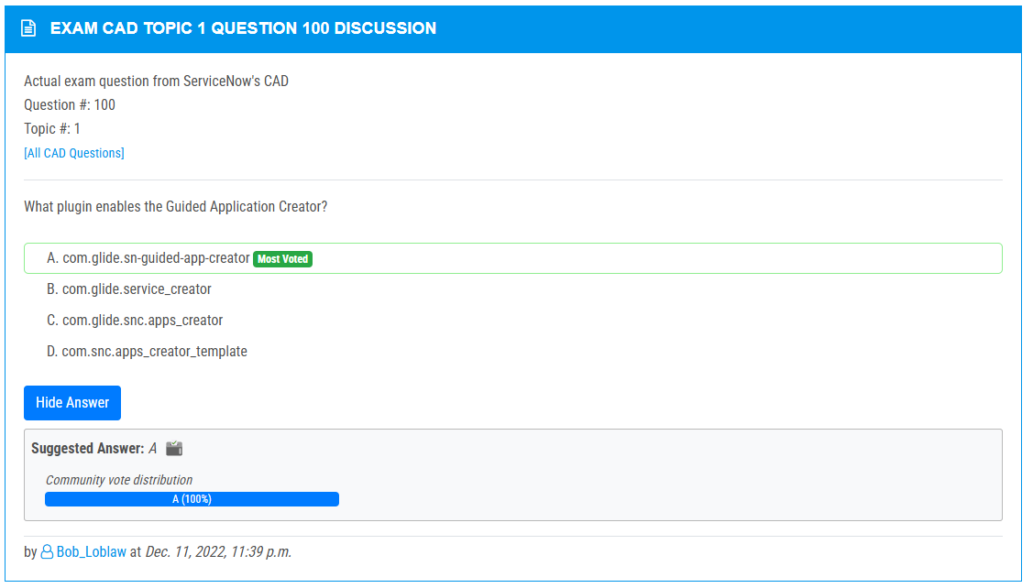

<https://www.examtopics.com/discussions/servicenow/view/108106-exam-cad-topic-1-question-95-discussion/>

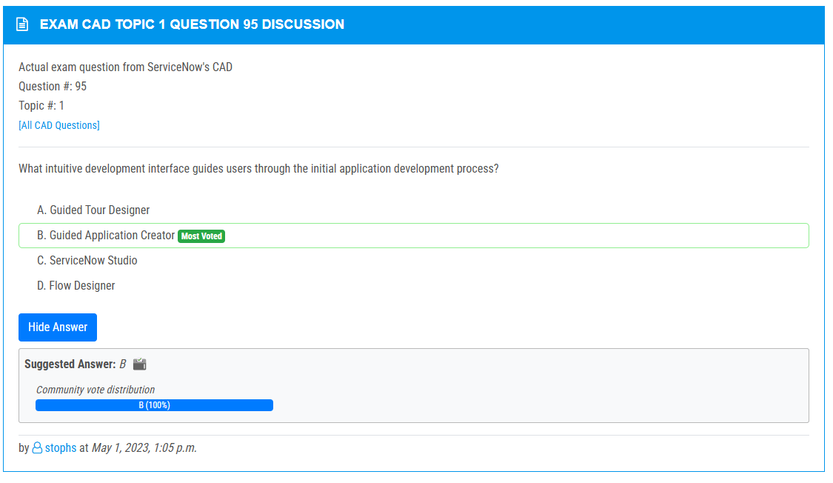

<https://www.examtopics.com/discussions/servicenow/view/134772-exam-cad-topic-1-question-143-discussion/>

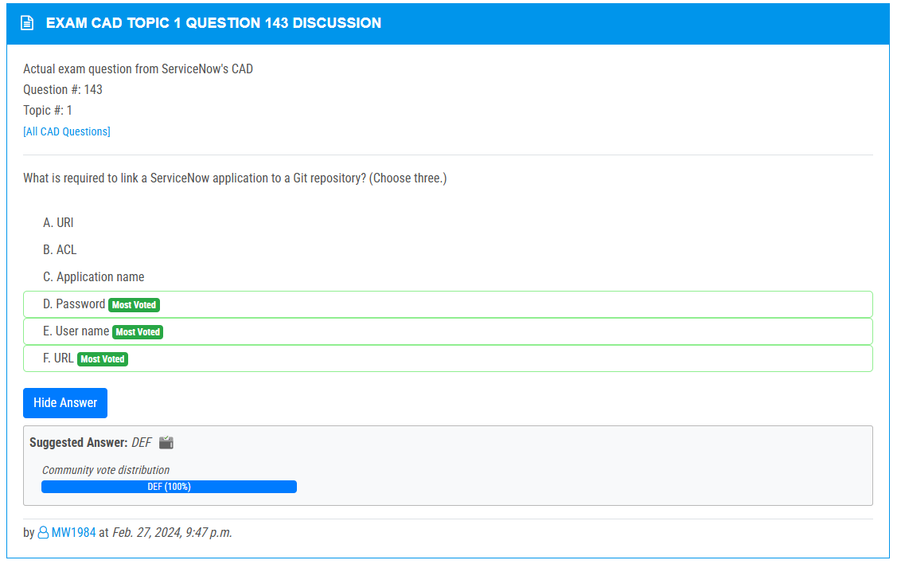

<https://www.examtopics.com/discussions/servicenow/view/134156-exam-cad-topic-1-question-137-discussion/>

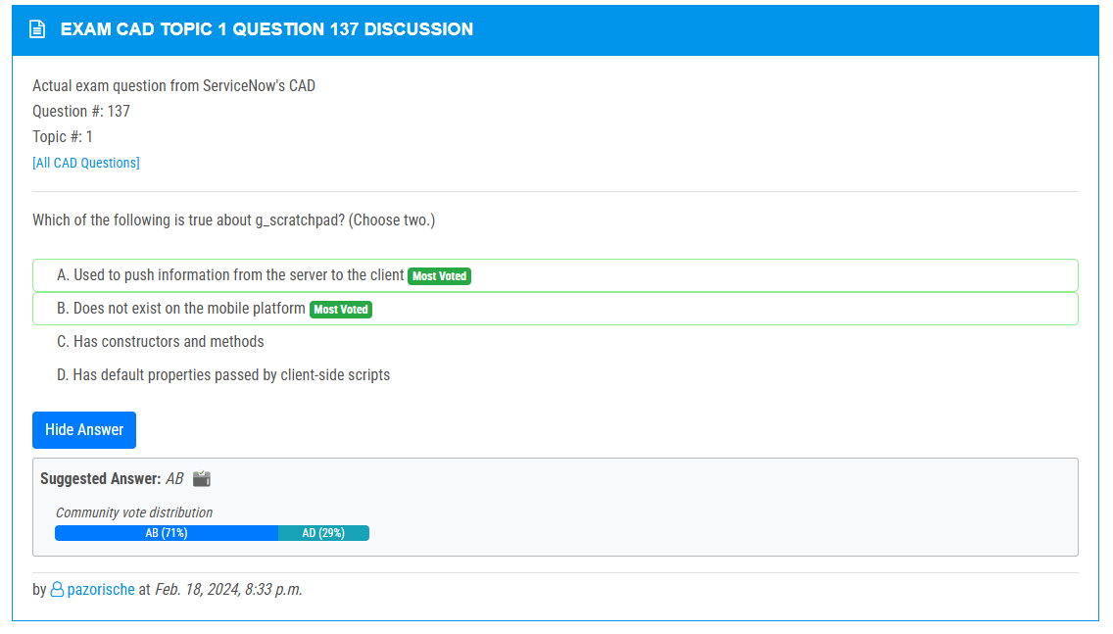

<https://www.examtopics.com/discussions/servicenow/view/64112-exam-cad-topic-1-question-13-discussion/>

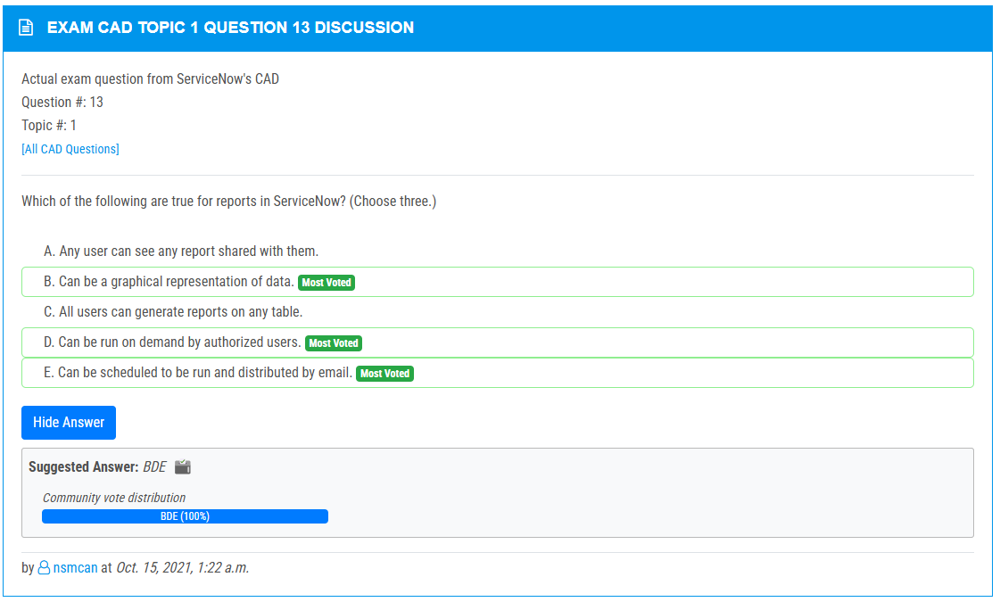

<https://www.examtopics.com/discussions/servicenow/view/82745-exam-cad-topic-1-question-12-discussion/>

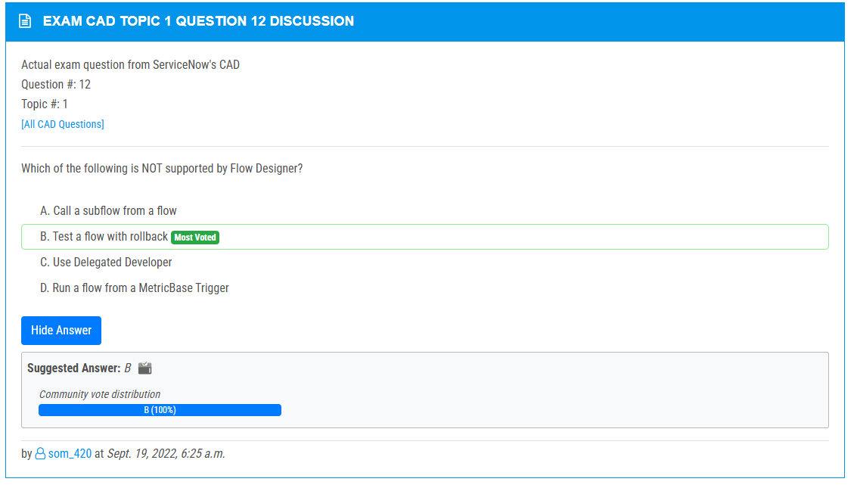

<https://www.examtopics.com/discussions/servicenow/view/74912-exam-cad-topic-1-question-11-discussion/>

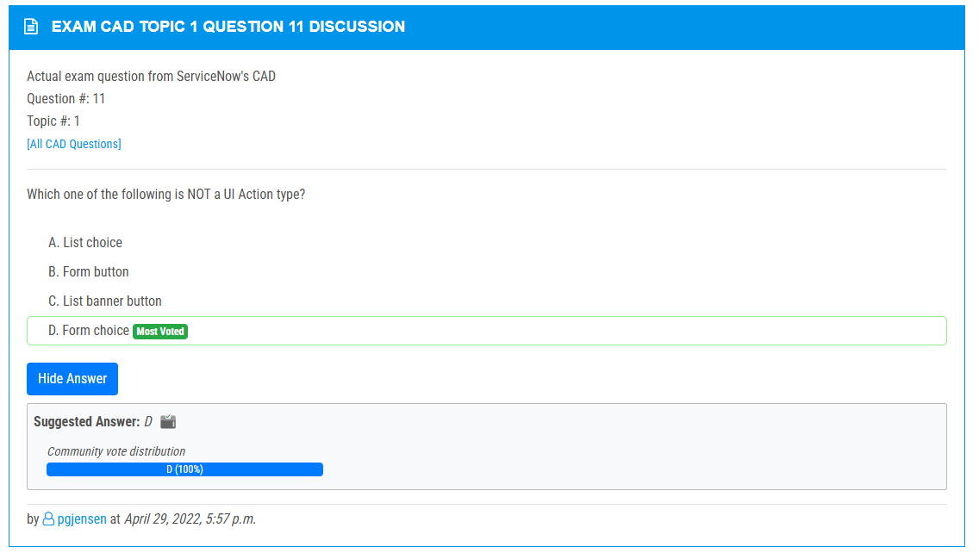

<https://www.examtopics.com/discussions/servicenow/view/73888-exam-cad-topic-1-question-8-discussion/>

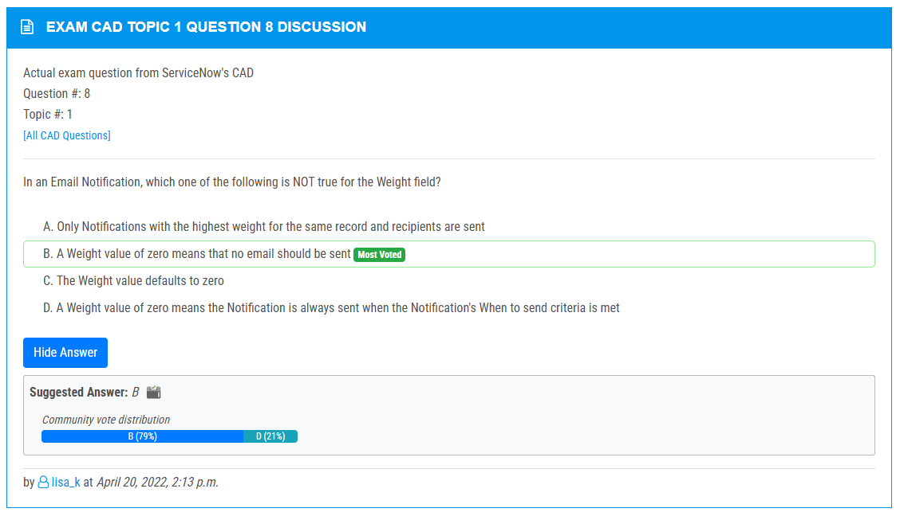

<https://www.examtopics.com/discussions/servicenow/view/61952-exam-cad-topic-1-question-22-discussion/>

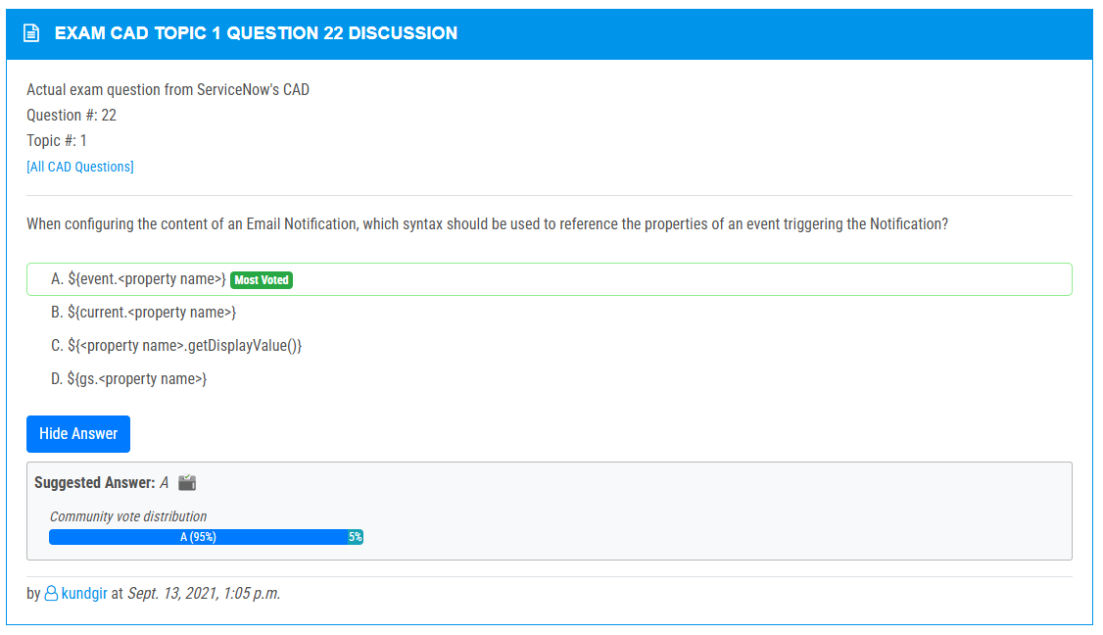

<https://www.examtopics.com/discussions/servicenow/view/70394-exam-cad-topic-1-question-55-discussion/>

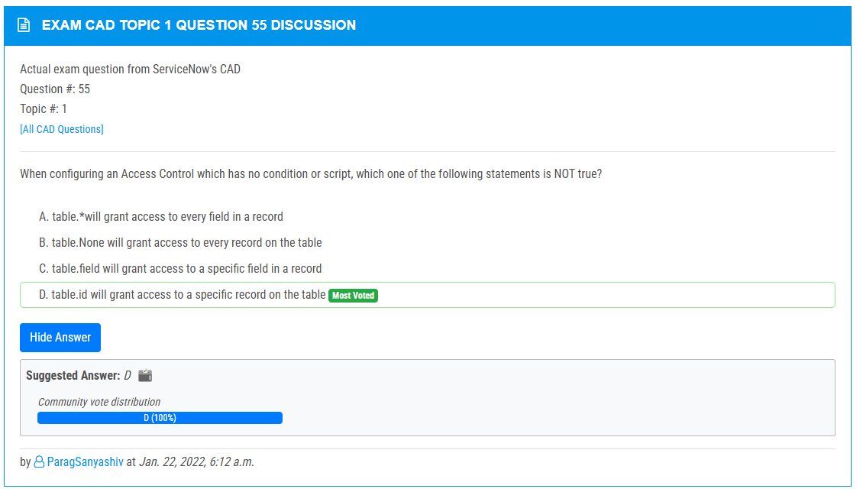

<https://www.examtopics.com/discussions/servicenow/view/64120-exam-cad-topic-1-question-33-discussion/>

